BUSY METABOLISM.

BOOST ENERGY, BURN FAT AND TRANSFORM YOUR METABOLISM IN 30 DAYS — WITHOUT SACRIFICING TIME.

TOMMASO ZANETTE.

GUIDING PRINCIPLE.

Structure speeds up results.
Adaptability keeps you consistent.
Table of contents.
INTRODUCTION. .
1. RISE AND SHINE. .
2. BREAKFAST BOOST. .
3. COMMUTE WITH PURPOSE. .
4. FOCUS AND FLOW. .
5. LUNCH AND LEISURE. .
6. REFLECT AND SHARE. .
7. ENERGIZE YOUR AFTERNOON. .
8. UNWIND AND DINE. .
9. RECHARGE AND PREPARE. .
10. FROM KNOWLEDGE TO ACTION. .
REFERENCES. .

INTRODUCTION.

Why I wrote this book and how to get the most out of it.
Welcome, I’m excited you’re here, and I want to start by telling you why I wrote this book.
If you’re like most people, you’re juggling a demanding schedule, and it feels like there’s never enough time to take care of yourself. You’re busy. Your metabolism might be “busy” too—slowing down, making it harder to stay energized and easier to gain weight. I wrote this book because I’ve been there. I know the struggle of balancing work, health and life, therefore I want to show you that it’s possible to boost your metabolism and feel more energized—even with a packed schedule.
As someone with a degree in “Nutrition and dietetics”, I’ve spent years studying how the body works and how small changes in our daily habits can have a big impact on our health. But this book isn’t about fancy theories—it’s about simple, actionable strategies that fit into your life. My goal is to help you boost your metabolism while making the most of the time you have.
To make this book as practical as possible, you’ll notice some repetition throughout the chapters. This is intentional. Key ideas, action plans, mistakes to avoid, reflections, and homework are repeated to reinforce learning and make this book easy to use as a reference. If you come back to revisit a chapter later, you’ll be able to quickly recall its main points and takeaways without having to reread everything or take extensive notes.

How to read this book for maximum retention.
I don’t just want you to read this book—I want you to absorb it and put it into action immediately. Here’s the best way to do that:
Finish a chapter in each session: whenever possible, try to finish a full chapter in each reading session. Why? Because stopping mid-chapter can cause you to lose context, making it harder to pick up where you left off. When you finish a chapter, you reinforce the concepts and absorb them one by one. This helps you build momentum, which keeps you motivated to keep reading and finish what you started.
Read and listen together: as you read, I recommend listening to the audiobook at the same time. By triggering two channels of information—visual (reading) and auditory (listening)—you’ll enhance your brain’s ability to process and retain the information. Research shows that combining both channels of input can improve comprehension and make it easier to recall key concepts later on.
About references throughout the book: you’ll notice small numbers like “(1).” throughout the text—these are not notes, but references to sources listed at the end of the book. This is the Vancouver citation style, which is the medical standard for citing sources, ensuring both accuracy and clarity. I chose this style because, unlike hyperlinks, it helps you stay focused on the text without navigating back and forth. If you’re curious about a reference, simply note the corresponding number and check the list at the end of the book after you’ve finished your reading session. There, you’ll find links to the original resources, which include podcasts, papers, scientific magazines, and videos.

Let’s get started.
I wrote this book to help you take control of your metabolism, your energy, and your life—without having to sacrifice time or overwhelm yourself. So, as you read, keep in mind: this is about small, consistent changes that lead to big results.
Let’s dive into the first chapter and get started—because every small action you take from here will help you build momentum and boost your metabolism faster than you think.

1. RISE AND SHINE.

Ignite your day with morning movement.

Chapter objective.
Master a quick morning movement routine that fires up your metabolism, sharpens your focus and sets you up for success—no matter how busy you are.

“The secret of getting ahead is getting started.” — Mark Twain.

How I took back my mornings.
Picture this: the alarm rings and you hit the snooze button. Once, twice, maybe even three times. The bed feels like a warm capsule you can’t escape. But each time you delay, the day seems to grow heavier. Sound familiar? That was me not too long ago—a perpetual snoozer, always chasing the clock and never quite catching up. My mornings were a blur of rushed showers, skipped breakfasts and frantic dashes out the door. I was living in a cycle of exhaustion and stress.

My morning mess.
Before I discovered the power of morning movement, my mornings felt like a battle I was destined to lose. I’d wake up feeling groggy and disoriented, as if I’d barely slept at all. The thought of facing another day filled with endless tasks and responsibilities was overwhelming. I was constantly on edge, snapping at colleagues over minor issues and struggling to find joy in activities I once loved.

The moment things changed.
But then something shifted. I stumbled upon an idea that seemed almost counter-intuitive: “Eat the frog first.”(1). What does that mean? It’s about tackling the toughest task of your day right at the start. For me—and for many others—that frog was exercise. It wasn’t just about getting fit; it was about setting a tone of accomplishment and energy from the start.
Imagine waking up and knowing you’ve already conquered something challenging before most people have even started their day. That’s what morning exercise did for me. It changed my mornings from feeling sluggish to being a great starting point for the rest of my day.

Movement flipped everything.
Now, don’t get me wrong—it wasn’t easy at first. My body resisted, and my mind conjured every excuse to stay in bed. Yet, with each passing day, it got easier. The transformation was profound. By prioritizing movement first thing in the morning, I found my energy levels soaring throughout the day. It was like starting at the top of a mountain and coasting downhill with ease.
The rest of my day felt lighter, more manageable. I was more focused at work, more present in meetings and even had energy left over for personal pursuits. Morning movement became my secret weapon—not just for physical health but for mental clarity and emotional resilience.
What started as a simple change in my morning routine turned into a complete transformation of my energy levels and metabolism. But here’s what troubles me: I see so many busy professionals still trapped in the same energy-draining cycle I escaped from. They’re starting their days in ways that set them up for exhaustion rather than success.
Let’s look at what most people do in the morning—and why these common habits might be secretly sabotaging your energy and metabolism.

The morning mistakes everyone makes.
Mornings can be challenging for most people. The alarm goes off, but rather than jumping out of bed, many press the snooze button, trying to steal a few more minutes of sleep. That extra time feels like a small victory, but in truth, it’s setting you up for a day of low energy and sluggishness. Then the rush begins—there’s barely enough time for breakfast (if it happens at all), let alone any form of exercise. And before your day really starts, it’s easy to fall into the trap of checking your phone, scrolling through emails or social media, allowing the digital world to dictate your morning.
Here’s where most people go wrong—three key habits that keep them trapped in a cycle of stress, low energy and poor focus:

The snooze button trap.
Hitting “snooze” might seem harmless, but it’s a quick way to drain your energy reserves before the day has even begun. Research shows that fragmented sleep can decrease alertness and impair cognitive function throughout the day.(2). Instead of giving you more rest, pressing the snooze button actually disrupts your natural sleep cycle, making it harder to wake up and feel energized.
Most people believe that hitting the snooze button will help them feel more rested, but it’s a false sense of recovery. Repeatedly delaying your wake-up time throws off your body’s circadian rhythms, which are designed to help you feel awake and alert in the morning.

Digital distractions.
Another common mistake is reaching for your phone the minute you wake up. Many professionals start their day by checking their phones. It feels productive—checking your emails or catching up on the news—but starting your day with digital distractions can lead to immediate stress, setting a reactive tone for the rest of the day.(3).
Rather than starting the day with focus and intention, this habit can leave you feeling scattered and overwhelmed long before you’ve even had breakfast. It’s a chaotic way to begin the day, and it undermines your ability to focus and be proactive.

Lack of morning movement.
Skipping movement in the morning is another trap. Most people skip any form of physical activity, thinking they’ll be fine without it or that they’ll catch up later. But without some movement first thing in the morning, you’re missing a critical opportunity to activate your metabolism and boost your energy. Think of your body like a car—without a proper warm-up, it’s going to sputter and stall.
Research shows that even brief periods of morning movement can significantly increase energy levels and improve focus throughout the day.(4). When you skip movement, your body stays in a state of low energy, making it harder to get through your day with the focus and clarity you need.
These morning habits—hitting the snooze button, checking your phone, skipping movement—might seem insignificant when looked at individually, but together, they’re sabotaging your energy and making it harder to start your day with clarity and purpose. Let’s dive deeper into how these habits are actively working against your body’s natural systems and what that means for your daily energy.

Why your mornings are working against you.
To truly understand why these common morning habits might be holding us back, we need to dive deeper into how our body’s natural systems work. These internal processes aren’t just random—they’re precisely timed to help you perform at your best, but only if you work with them, not against them.

Your body’s natural clock.
Our body operates on a natural 24-hour cycle that controls everything from sleep patterns to energy production. In the morning, these rhythms are designed to wake us up naturally, preparing us for peak performance. Our body’s natural wake-up processes peak in the early morning hours, preparing us to face the day with energy and focus.
When you hit the snooze button repeatedly, you’re not just stealing a few extra minutes of sleep—you’re actively fighting against your body’s natural rhythm. It’s like trying to drive with the parking brake on. Instead of waking up refreshed and ready to tackle the day, you end up feeling groggy and disoriented.

The morning energy crisis.
Starting your day stressed—whether from rushing or diving straight into emails—triggers an immediate stress response in your body. During these early hours, your body is naturally preparing for activity by increasing energy-producing hormones. According to Dr. Michael Breus, a chronotypes specialist, “Aligning your activities with your body’s natural energy peak can enhance your performance and improve metabolic function.”(5).
By jumping straight into stress-inducing activities like checking emails or social media, you’re adding unnecessary pressure when your body is trying to wake up naturally. This leads to increased anxiety and overwhelm—exactly what you don’t need first thing in the morning.

Why movement is the key.
Skipping morning movement is another crucial mistake. Movement during your body’s natural morning energy peak can be incredibly beneficial. It not only helps regulate your metabolism but also activates your mitochondria—the powerhouses of your cells—making them work more efficiently. This means your body becomes better at producing and using energy throughout the day.
When you start your day with movement, whether it’s a short yoga session or a brisk walk, you’re working with your body’s natural rhythms. As Dr. John Ratey, an expert in neuropsychiatry at Harvard Medical School, notes, “exercise in the morning can set off a cascade of positive effects on energy levels and metabolic function that last throughout the day.”(6).
Understanding these processes shows us why common morning habits can derail our entire day. When you disrupt your natural rhythms, increase stress first thing in the morning and skip movement, you’re setting yourself up for low energy and poor focus. But here’s the good news: by aligning with your body’s natural patterns, you can transform your mornings from energy-draining to energy-generating. Let’s explore exactly how to do that.

Flip the script: move first.
So, what’s the alternative? How can we flip our mornings from frazzled to fabulous? It starts with a simple shift: prioritize movement first thing in the morning. This doesn’t mean you need to run a marathon at dawn; even gentle stretching or a short yoga session can work wonders.
Here’s the thing—when cortisol is naturally high in the morning, it’s not just a wake-up call; it’s a window of opportunity. This surge in cortisol is like your body’s way of saying, “Let’s get moving!” By engaging in exercise during this time, you’re not only aligning with your body’s natural rhythm but also giving your metabolism a significant boost.

What the best do right.
Many successful people have harnessed the power of morning movement. Take Apple CEO Tim Cook, for example. He starts his day at 4:00 with a workout to clear his mind and energize his body.(7). Similarly, Jennifer Aniston is known for her commitment to morning exercise, often beginning her day with yoga and meditation to maintain her physical health and mental clarity.(8).
These routines aren’t just about physical fitness—they’re about mental clarity and emotional resilience. By starting their days with movement, these leaders are better equipped to handle the challenges ahead.

Turn your morning into a power move.
Imagine waking up 30 minutes earlier—not to rush through chores or emails but to dedicate time to yourself. Whether it’s yoga, a brisk walk, or even bouncing on a small trampoline to your favourite tunes, find what invigorates you. This isn’t just about exercise; it’s about setting a tone of empowerment and readiness for whatever comes your way.
By making these changes, you’re not just boosting your metabolism—you’re setting yourself up to win the day before most people have even started. Ready to transform your mornings? Let’s break this down into simple, actionable steps you can start implementing tomorrow.

Action plan: start strong, stay energized.
Now that we’ve explored the benefits of morning movement, let’s break it down into actionable steps. Here’s how you can transform your mornings into a powerful start to your day:

1. Prepare the night before.
Lay out your exercise clothes and set up a space for your morning routine. Having everything ready makes it easier to get started without second-guessing. Consider setting a playlist of energizing music to motivate you.

2. Set a gentle alarm.
Use a soft alarm or wake-up light to ease into your day. This gentle approach can help you wake up feeling refreshed rather than jolted. Apps with nature sounds or gradual volume increase can be particularly effective.

3. Start with stretching.
Begin with five minutes of gentle stretching right in bed. Focus on loosening up your neck, shoulders and back to get the blood flowing and ease your body awake. Try these simple stretches:
- Cat-cow stretch: arch and round your back to release tension.
- Seated forward bend: reach for your toes while sitting up in bed.
- Neck rolls: gently roll your head side to side to relieve stiffness.

4. Hydrate.
Drink a large glass of water as soon as you get out of bed. Hydration is key to activate your metabolism and keeping you alert. Consider adding a slice of lemon or a splash of apple cider vinegar for a refreshing start.

5. Engage in movement.
Choose a routine that suits your style and energy level. Here are some fun options:
Time available. | Quick guide. | Choose one: | Energy impact.
5 minutes. | Perfect for super busy mornings. | • Gentle stretches in bed.  • Basic bodyweight moves.  • Quick walk in place. | Gets your body moving and mind ready.
10 minutes. | Ideal for most mornings. | • Simple yoga flow.  • Bodyweight circuit.  • Trampoline session. | Boosts energy and metabolism.
15 minutes. | When you have extra time. | • Combined movements.  • Extended yoga.  • Walk + stretches. | Maximum energy boost for the day.
- Yoga routine for beginners: flow through sun salutations, warrior poses and gentle twists to engage your entire body and centre your mind. Plenty of free online resources offer beginner-friendly sessions.
- Bodyweight routine: for those who prefer bodyweight exercises, try this invigorating circuit:
      - Squats: 15 reps.
      - Push-ups: 10 reps.
      - Lunges: 10 reps per leg.
      - Plank hold: 30 seconds.
      - Rest: 30 seconds between each exercise.
Repeat the circuit as many times as you feel comfortable within 10–20 minutes.
If you’re curious about more structured routines, consider doing some online research on bodyweight exercises. Personally, I find inspiration in the George Hackenschmidt bodyweight routine for health—it’s a classic approach that balances strength, coordination and flexibility.(9).
- Trampoline jumps: if you have access to a small trampoline, bounce along to your favourite music for 10 minutes. This activity is not only fun but also highly effective at boosting metabolism, improving mood and aiding the lymphatic system.

6. Hydrate again if needed.
After your workout, have another glass of water if you feel thirsty. Staying hydrated supports recovery and keeps energy levels high.

7. Quick shower + mindful moment.
Take a quick shower to refresh yourself, using this time as an opportunity for mindfulness. Focus on the sensation of the water and take deep breaths, practising gratitude or setting intentions for the day ahead.

8. Enjoy a balanced breakfast.
Fuel your body with a nutritious breakfast that includes protein, healthy fats and fibre to keep your energy levels steady. We’ll dive deeper into crafting the perfect breakfast in the next chapter.

Making it work for you: your morning movement toolbox.
Now that you have the basic steps, let’s make this routine work for your specific situation. Remember, the goal is to make morning movement doable, not perfect.

Quick-start guide.
Choose your movement based on what works best for you:
When time is short (5 minutes).
- Basic stretches.
- 2-minute cardio burst.
- Quick yoga flow.
When you have more time (10–15 minutes).
- Full body activation.
- Complete energizing routine.
- Extended movement session.
Based on your energy level.
- Low: gentle stretches, walking, basic yoga.
- Medium: bodyweight exercises, trampoline.
- High: full movement routine, cardio combinations.
Working with your space.
- Bedroom: stretching, yoga, bodyweight exercises.
- Living Room: trampoline, dance, full routines.
- Outdoors: walking, jogging, dynamic movements.

Energy boosters (30 seconds moves).
For those extra-busy mornings:
- Full body reach and twist.
- Quick jumping jacks.
- Deep breathing with arm raises.

Backup plans.
Everyone needs a plan B:
- 5 minutes of stretching in bed.
- Walking in place while brewing tea.
- Desk stretches during first email check.
These steps give you a solid foundation for energizing mornings, but let’s be real—changing habits isn’t always smooth sailing. Even the best morning routines can hit some bumps along the way. Let’s tackle the most common challenges head-on and ensure you’re prepared to handle any obstacles that might try to derail your progress.

Troubleshooting: fix your morning mistakes.
As you embark on this new morning routine, it’s natural to encounter a few bumps in the road. Here are some common pitfalls and how to navigate them effectively:
- Trying to do too much too soon:
It’s tempting to overhaul your entire routine overnight, but this can lead to burnout. Imagine waking up on day one and trying to fit in a full workout, meditation, and breakfast prep all at once. It’s overwhelming, right? Instead, start small—perhaps with just stretching—and gradually build up as you become more comfortable. Remember, consistency is more important than intensity.
- Not adjusting bedtime:
Waking up earlier means going to bed earlier too. If you find yourself dragging through the day, it might be because you’re not getting enough sleep. Try setting a bedtime alarm as a reminder to wind down. A well-rested body is more likely to embrace early exercise and remain energized throughout the day.
- Skipping rest days:
Your body needs time to recover, so incorporate rest days or lighter activity days into your routine to prevent fatigue and injury. For example, if you feel sore or tired, consider swapping your workout for a gentle walk or some light stretching.
- Checking devices too early:
It’s easy to fall back into the habit of checking emails or social media first thing. Picture this: you’ve just finished your morning routine, feeling centred and calm, only to dive into a sea of notifications that spike your stress levels. Try keeping devices out of reach until after your morning routine is complete. This helps maintain focus and reduces unnecessary stress.
- Losing motivation over time:
It’s common for motivation to wane after the initial excitement fades. To keep the momentum going, set small goals and celebrate your progress. Perhaps treat yourself to a new workout playlist or enjoy a special breakfast on weekends as a reward for sticking with your routine.

Travelling challenges.
“I can’t keep up my morning routine while travelling.” I hear this from busy professionals all the time. Whether it’s jet lag, unfamiliar hotel rooms, or packed schedules, business trips seem like the perfect excuse to skip morning movement. But here’s the truth: maintaining this habit while travelling isn’t just possible—it’s crucial for managing jet lag, maintaining energy levels and staying sharp during important meetings.
Let’s tackle the most common excuses:
1. “The hotel room is too small.”.
Transform any space into your movement area. Clear a small spot (2×2 meters) near your bed—that’s all you need for:
- Basic bodyweight exercises (squats, push-ups).
- Wall-supported stretches and lunges.
- Gentle yoga flows using your bed as a mat.
- Simple marching or jumping jacks.
2. “I don’t want to disturb other guests.”.
Low-impact alternatives that won’t wake the neighbours:
- Isometric exercises (planks, wall sits).
- Silent yoga stretches.
- Controlled bodyweight movements.
- Quiet breathing exercises with movement.
3. “I’m too jet-lagged.”.
This is exactly when you need movement most. Start with:
- Light stretches to realign your body clock.
- Gentle movements to boost circulation.
- Basic exercises to wake up your metabolism.
- Short walks to expose yourself to natural light.
Remember: even five minutes of movement is better than none. Your body doesn’t know you’re travelling—it only knows whether you’re maintaining healthy habits or not. The key isn’t perfection; it’s adaptability.
Now that you know both the path forward and the potential pitfalls to avoid, it’s time to make this morning transformation your own. Let’s take a moment to reflect on where you are now and create a clear plan for where you want to be—starting tomorrow morning.

Reflection and action: audit your morning, boost your energy.
Now that you understand how morning movement can transform your day, let’s get real about where you stand and what needs to change. These questions aren’t just for thinking—they’re your roadmap to better mornings.

Your morning audit.
Take a hard look at your current morning routine. Be completely honest with yourself:
1. What’s actually holding you back?
- Is it poor sleep habits?
- Late-night device use?
- Lack of preparation?
- Write down your top 3 obstacles. You can’t fix what you don’t acknowledge.
2. Rate your current energy levels.
- How do you feel at 10:00?
- At 14:00?
- By the end of your workday?
- Track this for the next three days. This data becomes your baseline for measuring improvement.
3. What small win can you score tomorrow?
- Which part of your morning needs the most urgent change?
- What’s one thing you can do differently tomorrow?
- How can you make this change stick?

Your next move.
Here’s where most people stop—they reflect but never act. You’re going to be different. Your assignment is simple but powerful:
Commit to 5–10 minutes of morning movement.
Choose your weapon:
- Bodyweight exercises.
- Yoga flows.
- Trampoline jumps.
- Brisk walking.
Here’s your weekly blueprint:
Day. | Movement Type. | Intensity. | Completed.
MON. | Body Weight. | ⭐⭐⭐. | □.
TUE. | Yoga. | ⭐⭐. | □.
WED. | Jumps/HIIT. | ⭐⭐⭐. | □.
THU. | Yoga. | ⭐⭐. | □.
FRI. | Body Weight. | ⭐⭐⭐. | □.
SAT. | Stretches. | ⭐⭐. | □.
SUN. | Walk. | ⭐. | □.
The rules:
- Start with just 5 minutes if needed.
- No perfectionism allowed.
- Movement trumps intensity.
- Consistency beats everything.
Track your progress:
- How did you feel immediately after?
- Energy levels throughout the day?
- Quality of sleep that night?
Daily energy tracker.
Time of day. | Energy level (1-5).
Post-movement. | □ 1 □ 2 □ 3 □ 4 □ 5.
Mid-morning. | □ 1 □ 2 □ 3 □ 4 □ 5.
Afternoon. | □ 1 □ 2 □ 3 □ 4 □ 5.
End of day. | □ 1 □ 2 □ 3 □ 4 □ 5.
Daily movement check.
Activity. | Status.
Morning prep. | □ Done.
Movement done. | □ Done.
Hydration. | □ Done.
No phone use. | □ Done.
Remember: this isn’t about becoming a morning person overnight. It’s about taking control of your energy and metabolism, one morning at a time.

Key points.
- Morning movement matters: prioritizing exercise first thing in the morning harnesses your natural cortisol peak, boosting metabolism and setting a positive tone for the day.
- Common pitfalls: avoid hitting snooze, checking devices too early and skipping movement. These habits can disrupt your energy flow and increase stress.
- Actionable steps: prepare the night before, start with gentle stretching, hydrate and engage in a 10-20 minute routine. Follow with a quick shower and mindful moment to centre yourself.
- Reflect and adjust: consider what holds you back from energizing mornings and how small changes can align your routine with your goals.

2. BREAKFAST BOOST.

Fuel your fat-burning engine.

Chapter objective.
Learn how to quickly assemble balanced, metabolism-boosting breakfasts using the Power Plate Ratio method, designed for busy professionals seeking sustained energy and weight management.

“Let food be thy medicine and medicine be thy food.” — Hippocrates.

Breaking the breakfast crisis cycle.
It’s 07:30, and you’re already running late. Your stomach growls as you grab the quickest option—a bowl of cereal swimming in milk, maybe a couple of biscuits. By 10:00, you’re fighting to stay focused during that important meeting, your mind wandering and energy crashing harder than yesterday. Sound familiar?
That was my daily struggle not long ago. As a busy professional, my mornings were a blur of rushed decisions and missed opportunities. Breakfast? It was whatever I could grab in the 60 seconds between emails—quick fixes that drained both my wallet and my energy.

The wake-up call.
Then came the turning point. During a crucial client meeting at 10:00, as my mind wandered and my focus completely vanished, I realized my breakfast choices were setting me up for failure. The mid-morning brain fog and energy crashes were affecting my performance. I needed something more substantial—but what? The usual advice about elaborate morning meals wasn’t going to work with my schedule.
I decided to approach this like any other challenge: through experimentation and data. Each week, I tested different breakfast combinations, tracking my energy levels and focus throughout the day. Some attempts were disasters—like the bowl of porridge that left me crashing by 09:30 due to the insulin spike, or the fancy avocado toast that proved too expensive to maintain as a daily habit.
But gradually, patterns emerged. I discovered that planning ahead was crucial. Each evening, I’d decide exactly what tomorrow’s breakfast would be and ensure I had everything ready for quick assembly. Instead of reaching for processed cereals and sugary snacks, I developed a system for quick, balanced meals. Greek yogurt with fresh berries, granola, and a sprinkle of nuts became my go-to option—components ready to combine in minutes. On days when I had more time, sliced tomatoes seasoned with oregano and olive oil, paired with eggs and toasted bread, plus a crisp apple, proved equally effective. These weren’t just tasty; they were transformative.

The energy breakthrough.
The difference was astounding. My mornings became less about survival and more about thriving. I felt energized, focused and ready to tackle whatever the day threw at me. It was like flipping a switch—the brain fog lifted and clarity took its place.
The results spoke for themselves:
- Sustained energy until lunch.
- Sharp focus during morning meetings.
- Better decision-making ability.
- Improved mood and patience with colleagues.

The morning power combo.
But here’s the game-changer I discovered: when you pair the right breakfast with morning movement, you create a metabolic advantage that lasts all day. This combination doesn’t just fuel your body—it optimizes your fat-burning potential for hours afterwards.
This revelation transformed my approach to morning nutrition. Yet I see countless professionals still trapped in the same energy-draining cycle I escaped. Let’s look at the common breakfast mistakes that might be holding you back—and how to fix them.

The breakfast mistakes killing your metabolism.
Let’s face it: mornings can be rough. Research from the International Journal of Behavioural Nutrition shows that while most professionals understand the importance of breakfast, quite a lot admit their morning nutrition habits aren’t serving them well.(10). In our fast-paced world, it’s easy to see why breakfast often gets neglected. But what exactly are these habits costing us?

The random eating pattern.
Many busy professionals skip breakfast, thinking it will save time or help with weight loss. An extensive infographic from Online Colleges reveals that while 93% believe breakfast is important, only 44% actually eat it regularly. The most common excuses? “No time” and “Not hungry in the morning.”(11).
This often leads to a cycle of multiple small snacks throughout the day, followed by larger meals in the evening. Each time you eat, you trigger a metabolic response—meaning most people are activating their metabolism 5–6 times daily instead of the more efficient pattern of three structured meals.

The sugar spike cycle.
When people do eat breakfast, they often reach for what’s quick and convenient. A survey from the Environmental Working Group found that the typical breakfast for children contains more sugar than dessert.(12). For adults is not very different, think about these common choices:
- Average breakfast cereal: 12g of sugar per serving (3 teaspoons).
- Flavoured yogurt: up to 15g of sugar (nearly 4 teaspoons).
- Store-bought smoothie: can contain 30g+ of sugar (7+ teaspoons).

The empty energy fix.
Then there’s the coffee-only crowd. Research from the Journal of Psychology Research and Behaviour Management shows that 72% of young professionals rely on coffee as their primary morning fuel with the 28% admitting choosing it for its reinforcing effect.(13). But here’s the catch—most aren’t drinking plain black coffee. They’re picking sugar-laden variations like vanilla lattes (250+ calories), caramel frappuccinos (400+ calories), or seemingly innocent cappuccinos with added sugar. This trend of liquid breakfasts has become the norm in corporate culture, with coffee shops on every corner making it all too convenient to skip real food in favour of a caffeine fix.

The corporate breakfast culture.
The corporate world has its own distinct breakfast patterns. A survey by Resume Builder reveals that 60% of office workers rely on chain coffee shops and office cafés for their morning fuel at least three times per week—often choosing convenience over nutrition.(14).
Then there’s the Full English crowd—often seen as a “power breakfast” choice during morning meetings. These heavy meals typically include eggs, bacon, sausages, beans, and toast. While it might seem like a hearty start, it’s become a default choice for many corporate breakfast meetings.
More commonly, you’ll find the “desktop diners”—those who bring breakfast to eat at their desk while checking emails. A workplace survey indicates that 6 out of 10 consumers worldwide replace their meals, especially breakfasts, with snacks at least once a week.(15). They report that they prefer them to traditional meals, choosing processed cereal bars, sugary fruit yoghurts or meal replacement shakes, while multitasking in their morning routine at work.

The hidden energy tax.
These morning mistakes aren’t just affecting your immediate energy—they’re creating a compound effect that impacts your entire day. Different studies, in particular one published in the International Journal of Obesity, reveal that these common breakfast habits can:(16).
- Decrease morning productivity by up to 30%.
- Lead to overeating at lunch by an average of 20%.
- Cause afternoon energy crashes affecting 75% of office workers.
- Disrupt your natural metabolic rhythm for up to 24 hours.
The good news? Understanding these patterns is the first step to breaking free from them. Let’s dive deeper into why these common breakfast choices don’t work and what you can do instead.

Why your breakfast is sabotaging your energy.
Your morning food choices set off a complex chain of metabolic reactions that impact your entire day. Understanding these mechanisms isn’t just about nutrition—it’s about unlocking your body’s natural ability to generate and sustain energy when you need it most.

The random eating pattern.
While strategic meal timing can be beneficial (a topic we’ll explore in a future book about intermittent fasting), randomly skipping breakfast disrupts your metabolic function in significant ways. A study explains that unplanned skipping of main meals is linked to unhealthy snacking behaviours that lower the quality of subsequent meals.(17).
When you skip breakfast and compensate with multiple snacks, you’re forcing your body to constantly process food. Each time you eat, your body releases insulin to process nutrients. Instead of three distinct metabolic peaks that align with main meals, you’re creating 5-6 smaller, less efficient responses throughout the day, never allowing your body to establish a proper rhythm of energy use and storage.

The metabolic disruption.
The way you break your overnight fast matters tremendously. High-sugar breakfast choices trigger what endocrinologists call a ‘glucose tsunami’—a sudden flood of sugar into your bloodstream. Your body responds with an equally dramatic insulin surge, followed by an inevitable crash. In a podcast episode of Dr. Rangan Chatterjee’s, Jessie Inchauspé reveals how this morning glucose roller-coaster affects your metabolic rate for several hours, essentially switching your body from fat-burning to fat-storing mode.(18).
Heavy breakfast choices, like the traditional Full English, present a different challenge. Your digestive system, still waking up from its nightly rest, suddenly faces an overwhelming amount of nutrients to process. A study published in the British Journal of Nutrition highlights that having a high glycaemic index breakfast, eating carbohydrates from starches and flours, is associated with poorer cognitive function compared to a low glycaemic index breakfast.(19). Precisely when you need maximum mental performance at work, your body cannot deliver it because your blood is concentrated in your stomach doing digestion. While your blood sugar levels rise and fall, altering your mental focus along with your ability to react.

The distracted consumption impact.
Modern workplace habits have created what scientists term ‘mindless eating syndrome.’ When you eat while checking emails or during morning meetings, your body’s sophisticated hunger and fullness signals get disrupted. This isn’t just about poor digestion—it’s about your body’s ability to recognize and process nutrients efficiently.
The morning coffee routine adds another layer of complexity. That vanilla latte isn’t just a drink—it’s a powerful combination of stimulants and sugar that hijacks your body’s natural energy-production systems. When caffeine and sugar hit your system simultaneously, they trigger a cascade of hormonal responses. Your adrenal glands release stress hormones, your pancreas pumps out insulin and your body experiences a false energy high. Within two hours, this artificial peak crashes, leaving you craving more sugar and caffeine—a cycle that repeats throughout the day.
The impact goes beyond simple energy levels. This pattern disrupts your body’s natural cortisol rhythm, affects nutrient absorption and can even influence your food choices hours later. Studies show that morning metabolic disruption can lead to increased cravings, poor concentration and compromised decision-making throughout the day.
These breakfast habits create a cascading effect that impacts your entire metabolic system. Understanding these patterns isn’t just about knowledge—it’s about recognizing how profoundly your morning choices shape your professional performance and metabolic health. In the next section, we’ll explore how to transform these patterns into powerful allies for sustained energy and optimal metabolism.

The Power Plate Ratio: ignite your metabolism.
Transforming your breakfast routine can be a game-changer for your energy levels and overall well-being. The Power Plate Ratio Method is designed to help busy professionals quickly assemble balanced, metabolism-boosting breakfasts that support sustained energy and weight management. This method works with your body’s natural morning metabolic peak to maximize nutrient absorption and energy production.

The ratio revolution.
The Power Plate Ratio is a strategic approach to breakfast that optimizes your metabolism through precise nutrient timing. Visualize your entire breakfast on a single plate, divided into sections that represent ideal proportions for a nourishing meal. This method harnesses the power of natural carbohydrates from fruits and vegetables, leverages proteins and healthy fats for sustained energy and strategically incorporates refined carbohydrates to maintain stable blood sugar levels throughout your morning.

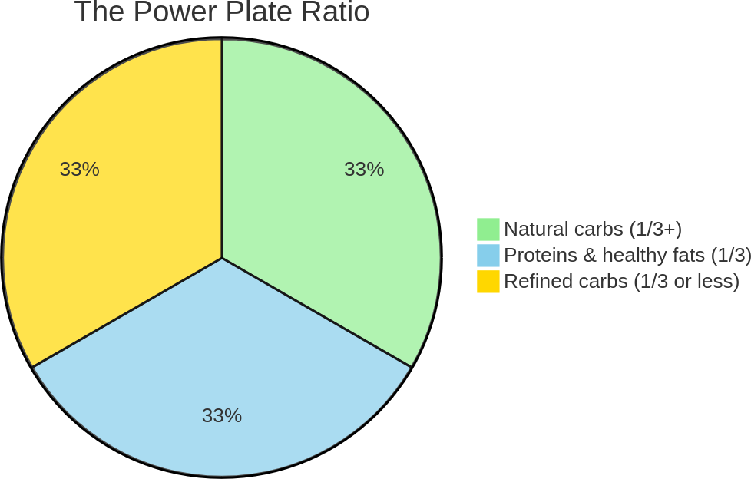
Natural carbohydrates (1/3 or more of the plate).
Your morning plate should prioritize fruits and vegetables as they provide the essential nutrients your body needs during its peak metabolic window. Think of these foods as your body’s premium fuel—they deliver sustained energy while supporting your metabolism.
- Fruits: choose options like berries, apples, or citrus fruits. Their natural sugars combined with fibre create a steady release of energy, preventing the crashes associated with processed foods. For example, a cup of mixed berries provides both quick energy and lasting satiety through their fibre content.
- Vegetables: incorporate colourful options like tomatoes, bell peppers, or leafy greens. Each colour represents different phytonutrients that support your body’s energy production systems. Adding vegetables to breakfast might seem unconventional, but they’re powerful allies for sustained morning energy.

Proteins and healthy fats (1/3 of the plate).
This powerful combination acts as your morning anchor, providing lasting energy and mental clarity. When you combine proteins and healthy fats, you create a sustained release of energy that keeps you focused until lunch.
- Proteins: eggs remain the gold standard—they’re complete proteins containing all essential amino acids. Greek yogurt offers both protein and beneficial probiotics. The key is choosing options that provide substantial protein to fuel your morning performance.
- Healthy fats: think of healthy fats as your brain’s preferred energy source. Nuts, seeds, avocados and olive oil don’t just add flavour—they enhance nutrient absorption and support cognitive function. A handful of nuts or a teaspoon of seeds can transform a good breakfast into a great one.

Refined carbohydrates (1/3 or less of the plate).
Refined carbohydrates—including grains, processed starchy foods, very sugary fruits, honey, jams, and marmalade often breakfast staples. While they provide quick energy, they need to be managed carefully. For those seeking optimal metabolic function, consider limiting these to 1/4 of your plate to maintain stable blood sugar levels throughout the morning.
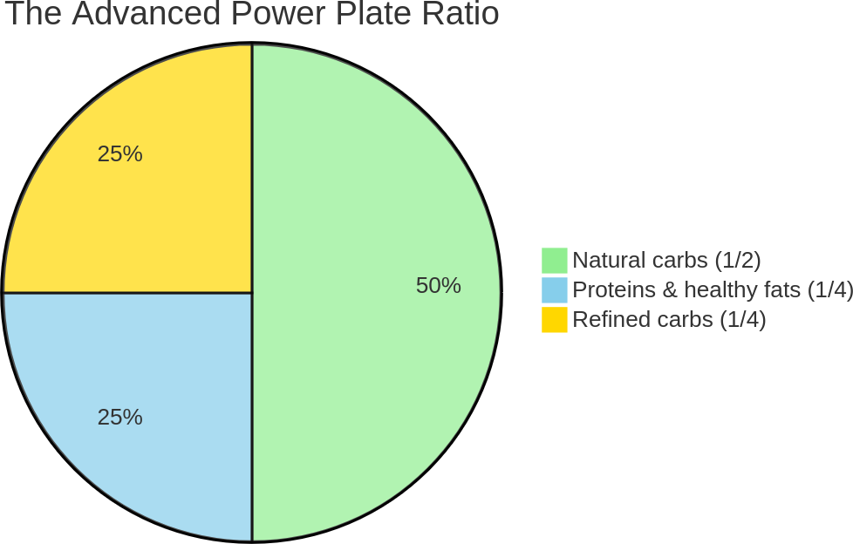
You don’t have to give up all your favourite sugary breakfasts immediately. The key is moderation. If you’re used to sweet cereals or pastries, try incorporating small quantities within this portion of the plate while gradually transitioning to healthier choices like whole-grain toast or oatmeal. This approach allows you to enjoy familiar comforts without compromising your health goals.
The key is finding your sweet spot with refined carbs—enough to enjoy your breakfast while supporting your body’s natural energy rhythms.

Power Plate blueprints.
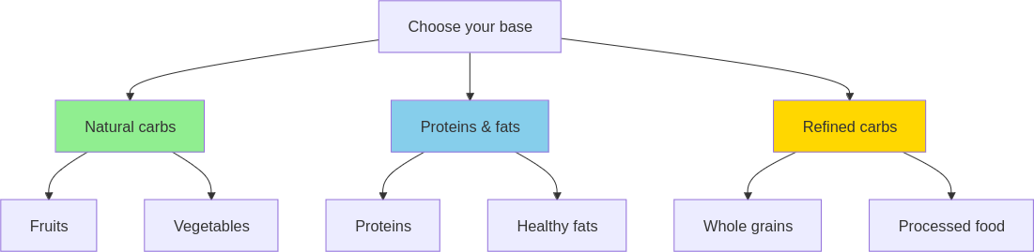
Let’s make this practical with real-world examples that take 5–10 minutes to assemble and deserve your full attention at the breakfast table:
The classic Power Plate (3 minutes).
- Cherry tomatoes, carrots and an apple.
- Two hard-boiled eggs (prep night before) and olive oil.
- One slice whole-grain toast.
Perfect for: a nourishing start to any day.
The quick assembly (3 minutes).
- Cup of mixed berries and sliced banana.
- Plain Greek yogurt with almonds and chia seeds/flaxseed.
- Small portion of granola.
Perfect for: when time is tight, but you still sit to eat.
The market fresh (5 minutes).
- Colourful bell peppers, a cucumber, and a pear.
- Fresh cottage cheese and nut butter.
- Small piece of sourdough.
Perfect for: a light yet satisfying breakfast.
These examples illustrate how you can enjoy a balanced breakfast that aligns with the Power Plate Ratio while keeping refined carbohydrates in check.

The tea solution: your morning energy upgrade.
While coffee might seem like the obvious choice for morning energy, tea offers a sophisticated alternative that can transform your metabolism and focus. Unlike coffee’s harsh spike and crash, tea provides a gradual rise in energy that aligns perfectly with your body’s natural morning rhythm.

Types of tea to consider.
- Green tea: rich in catechins that boost metabolism and enhance brain function. These compounds work with your body’s natural morning cortisol peak to optimize energy production.
- Black tea: contains theaflavins that provide sustained energy without coffee’s jitters. Perfect for those who need robust morning fuel without the afternoon crash.
- Red tea (Pu-erh): known for its unique fermentation process that enhances digestion and supports metabolic function throughout the morning.
- Herbal teas: options like peppermint stimulate digestion, while chamomile provides a gentle, caffeine-free start for those sensitive to stimulants.

How to enjoy your tea.
For optimal metabolic benefits, brew your tea properly and enjoy it without sugar. Time your tea with your Power Plate breakfast to enhance nutrient absorption and energy release.
Brewing tips:
- Green tea: 80 °C water, steep 2–3 minutes.
- Black tea: 90-95 °C water, steep 3–4 minutes.
- Pu-erh: 95 °C water, steep 3–5 minutes.
- Herbal: 100 °C water, steep 5–7 minutes.

The metabolic edge.
Tea offers unique benefits that coffee can’t match:
- L-theanine + theine (caffeine): this natural combination provides focused energy without anxiety.
- Polyphenols: support metabolic function and help regulate blood sugar.
- Antioxidants: enhance cellular energy production and recovery.
Making the switch to tea can transform your morning energy patterns. If you’re not ready for a complete switch, try alternating between tea and coffee, always avoiding added sugars to maintain stable blood sugar levels.

Breaking free from sugar: the morning energy trap.
The desire for sweetness in the morning is natural, but managing it is crucial for maintaining metabolic balance. Understanding how different types of sugars affect your body can help you make better breakfast choices.

The hidden impact.
Artificial sweeteners aren’t the metabolic free pass many believe them to be. They interfere with your body’s natural ability to regulate blood sugar and energy levels. When you consume these substances in the morning, you’re disrupting your metabolism during its most active period. Zero-calorie sweeteners might seem like a smart choice, but they can alter the gut microbiota and potentially increase the risk of cardiovascular disease, affecting overall health.(20,21).
Moreover, these sweeteners impact your taste perception, making you crave increasingly sweeter foods. This creates a cycle that can derail your metabolism and energy levels, precisely when you need them most for peak performance.

Natural sweetness strategy.
The key is working with your body’s natural preferences while maintaining metabolic balance. Here’s how:
- Fruits: choose lower-sugar options like berries, apples, and pears. A cup of mixed berries provides sweetness while keeping your blood sugar stable.
- High-sugar fruits: be strategic with bananas, mangos, and dates. While nutritious, these are best combined with protein and fats to slow sugar absorption.
- Natural sweeteners: even honey and maple syrup should be used sparingly—no more than a teaspoon if needed. Remember, they still impact your blood sugar like any other sweetener.
The goal isn’t to eliminate sweetness but to manage it within your Power Plate Ratio. By selecting natural sources and controlling portions, you maintain stable energy levels while satisfying your taste for sweetness.

The total meal ratio.
Remember: the Power Plate Ratio applies to everything consumed during your breakfast—not just what’s on your plate. A common mistake is following the ratio with solid foods but forgetting about drinks. That cappuccino with sugar or honey in your tea counts toward your refined carbohydrates portion. Even a seemingly innocent splash of flavoured syrup in your coffee can push you well beyond the 1/3 ratio for refined carbs.
Think of your breakfast as a complete package—everything you consume within that meal must fit into the ratio. While we visualize the ratio on a plate for simplicity, it’s crucial to account for all sources of sugar, whether they come from your food or your morning beverage. This holistic approach ensures you maintain true metabolic balance throughout your morning.
Now that you understand the principles behind the Power Plate Ratio, let’s turn this knowledge into action with a step-by-step implementation plan.

Action plan: build your perfect breakfast.
Implementing the Power Plate Ratio into your morning routine is about more than just eating breakfast—it’s about optimizing your body’s natural metabolic peak. With strategic planning and the right approach, you can transform your morning meal into a powerful metabolic activator. Here’s your step-by-step guide to implementation:

1. Evening planning: the 5-minute Power Prep.
Take exactly 5 minutes each evening to prepare for metabolic success:
- 2 minutes: check ingredients and portions for tomorrow’s Power Plate.
- 2 minutes: pre-wash fruits/vegetables, portion proteins.
- 1 minute: set up your breakfast station (plates, utensils, tea preparation).
This 5-minute investment prevents morning stress and ensures your metabolism gets the right fuel at the right time.

2. Stocking your kitchen for quick Power Plate assembly.
Smart shopping is key to efficient breakfast preparation. Focus on versatile staples that align with the Power Plate Ratio:
- Natural carbohydrates: fresh fruits and vegetables.
- Proteins & healthy fats: eggs, Greek yogurt, nuts.
- Refined carbohydrates: whole-grain bread toast (in moderation).
Having these staples readily available maintains balance with minimal effort.

3. Power plate assembly: the 7-minute morning method.
- Minutes 1-2: natural carbohydrates base.
  - Fill 1/3+ of your plate with fruits/vegetables.
  - This activates your metabolism with fibre and nutrients.
- Minutes 3-4: protein power.
  - Add your pre-prepared protein source.
  - Essential for sustained energy and metabolic function.
- Minutes 5-6: strategic carbs.
  - Add refined carbs (max 1/3).
  - Satisfy carb cravings mindfully.
- Minute 7: final touch.
  - Add any seasoning/herbs.
  - Check your portions align with the ratio.

4. Strategies for maintaining variety.
Keep meals exciting while staying within the ratio:
- Rotate ingredients: change up your fruits, vegetables and proteins regularly.
- Experiment with flavours: use herbs and spices for added interest.
- Mix textures: combine crunchy, smooth and chewy elements.

5. Tips for different schedules.
Maintain flexibility while respecting the ratio:
- Early starts: prep ingredients the night before.
- Busy mornings: focus on simple combinations that follow the ratio.
- Weekend flexibility: enjoy more elaborate breakfasts while maintaining proportions.

6. Metabolic window optimization.
Time your Power Plate breakfast within 30–45 minutes of waking to:
- Maximize nutrient absorption.
- Support natural cortisol rhythm.
- Enhance fat-burning potential throughout the day.

Quick wins.
Focus on these quick wins for a smoother transition:
- Simplify choices: stick to staple ingredients you enjoy.
- Batch prep: prepare proteins like boiled eggs that last several days.
- Read labels: check ingredient lists for hidden sugars in packaged foods.
- Set up your space: organize your kitchen for efficient Power Plate assembly.
- Time management: use the 5-minute evening prep to ensure morning success.
By following these steps and tips, you’ll find that integrating the Power Plate Ratio into your morning routine is not only manageable but also rewarding. You’ll enjoy delicious breakfasts that set a positive tone for your day while boosting your metabolism and productivity goals.
While this method is straightforward, you might encounter some challenges along the way. Let’s address the most common pitfalls and their solutions.

Troubleshooting: common Power Plate pitfalls.
Your success with the Power Plate Ratio depends on recognizing and fixing common mistakes before they become habits. Here are the five most critical issues I see in my practice:
- The refined carbs balance:
When refined carbs start taking over your plate, or when you skip fruits entirely, you’re missing opportunities to manage cravings naturally.
Solution: use your palm as a guide for refined carbs and remember that fruits are your allies—they satisfy sweet cravings while keeping blood sugar stable. Load up on apples, berries, or pears as much as you like within your natural carbs portion, just be mindful with very sweet options like dates or mangoes.
- The morning rush compromise:
When time pressure hits, the ratio is often the first thing to go. This reactive approach sets off a chain of metabolic disruptions that can affect your entire day.
Solution: start with the quickest part—natural carbohydrates. Raw fruits and vegetables need minimal prep: just wash and cut. Add your protein source (like pre-boiled eggs) and finish with your chosen refined carb. A complete Power Plate breakfast can be ready in under 3 minutes.
- The portion distortion:
Many people struggle with portion sizes at breakfast, either eating too many refined carbs or too little overall. This throws off their metabolism for the entire day.
Solution: use the Power Plate Ratio as your visual guide. Start with a regular-sized plate and divide it according to the ratio: 1/3+ natural carbs (fruits and vegetables), 1/3 proteins and healthy fats and 1/3 or less refined carbs.
- The hidden sugar sabotage:
Many “healthy” breakfast foods pack hidden sugars that throw off your ratio.
Solution: focus on whole, single-ingredient foods for most of your plate. When choosing packaged foods, follow the “5 by 5 Rule”: look for options with no more than 5 ingredients and less than 5g of sugar per serving.
- The perfectionism paralysis:
Getting too stressed about exact ratios and portions can spike cortisol levels, which ironically can affect your metabolism negatively.
Solution: focus on one simple rule: make sure your natural carbs plus proteins and fats combined are at least double the amount of refined carbs on your plate. This keeps things manageable without obsessing over perfect thirds. Remember, stress-free consistency beats anxious perfection every time.

Travelling challenges.
Ever found yourself staring at a hotel breakfast buffet, wondering how to maintain your metabolism-boosting morning meal? Between pastry-loaded breakfast spreads and rushed business trips, travel can make it challenging to follow the Power Plate Ratio.
Let’s solve your biggest breakfast challenges:
1. “The hotel buffet is all refined carbs.”.
Build your Power Plate strategically:
- Load up on fresh fruits to satisfy sweet cravings naturally.
- Add fresh vegetables (cucumber, tomatoes).
- Include quality protein (eggs, yogurt).
- Choose healthy fats (nuts, olive oil).
- Keep refined carbs to 1/3 of your plate or less.
2. “I’ve got an early flight.”.
Create a proper breakfast moment:
- Pack fresh fruit from local shops.
- Bring plain yogurt in a travel container.
- Include nuts for healthy fats.
- Find a quiet spot to eat mindfully.
- Focus on one balanced meal, no grazing.
3. “I keep snacking due to back-to-back meetings.”.
Plan your breakfast properly:
- Take 15 minutes to enjoy your meal.
- Stock up on fresh local fruits.
- Focus on one balanced plate.
- Stay hydrated with water.
- Avoid grazing until lunch.
Pro tip: local seasonal fruits are perfect for breakfast and often don’t need refrigeration. They’re usually fresher and cheaper than airport options, plus they’re great for fighting sugar cravings throughout the day.
Remember: your metabolism requires structure and balance, whether you’re at home or travelling. Focus on the Power Plate Ratio—natural carbs first, then protein and fats, keeping refined carbs minimal. It’s about maintaining energy through proper meals, not constant snacking.
These aren’t just guidelines—they’re metabolic safeguards that protect your morning energy and set you up for sustained focus throughout your day.
As you continue your journey, take a moment to reflect on your progress and consider the following questions and assignments designed to deepen your understanding and commitment to this transformative routine.

Reflection and action: design your energy-boosting menu.
As you integrate the Power Plate Ratio into your morning routine, it’s important to pause and reflect on your progress. These questions are designed to help you introspect and identify areas for growth:
- How does your current breakfast routine align with your energy and productivity goals?
Consider whether your morning meals are setting a positive tone for your day or if there are areas where you feel stuck.
- What challenges have you faced in maintaining a balanced breakfast, and what might be holding you back from making changes?
Reflect on any obstacles or habits that might be preventing you from fully embracing the Power Plate Ratio.
- How would incorporate more natural carbohydrates, proteins and healthy fats into your breakfast impact your daily life?
Visualize the potential benefits of a more balanced meal and how it could enhance your overall well-being.

Your next move.
- Try the Power Plate Ratio method for breakfast at least three times this week. Ensure that natural carbs and proteins & fats are at least double the volume of refined carbohydrates. Note any changes in your energy levels or focus after these meals.
Looking at the Progress Tracking Template, let’s enhance it with visual icons and clearer tracking elements while maintaining its practicality:
Track your Power Plate progress.
Daily breakfast tracker.
Day. | Components. | Energy. | Hunger.
MON. | □ Natural carbs.  □ Proteins & fats.  □ Refined carbs. | ⚡ □□□□□. | □□□□□.
TUE. | □ Natural carbs.  □ Proteins & fats.  □ Refined carbs. | ⚡ □□□□□. | □□□□□.
WED. | □ Natural carbs.  □ Proteins & fats.  □ Refined carbs. | ⚡ □□□□□. | □□□□□.
THU. | □ Natural carbs.  □ Proteins & fats.  □ Refined carbs. | ⚡ □□□□□. | □□□□□.
FRI. | □ Natural carbs.  □ Proteins & fats.  □ Refined carbs. | ⚡ □□□□□. | □□□□□.
Key:
⚡ Energy level: 1=Low, 5=High.
Hunger until lunch: 1=Very hungry, 5=Satisfied.
✅ Daily success checklist.
- Natural carbs portion larger than refined carbs.
- Proteins & fats included.
- Refined carbs within limit.
- No added sugars in drinks.
Weekly goals achieved:
- Energy lasting until lunch.
- No mid-morning cravings.
- Better focus during peak hours.
- Natural hunger signals at mealtimes.

Key points.
- The Power Plate Ratio: focus on balancing natural carbohydrates, proteins and healthy fats to be at least double the volume of refined carbohydrates for optimal energy and metabolism.
- Common pitfalls: overestimating refined carbs, lacking protein and healthy fats and falling into repetitive meal patterns can hinder progress.
- Actionable steps: plan your breakfasts in advance, stock your kitchen with Power Plate essentials and use quick wins to streamline your routine.
- Reflect and adjust: regularly assess your breakfast habits and adjust as needed to enhance your energy and productivity.

3. COMMUTE WITH PURPOSE.

Turn travel time into success time.

Chapter objective.
Transform commute time into a productive, stress-reducing period that supports metabolic health and sets a positive tone for the day, with immediate and long-term benefits.

“The journey is the reward.” — Steve Jobs.

From road rage to morning sage.
Every morning commute felt like suffocating. Whether I was in a car with my parents during my childhood on the way to school, pedalling my bike through busy streets, or navigating public transport, the commute was always a source of stress. The radio would blare news, or I’d find myself scrolling through social media, each headline adding to my anxiety. Traffic, crowded buses, or train delays were constant worries, as was the looming workday. My mind raced with thoughts of meetings, deadlines and endless to-do lists. Sound familiar? For many of us, the daily commute is a source of stress rather than a moment of calm.

The tipping point.
The world seemed to conspire against me, each red light or delayed train a reminder of time slipping away. The surrounding noise mirrored my internal chaos. I felt trapped in a cycle of stress, unable to break free. But then I reached a tipping point. One particularly chaotic morning, stuck in traffic and overwhelmed by the constant barrage of negative news, I realized something had to change. I was tired of starting each day on edge and knew there had to be a better way to approach my commute.

Discovering new possibilities.
I began seeking inspiration from others who seemed to navigate their mornings with ease and grace. A friend mentioned how he used his commute as a time for personal growth, listening to interesting podcasts and audiobooks that set a positive tone for his day. Intrigued by this idea, I decided to have a go.
Podcasts quickly became a favourite—each episode offering new insights and stories that sparked curiosity and inspiration. Audiobooks transported me to different worlds, providing both entertainment and education. These auditory companions transformed my travel time into an enriching experience that I still enjoy today.

Embracing calmness.
After some time, though, I craved something different—something quieter that allowed me more space for introspection. I remembered reading about the calming effects of classical music and decided to give it a try. At first, I was sceptical; could music without lyrics really make such a difference? But as I listened, I found myself drawn into its soothing rhythms. It offered a peaceful backdrop that encouraged reflection without distraction.
I also experimented with lo-fi music but found it reminded me too much of studying for exams—a time that wasn’t exactly relaxing for me. Classical music became my go-to choice for creating a serene commute experience. Now, I alternate between podcasts, audiobooks and classical music depending on my mood and what the day ahead holds.

A new perspective.
Imagine the soft strains of a symphony replacing the blaring horns or an engaging podcast turning gridlock into an opportunity for learning. Suddenly, traffic wasn’t an enemy but just another part of the journey. I stopped worrying about things outside my control and focused on what I could influence—my mindset. This shift didn’t just make my mornings more enjoyable; it set a positive tone for the entire day.
I began to arrive at work feeling refreshed rather than frazzled, ready to tackle challenges with clarity and calm. The commute became a time for reflection and growth, a chance to centre myself before diving into the demands of the day.

Health benefits.
Transforming your commute from a stressor into an opportunity is not just about changing what you do; it’s about changing how you think about it. By reducing stress during this time, you can positively impact your metabolism and overall health. Lower stress levels mean lower cortisol production, which supports better energy management and weight control.
As you consider your own commute, think about how you spend that time. Are you using it to set yourself up for success or letting it drain your energy before the day even begins? Let’s explore what most people do during their commutes and why these habits might not be serving them well.

The commute trap.
For many busy professionals, the commute is a necessary evil. We hop into our cars or onto public transport, often on autopilot. Let’s explore some common habits and their implications.

Passively listening to radio or scrolling through social media.
Many of us start our day by tuning into the radio or diving into social media feeds. According to a study by the Pew Research Center, about 54% of adults get their news from social media platforms.(22). While this might seem like a convenient way to stay informed, the constant barrage of information can heighten stress and anxiety. The rapid-fire updates and often negative news can set a tense tone for the day, leaving us feeling overwhelmed before we even reach the office.

Stressing about traffic or the upcoming workday.
It’s no secret that traffic can be a major stressor. A report from HiRoad found that 49% of Americans identify traffic as a significant source of stress.(23). As we sit in gridlock, our minds often wander to the challenges awaiting us at work—meetings, deadlines and endless tasks. This anticipatory stress can cloud our judgment and sap our energy before we even start the day.

Engaging in work-related activities during commute.
Some try to get a head start by checking emails or planning their day during the commute. While this might seem productive, it often adds to stress rather than alleviating it. A study published in Sage Journals found that work-related activities during commute time can increase stress levels and reduce overall job satisfaction.(24). Rather than providing a head start, it can lead to burnout and decreased productivity.

Listening to modern music.
Many commuters turn up the volume on their favourite modern music tracks, hoping to inject some energy into their morning routine. However, songs with fast-paced rhythms and explicit lyrics can sometimes have the opposite effect. The “party rhythm” may not align with the mindset needed for a productive workday. Once the music stops, you might feel an unexpected dip in mood—a joy deprivation of sorts—as you’re jolted back into reality without its upbeat distraction.

The cumulative impact.
According to U.S. Census Bureau data, the average American takes 26 minutes to get to work, which is almost an hour a day of commuting time.(25). That’s over 200 hours a year! When spent unproductively, this time can contribute to increased stress levels and decreased overall life satisfaction. The cumulative effect of these habits can take a toll on both mental and metabolic health.
As we delve into why these common approaches don’t work, consider how your current commute habits might be affecting your stress levels and overall well-being. Understanding these impacts is key—especially their effect on your metabolism. Let’s explore how this daily stress impacts your body at a deeper level.

The metabolic cost of stress.
Understanding the impact of our commuting habits is crucial for making meaningful changes. While it might seem harmless to spend your commute listening to the radio or stressing about traffic, these habits can have profound effects on your well-being.

Stress signals sabotage metabolism.
When we start our day with stress, whether from traffic or negative news, our bodies respond by releasing cortisol, often referred to as the “stress hormone.” Remember cortisol from Chapter 1? Elevated levels can wreak havoc on your metabolism, leading to weight gain and energy slumps. It’s like starting a race with a heavy backpack—you’re already at a disadvantage before you’ve even begun.
Nobel laureate Dr. Elizabeth Blackburn, known for her work on stress and cellular ageing, explains that chronic stress keeps cortisol levels high, which can impair cognitive function and weaken the immune system.(26). This constant state of alertness drains your energy and leaves you feeling depleted.

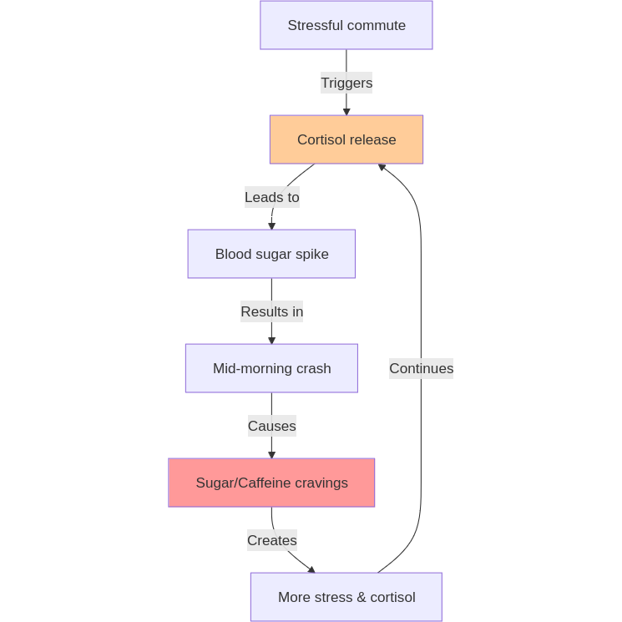
Impact on decision-making and eating habits.
Starting your day stressed can cloud your judgement and lead to poor choices later on. When cortisol is elevated, it can increase cravings for sugary and fatty foods as your body seeks quick energy boosts. This can derail even the best-laid plans for healthy eating.
As Dr. Kelly McGonigal, a well-known health psychologist, points out, stress affects our ability to make thoughtful decisions. It pushes us towards impulsive actions rather than deliberate choices.(27,28) So, if you’re starting your day stressed from your commute, you might find yourself reaching for that doughnut instead of a healthier option.

The ups and downs of modern music and social media.
Listening to modern music with its fast-paced rhythms and catchy beats might seem like a great way to energize your morning. However, these tunes often deliver a quick dopamine hit—a rush of pleasure that feels invigorating at the moment. But once the music stops, there’s frequently a noticeable drop in mood. This roller-coaster effect can leave you feeling more drained than before.
Similarly, scrolling through social media during your commute can create a cycle of highs and lows. The instant gratification from likes and updates provides temporary satisfaction but can quickly lead to feelings of inadequacy or anxiety as you compare yourself to others. This constant engagement with your phone keeps your mind active but not necessarily productive.
Dopamine is the neurotransmitter associated with pleasure and reward. Whether from upbeat music or social media interactions, when you receive these bursts of dopamine, it feels good temporarily. However, as levels drop back to normal, you might experience a dip in mood or energy—a kind of joy deprivation.
This isn’t to say modern music or social media should be off-limits. Instead, consider saving those high-energy tracks and scrolling sessions for after work when you’re looking to unwind or connect socially. There’s a time and place for everything and aligning your choices with your daily rhythm can help maintain emotional balance.

The role of mental preparation.
How you begin your day sets the tone for everything that follows. A stressful commute can sabotage your productivity before you even reach the office. Instead of arriving ready to tackle challenges with clarity and calm, you might find yourself frazzled and unfocused.
Richard Branson often emphasizes the importance of intentional mornings.(29). By taking control of how you start your day, you set a positive tone that influences your mood and productivity. This mental preparation is key to navigating the demands of a busy schedule effectively.

Long-term consequences.
The immediate effects of a stressful commute are clear: increased anxiety and decreased focus. But over time, these habits can contribute to chronic stress, weight gain and even burnout. By understanding why these common approaches don’t work, you’re better equipped to make changes that support both your metabolic health and overall well-being.
As we move forward, let’s explore what you can do differently to transform your commute into a time for personal growth and stress reduction. This shift not only enhances your daily routine but also sets a positive foundation for long-term success.

The mindful journey method.
Transforming your commute into a time of personal growth and stress reduction is not just a dream—it’s entirely achievable with a few mindful changes. Let’s explore how you can turn this daily ritual into a powerful tool for enhancing your well-being and productivity.

Reframe your commute.
First, shift your perspective. Rather than viewing your commute as a tedious chore, see it as an opportunity. This is your time to prepare mentally for the day ahead, free from the demands of work or home. By reframing your commute, you open the door to possibilities for personal enrichment and relaxation.

Embrace mindfulness.
Incorporate mindfulness into your travel routine. Whether you’re driving, cycling, or on public transport, take a moment to focus on your breathing and surroundings. Mindfulness helps reduce stress and brings you into the present moment. Consider batching this with other activities: take a deep breath before turning on the car engine, or focus on your breath as you start listening to a podcast. These small actions can ground you and set a positive tone for the day.
Emma Watson is known for incorporating mindfulness into her busy schedule, using it as a tool to maintain balance and composure amidst her demanding career. Her practice serves as an inspiring example of how mindfulness can transform even the most hectic routines into moments of calm.

Curate your audio experience.
Choose what you listen to with intention. Podcasts and audiobooks offer endless opportunities for learning and inspiration. Select topics that genuinely interest you or that align with your personal and professional goals. If you’re in the mood for something soothing, classical music can provide a peaceful backdrop that encourages reflection.
Remember, it’s about creating an audio environment that supports your mood and energy levels. By curating what you consume, you transform passive listening into an active choice that benefits your mental health.

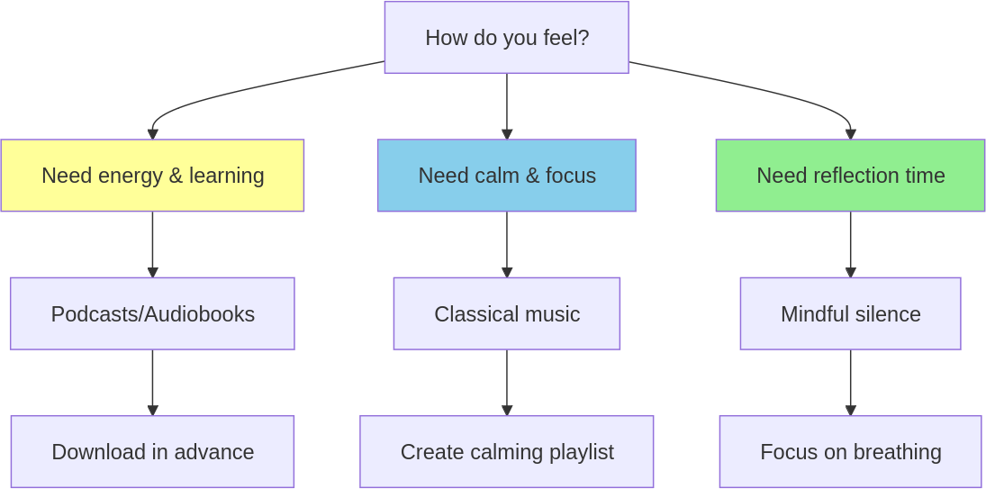
Introduce gentle movement and sunlight exposure.
If your commute involves walking or cycling, embrace it as an opportunity for gentle exercise. Physical activity boosts endorphins, which improve mood and reduce stress. Additionally, being outdoors allows for exposure to natural sunlight, which is crucial for regulating your circadian rhythm. Sunlight helps signal to your body that it’s time to be awake and alert, supporting better sleep patterns at night.
Jack Dorsey, co-founder of Twitter (now X), famously walks to work to incorporate movement into his day.(30). His routine not only provides physical benefits but also offers a chance to enjoy sunlight exposure during his commute.
Even if you’re using public transport, consider getting off a stop early to incorporate some walking into your routine. If that’s not feasible, try sitting by the window to soak up some natural light during the ride. Gentle movement combined with sunlight exposure not only supports physical health but also clears the mind, making you more alert and ready to tackle the day’s challenges.
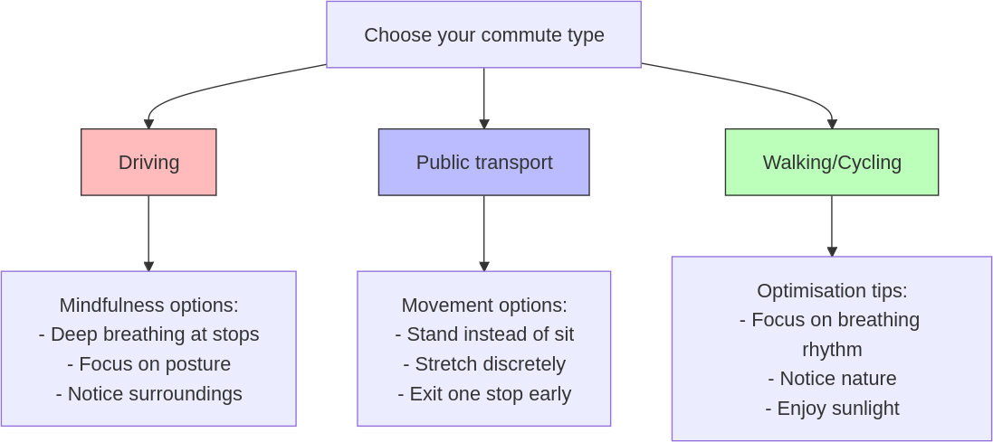
By consciously transforming your commute, you reclaim valuable time in your day. This isn’t just about reducing stress—it’s about enriching your life with moments of learning, reflection and growth. As you embrace these new habits, you’ll find that your commute becomes not just a journey from point A to point B but a meaningful part of your daily routine.
Now that you understand the method, let’s turn these insights into practical steps you can implement tomorrow morning. Transform your commute into a journey of growth.

Action plan: make your commute count.
Transforming your commute into a productive and stress-reducing experience is within reach. Here’s a straightforward plan to help you get started with minimal effort and maximum impact.

1. Assess your current commute.
Start by understanding your current routine. Are you driving, cycling, walking, or using public transport? Identify opportunities for change that align with your lifestyle and preferences.

2. Curate your audio experience.
Create a playlist of podcasts, audiobooks, or music that inspires and relaxes you. Choose content that aligns with your goals or interests. This simple step can turn passive travel time into an enriching experience.
- Quick tip: download content in advance to avoid connectivity issues.

3. Incorporate mindfulness.
Batch mindfulness with existing habits. Take a deep breath before starting the car or focus on your breath as you begin listening to your chosen audio. These small practices can ground you and reduce stress.
- Quick tip: consider putting your phone in aeroplane mode during your commute. This helps minimize distractions and allows you to focus on your breathing or selected audio content.

4. Embrace gentle movement.
If possible, incorporate walking or cycling into your commute. Even a short walk can boost endorphins and expose you to natural sunlight, enhancing mood and regulating your circadian rhythm.
- Quick tip: if using public transport, consider getting off a stop early for a brief walk.

5. optimize your environment.
Make small adjustments to improve your commute environment. If on public transport, sit by the window for natural light. In the car, maintain a clutter-free space to promote calmness.

6. Set small goals.
Start with achievable changes. Implement one new habit at a time to avoid feeling overwhelmed. Gradual adjustments are more sustainable and lead to lasting benefits.

Quick wins.
- Download a podcast tonight: choose one episode to listen to tomorrow.
- Plan for movement: decide if you can walk or cycle part of your commute.
- Set a reminder: place a note in your car or bag to prompt a deep breath before starting.
- Put your phone in aeroplane mode: worried about missing out? Remember, even celebrities take breaks from their phones to stay focused. Being offline for a short time can enhance your commute experience, reduce stress and help you engage more fully with your surroundings.
By following these steps, you can transform your commute into a time of personal growth and relaxation with minimal effort and sacrifice. Each small change contributes to a healthier, more productive day, turning travel time into an opportunity for enrichment and well-being.
However, as with any new routine, there may be challenges along the way. In the next section, we’ll explore common mistakes and provide troubleshooting tips to help you stay on track.

Troubleshooting: rescue your rough commute.
As you transform your commute into a more productive and relaxing experience, it’s natural to encounter a few bumps along the way. Here are some common mistakes and how to troubleshoot them effectively:
- Trying to multitask:
Attempting to juggle too many activities during your commute can lead to increased stress rather than relaxation. While it might seem efficient to catch up on emails or plan your day, this can detract from the benefits of a focused, calming routine. Instead, concentrate on one or two enriching activities, like listening to a podcast or practising mindfulness, to truly benefit from the experience. Remember, quality over quantity is key.
- Neglecting safety:
It’s easy to get caught up in new habits, but safety should always come first. If you’re driving, ensure that any audio content is set up before you start moving to avoid distractions. For those walking or cycling, stay aware of your surroundings and prioritize safety over engagement with audio content. A safe commute is a successful commute.
- Constantly checking phone notifications:
It’s tempting to check your phone for messages or updates during your commute, but this can disrupt your focus and increase stress levels. Instead, try to resist the urge to constantly check your notifications and focus on enjoying your chosen audio content or simply being in the present moment.
- Inconsistency in applying new strategies:
It’s common to start strong with new habits but then fall back into old routines as time goes on. To combat this, set small, achievable goals and gradually incorporate new practices into your commute. Consistency will help solidify these changes into lasting routines. Consider using reminders or habit trackers to keep yourself accountable.
- Overlooking the importance of environment:
A cluttered or uncomfortable commute environment can detract from your experience and increase stress levels. Take time to organize your space—whether it’s your car or your seat on public transport—to create a calming atmosphere. A tidy environment supports a calm mind, making your commute more enjoyable.
- Ignoring personal preferences:
What works for one person might not work for another. Tailor your commute strategies to fit your unique preferences and lifestyle. Experiment with different audio content, routes, or activities until you find what resonates with you. Personalization is key to creating a sustainable and enjoyable routine.

Travelling challenges.
Business travel disrupts your usual commute routine. Instead of your controlled environment, you’re dealing with delays, unfamiliar routes, and unpredictable schedules. But here’s the truth: these moments of transit are opportunities to recharge rather than drain your energy.
Let’s solve your biggest travel challenges:
1. “I waste time during delays and transfers.”.
Turn dead time into power time:
- Choose podcasts that fuel your growth.
- Use audiobooks to stay ahead.
- Plan your day strategically.
- Get natural light exposure when possible.
2. “I feel drained by constant travel changes.”.
Take back control:
- Accept what you can’t change (saves mental energy).
- Focus on what you can influence.
- Use travel time for strategic thinking.
- Turn waiting into planning time.
3. “I lose momentum during business trips.”.
Create structure in chaos:
- Walk to nearby meetings when possible.
- Use transit time for mental resets.
- Choose energy-building content.
- Stay focused on your goals.
Remember: travel time isn’t wasted time unless you let it be. Focus on using these moments to recharge and reset—even when your usual routine is disrupted. The key isn’t perfection; it’s strategic use of your time.
By being mindful of these common pitfalls and applying these troubleshooting tips, you’ll be better equipped to maintain a rewarding commute routine. This proactive approach ensures that your travel time remains a valuable part of your day, contributing positively to your overall well-being and productivity.
Now that we’ve addressed common challenges, let’s reflect on your journey and plan your next steps.

Reflection and action: transform your travel time.
As you continue to transform your commute, take a moment to reflect on your current habits and how they align with your goals. These questions are designed to inspire introspection and motivate meaningful change:
- In what ways does your current commute routine either support or hinder your daily energy and focus?
Consider how your travel time influences your mindset and productivity throughout the day.
- What specific obstacles prevent you from incorporating more movement, like walking or cycling, into your commute?
Reflect on logistical challenges or personal habits that might be holding you back from a more active start to your day.
- How can redefining your commute as a time for personal enrichment enhance both your professional performance and personal well-being?
Visualize the broader impact of a more intentional approach to your travel time on various aspects of your life.

Your next move.
- Choose one inspiring podcast episode or relaxing music album to listen to during your commute this week. Download it in advance to ensure seamless listening and set a daily reminder to start your chosen audio as soon as your commute begins. This simple action helps you experience the positive effects of a curated audio environment with minimal effort, enhancing your mood and readiness for the day.
Track your commute transformation.
Day. | Morning mindset. | Audio choice. | Stress management. | Energy on arrival.
MON. | □ Rushed.  □ Prepared. | □ Podcast.  □ Classical.  □ Silence. | □ Deep breathing.  □ Present focus. | ⚡ □□□□□.
TUE. | □ Rushed.  □ Prepared. | □ Podcast.  □ Classical.  □ Silence. | □ Deep breathing.  □ Present focus. | ⚡ □□□□□.
WED. | □ Rushed.  □ Prepared. | □ Podcast.  □ Classical.  □ Silence. | □ Deep breathing.  □ Present focus. | ⚡ □□□□□.
THU. | □ Rushed.  □ Prepared. | □ Podcast.  □ Classical.  □ Silence. | □ Deep breathing.  □ Present focus. | ⚡ □□□□□.
FRI. | □ Rushed.  □ Prepared. | □ Podcast.  □ Classical.  □ Silence. | □ Deep breathing.  □ Present focus. | ⚡ □□□□□.
Key:
Energy level: 1=Drained, 5=energized
By taking these steps, you’re not just altering how you spend your commute—you’re transforming it into a powerful tool for personal growth and well-being.

Key points.
- Commute with purpose: transform your commute into a productive, stress-reducing period that supports metabolic health and sets a positive tone for the day.
- Common pitfalls: multitasking, neglecting safety, checking phone notifications and inconsistency in applying new strategies can hinder progress.
- Actionable steps: reframe your commute as an opportunity, incorporate mindfulness, curate your audio experience, embrace gentle movement and sunlight exposure and put your phone in aeroplane mode to minimize distractions.
- Reflect and adjust: regularly assess how your commute routine impacts your energy and focus, identify obstacles preventing positive changes and visualize the benefits of redefining your travel time for personal enrichment.

4. FOCUS AND FLOW.

Hydration hacks for peak performance.

Chapter objective.
Optimize hydration throughout your workday to enhance focus, boost metabolism and maintain energy levels—while mastering balanced water intake.

“Water is the driving force of all nature.” — Leonardo da Vinci.

Confessions of a chronic dehydrator.
Fatigue would creep in during the morning hours, just as I was settling into my work routine. I’d find myself reaching for snacks, convinced that hunger was the culprit behind my dwindling energy. My skin felt dry, almost exfoliating itself and my concentration slipped away like sand through fingers. Sound familiar? It’s a struggle many face in the hustle and bustle of a busy workday.

Misreading the signals.
But here’s the twist—I wasn’t hungry; I was thirsty. It took me a while to realize that my body’s signals were getting crossed. Instead of hydrating, I was snacking, mistaking thirst for hunger. This revelation was just the beginning of my hydration journey.
In an attempt to fix things, I swung to the opposite extreme. I started drinking water constantly, thinking more was better. But soon, I found myself in a cycle of endless bathroom trips and still, my skin didn’t glow, nor did my concentration improve. It was frustrating, to say the least.

The turning point.
Motivated to find a solution, I delved into books and research, experimenting with different hydration strategies. The breakthrough came when I learned about balanced hydration. It wasn’t just about guzzling water; it was about drinking mindfully and maintaining electrolyte balance. A squeeze of lemon in my water made all the difference. Suddenly, my skin felt supple and my focus sharpened. It was like flipping a switch.
This journey taught me that hydration is an art—a delicate balance that can transform your workday experience. Imagine starting your day with sustained energy, clear skin that glows with health and a mind as sharp as a tack. These are not just dreams but achievable outcomes with the right approach.

Embracing change.
Armed with this knowledge, I began to see hydration not just as a necessity but as a tool for enhancing productivity and well-being. By incorporating these insights into my daily routine gradually and consistently, I experienced a profound shift in energy levels and concentration.
Others have found similar success by adopting these strategies—proof that small changes can lead to big results. As we explore this chapter, I’ll share the best solutions I’ve discovered for mastering workday hydration. These strategies are designed to fit seamlessly into your busy life, helping you optimize focus and metabolism.
Understanding these principles can empower you to take control of your hydration habits. Let’s explore how most people approach hydration during their workday and why these common habits might be undermining their performance.

Your hidden hydration crisis.
In the fast-paced world of busy professionals, hydration often takes a backseat. Let’s explore some common habits that might be undermining your focus and energy.

Relying on coffee or energy drinks.
For many, coffee and energy drinks are the go-to solutions for a morning jolt or an afternoon pick-me-up. They’re convenient and provide a quick boost. However, relying heavily on caffeine can lead to dehydration over time. The diuretic effect means you might be losing more fluids than you’re taking in.
Although studies show that moderate coffee consumption can hydrate similarly to water, people tend to drink much less coffee than water in a single serving.(31). Water, unlike high-caffeine coffee, provides constant hydration without diuretic effects, making it the best choice for optimal hydration.
Energy drinks, often loaded with sugar and caffeine, can cause energy spikes followed by crashes, further impacting hydration and focus. Imagine starting your day with a burst of energy only to hit a wall by mid-morning—it’s a cycle many know too well.

Forgetting to drink water regularly.
Amidst meetings and deadlines, it’s easy to forget something as simple as drinking water. Many people only remember when they’re already parched, which is often too late to prevent the effects of dehydration on focus and energy.
A report by Modena's Local Health Authority found that 75% of its office workers drink less than the recommended daily amount of 1.5 L of water, which affects their cognitive performance and productivity.(32). Picture this: you’re deep into a project when your concentration starts slipping—could it be dehydration?

Hydrating only when thirsty.
Thirst is a late indicator of dehydration. By the time you feel thirsty, your body is already playing catch-up. This reactive approach can leave you feeling sluggish and unfocused throughout the day. ACSM's Health & Fitness Journal research shows that mild dehydration (i.e. 1-2% body water loss) can impair cognitive performance.(33). This statistic underscores the importance of proactive hydration. Think about how much sharper your mind could be with just a little more attention to hydration.

Snacking instead of drinking.
It’s common to mistake thirst for hunger—reaching for snacks rather than a glass of water. This habit is particularly problematic as most snacks (like crackers, chips, or granola bars) are made with dry grains that actually absorb water from your body and many contain added processed salt that further increases dehydration. This not only affects your hydration levels but also leads to unnecessary calorie intake and potential weight gain. A study published in the journal Physiology & Behavior found that individuals often confuse thirst with hunger, leading to increased snacking and caloric consumption.(34). Imagine cutting out those extra snacks simply by reaching for water first—it’s a small change with big potential benefits.

Choosing sodas over water.
Many people reach for sodas because they find water bland or unappealing. The fizz and flavour of sodas seem more enticing during a busy day. Research from the Centers for Disease Control and Prevention (CDC) shows that nearly 50% of Americans consume sugary drinks daily, often choosing them over water.(35). Sodas are often loaded with high fructose corn syrup, which makes them addictive and leads to excessive sugar intake. This temporary pleasure comes at the cost of long-term health, contributing to metabolic issues and deteriorating overall well-being.
These habits are widespread but often go unnoticed until fatigue sets in or productivity drops. Let’s explore why these common approaches affect your metabolism and focus.

Why your water strategy fails.
Understanding why common hydration habits fall short is key to unlocking your full potential. Let’s dive into the science behind why these approaches might be holding you back.

The role of water in metabolism.
Water is not just a thirst quencher; it’s the lifeblood of your metabolism. Every cell in your body relies on water to function optimally. It acts as a solvent for biochemical reactions, a transport medium for nutrients and a regulator of body temperature. When you’re dehydrated, these metabolic processes slow down, leading to fatigue and decreased cognitive function.
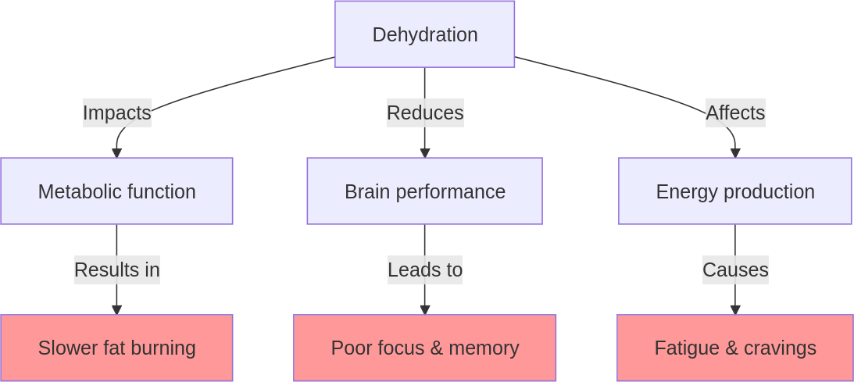
Imagine trying to run a marathon with no fuel—your body struggles to keep up.
Even mild dehydration can impair metabolic efficiency. Without adequate water, your body can’t effectively burn fat or convert food into energy, leaving you feeling sluggish and unfocused.

The dehydration-cognition connection.
Dehydration doesn’t just affect your physical performance—it hits your brain hard too. Water is crucial for maintaining the balance of electrolytes and neurotransmitters essential for brain function. When you’re dehydrated, this balance is disrupted, leading to cognitive decline. As I have already mentioned, several studies have shown that dehydration can reduce cognitive function, attention span and short-term memory.(36).
Neuroscientist Dr. Lisa Mosconi highlights that the brain is one of the first organs to feel the effects of dehydration.(37). She notes that even slight fluid loss can lead to noticeable declines in mood and mental clarity. It’s like trying to tune a radio with static—you miss the signal amidst the noise.

The caffeine conundrum.
Relying on coffee or energy drinks might seem like a quick fix, but caffeine can be a double-edged sword. While it temporarily boosts alertness, it also acts as a diuretic, increasing urine production and exacerbating dehydration. This cycle of caffeine-induced energy spikes followed by crashes can leave you more fatigued than before.
Think of it as putting a plaster on a deeper wound—addressing symptoms without tackling the root cause. Over-reliance on caffeine masks underlying hydration issues, preventing you from achieving optimal energy levels.

The downside of sodas.
Opting for sodas instead of water can wreak havoc on your health and metabolism. The high sugar content leads to insulin spikes, which can cause energy crashes and hinder fat burning. According to the CDC, regular consumption of sugary drinks is linked to an increased risk of obesity, type 2 diabetes and heart disease.(35). Additionally, sodas contribute to dehydration rather than alleviating it. The phosphoric acid in many sodas can also interfere with nutrient absorption, further impacting metabolic efficiency. By choosing water over soda, you support your body’s natural hydration needs and promote better health overall.

Misinterpreting thirst signals.
Many people mistake thirst for hunger, leading to unnecessary snacking and calorie intake. This confusion arises because both hunger and thirst signals originate from the same area of the brain—the hypothalamus. When you misinterpret these signals, you not only risk dehydration but also disrupt your body’s natural hunger cues.
Dr Zachary Knight explains that learning to distinguish between thirst and hunger is key to maintaining metabolic health and avoiding weight gain.(38). By tuning into your body’s signals more accurately, you can make choices that support both hydration and nutrition.
Understanding these concepts underscores the importance of proper hydration as a cornerstone of health and productivity. As we move forward, we’ll explore actionable strategies to help you optimize your hydration routine and unlock your full potential during the workday.

Your metabolic water blueprint.
Optimizing your hydration routine is simpler than you might think. With a few mindful adjustments, you can transform your workday experience. Here’s how:

Implement a structured hydration schedule.
Integrate hydration naturally into your daily routine without relying on digital reminders. Use the formula: weight in kilograms divided by 7 equals the number of glasses of water you should aim to drink each day. This approach accounts for metabolic processes and physical activity. For example, if you weigh 70 kg, aim for about 10 glasses of water daily.
To make this manageable, batch drinking water with regular activities. Have a glass when you wake up, after the morning movement, then when you arrive at the office, another after each bathroom break, one after each meal and one before meetings.
This spreads your intake throughout the day without feeling forced. If you prefer using a water bottle, choose one that holds two glasses of water (about 500 ml) and refill it five times a day. This way, your hydration is always within reach.

Choose water as your primary beverage.
Make water your go-to drink throughout the day. While coffee can be enjoyed in moderation, energy drinks are best avoided due to their high sugar and caffeine content, which can lead to dehydration and energy crashes. Similarly, sodas and alcoholic beverages are not ideal for hydration—they contain sugars and additives that can dehydrate you further. Cristiano Ronaldo famously rejects sodas in favour of water, highlighting the importance of pure hydration for maintaining peak performance.(39). By prioritizing water over these options, you provide your body with the essential fuel it needs to function at its best.

Enhance water with electrolytes and flavour.
Elevate your hydration by adding lemon or cucumber slices to your water. These additions not only make hydration more enjoyable but also contribute to maintaining electrolyte balance with their natural minerals. To further support this balance, incorporate a splash of fresh lemon juice or a small pinch of whole salt into one litre of water. I use local unrefined salt from the Atlantic, but you can also opt for Celtic salt or mountain salts—choose what is more local and convenient for you. Avoid table salt, as it is stripped of essential minerals and consists mostly of sodium chloride, which doesn’t provide the same benefits. This approach ensures optimal hydration and flavour without overloading your system. Just like Rafael Nadal emphasizes electrolyte balance to maintain peak performance on the tennis court, you too can enhance your daily hydration routine for better results.

Recognize and respond to thirst cues.
Learning to distinguish between thirst and hunger is crucial. When you feel hungry between meals, try drinking a glass of water first and then wait until your next meal. Avoid reaching for snacks; often what feels like hunger is just emotional hunger or a habitual response driven by ghrelin—the hunger hormone—rising at that time. By hydrating instead of snacking, you not only stay hydrated but also boost your metabolism and enhance fat burning. This approach helps maintain stable energy levels and supports weight management.

Limit meals to three main ones per day.
Focus on having three balanced meals rather than frequent snacking. This approach aids digestion and reduces the likelihood of mistaking thirst for hunger. The Power Plate Ratio, as discussed in previous chapters, ensures satiety and nutritional balance, supporting hydration through high water content in fruits and vegetables. For even better hydration, reduce refined carbs and increase natural carbs from local, seasonal fruits. This not only enhances hydration but also boosts nutrient intake, aligning with your body’s natural rhythms.
By making these changes, you’ll not only boost your focus and energy but also support your overall well-being. As you integrate these strategies into your daily routine, you’ll notice a significant improvement in how you feel and perform at work. Let’s turn hydration into a powerful ally in mastering your workday.

Action plan: optimize your daily flow.
Creating a sustainable hydration routine doesn’t have to be complicated. By following these straightforward steps, you can integrate effective hydration habits into your busy day with minimal effort and maximum benefit.

1. Calculate your daily water needs.
Start by determining how much water you need each day using the formula: weight in kilograms divided by 7 equals the number of glasses of water. This personalized approach ensures you’re meeting your body’s specific hydration requirements.
- Quick tip: keep a note of your daily target on your phone or desk for easy reference and adjust as needed based on activity levels and climate.

2. Set up a simple hydration system.
Choose a water bottle that holds about two glasses of water (500 ml) and aim to refill it five times throughout the day. This method simplifies tracking your intake and keeps hydration convenient and accessible.
- Quick tip: use a durable, reusable bottle that you enjoy using, making it more likely you’ll stick to your hydration goals. Remember, consistency is key.

3. Integrate hydration into your routine.
Batch your water intake with regular activities to make it effortless. Drink a glass when you arrive at the office, after each bathroom break, with meals and before meetings. This strategy naturally spreads your water consumption throughout the day without feeling forced.
- Quick tip: pair drinking water with checking emails or starting a new task to create a seamless habit loop. Notice how this small change boosts your productivity.

4. Enhance your water for taste and balance.
Add lemon or cucumber slices to your water for flavour and nutrients. Include a splash of lemon juice or a small pinch of whole salt—such as sea salt or mountain salt—to maintain electrolyte balance. This not only makes hydration more enjoyable but also optimizes absorption.
- Quick tip: prepare flavoured water in advance and keep it chilled in the fridge for a refreshing option. Enjoy experimenting with different combinations to keep things exciting.

5. Practice mindful hydration.
When you feel hungry between meals, fight that hunger with a glass of water and relax until your next main meal. Often, what feels like hunger is just emotional hunger or habit-driven cravings. By drinking water instead, you not only quench this false hunger but also boost your metabolism and maintain focus.
- Quick tip: use water as a tool to combat emotional hunger, knowing it supports productivity and metabolic health simultaneously. Feel empowered by this simple yet effective strategy.

6. Plan balanced meals.
Focus on three main meals a day, incorporating the Power Plate Ratio discussed in previous chapters. Prioritize high-water-content foods like fruits and vegetables to enhance hydration naturally.
- Quick tip: plan meals ahead of time to ensure you include plenty of hydrating foods, reducing decision fatigue during busy days. Celebrate the ease of having nourishing meals ready when you need them.

Quick wins.
- Start your day with water: drink a glass of water first thing in the morning to activate your metabolism and hydrate after sleep.
- Keep water visible: place your water bottle in clear sight on your desk as a constant reminder to drink throughout the day.
- Flavour variety: experiment with different fruit or herb infusions weekly to keep things interesting and prevent monotony.
By implementing these steps and quick wins, you’ll reduce the effort needed to maintain proper hydration while reaping significant benefits in focus, energy and overall well-being. With these strategies in place, hydration becomes an effortless part of your daily routine, empowering you to master your workday with ease.
However, even with the best intentions, it’s easy to fall into common pitfalls. Let’s explore some typical mistakes and how to troubleshoot them effectively.

Troubleshooting: fix your water balance.
Even with a solid plan, it’s easy to encounter a few bumps along the road to optimal hydration.
Here are some common mistakes and how to troubleshoot them:
- Mistaking thirst for hunger:
While this has been discussed, it’s a common issue worth revisiting. If you feel hungry between meals, try drinking a glass of water first. This simple action can often curb cravings and help you stay on track by addressing what might actually be thirst rather than hunger. You’ll quickly notice improved focus and fewer unnecessary snacks.
- Relying on sugary or caffeinated drinks:
Using sodas, energy drinks, or excessive coffee for hydration can backfire. These beverages can lead to dehydration and energy crashes due to their high sugar and caffeine content. Stick to water as your primary beverage and save caffeinated drinks for occasional enjoyment to maintain steady energy levels. You’ll feel more balanced throughout the day.
- Obsessing over water intake:
Tracking every millilitre of water can become overwhelming and unsustainable. This obsession can lead to stress and disappointment when goals aren’t met. Focus instead on maintaining a general daily target that fits naturally into your routine, allowing for flexibility based on your day-to-day needs. Enjoy the freedom of a more relaxed approach.
- Using artificial sweeteners or powders:
Adding artificial zero-calorie sweeteners or powders to your water might seem convenient, but they can detract from the natural benefits of hydration. These additives may also lead to cravings for sweet flavours. Opt for natural flavourings like lemon juice, cucumber slices, or mint leaves instead. You’ll enjoy refreshing taste without added chemicals.
- Over hydrating or under-hydrating:
It’s important to find a balance. Drinking too much water can lead to frequent bathroom trips without added benefits, while too little can leave you dehydrated. Use the daily water formula as a guide, but listen to your body’s signals and adjust accordingly. Experience more consistent energy by finding your personal balance.
- Neglecting electrolyte balance:
Simply drinking water isn’t always enough; maintaining electrolyte balance is crucial for effective hydration. If you find yourself feeling fatigued despite drinking plenty of water, consider adding a splash of lemon juice to your routine to enhance absorption and energy levels. Feel revitalized with this simple adjustment.

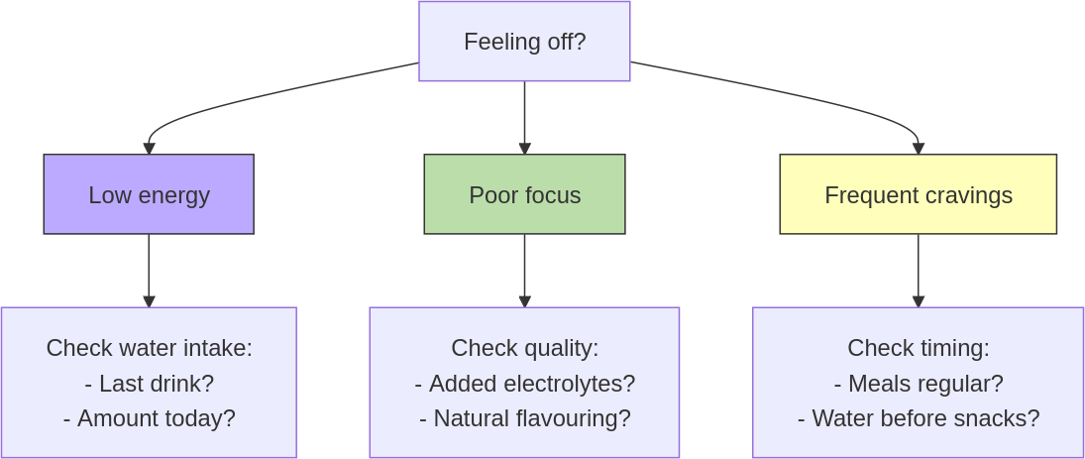
Travelling challenges.
Business travel often disrupts our hydration habits. Between long flights, different time zones and back-to-back meetings, staying properly hydrated can feel impossible. But maintaining your water intake while travelling isn’t just possible—it’s crucial for keeping your energy and focus sharp during important business trips.
Let’s solve your biggest hydration challenges:
1. “Airport security took my water bottle.”.
Stay hydrated through security:
- Empty bottle before security, refill after.
- Buy quality water once through.
- Use hotel gym water stations.
- Carry a slim water bottle.
2. “I’m stuck in meetings all day.”.
Create hydration opportunities:
- Keep water visible on meeting table.
- Use breaks strategically.
- Choose water at coffee breaks.
- Request water jugs in meeting rooms.
3. “Long flights dehydrate me.”.
Plan your flight hydration:
- Drink water before boarding.
- Ask for water whenever offered.
- Avoid alcohol and limit caffeine to morning only.
- Aim for 1 glass (250ml) per hour during flights.
Remember: travel doesn’t have to derail your hydration habits. Focus on maintaining regular water intake—even when your usual routine is disrupted. The key isn’t perfection; it’s staying consistent with your hydration strategy throughout your journey.
By being aware of these common pitfalls and addressing them proactively, you’ll be better equipped to maintain consistent hydration and enjoy the benefits of improved focus and energy throughout your day.
As you continue to refine your hydration habits, take a moment to reflect on your progress and consider some targeted questions and assignments designed to deepen your understanding and commitment to this vital aspect of well-being.

Reflection and action: track your hydration success.
As you work towards mastering your hydration habits, it’s important to pause and reflect on your current practices. These questions are designed to help you gain insight into your relationship with hydration and motivate positive change:
- How often do you find yourself reaching for snacks or caffeinated drinks when you might actually be thirsty?
Consider the triggers that lead you to these choices and how they impact your energy and focus.
- What barriers do you face in maintaining a consistent hydration routine throughout your workday?
Reflect on the obstacles that might be holding you back and think about strategies to overcome them.
- How does your current hydration routine affect your mood and stress levels during the day?
Explore how staying hydrated or dehydrated influences your emotional well-being and ability to handle daily challenges.

Your next move.
- 3-day hydration reset: at the end of each workday, reflect on your hydration habits and make one small adjustment. Day 1: add a morning glass. Day 2: add a glass before lunch. Day 3: add an afternoon glass. This approach encourages immediate feedback and allows for quick, manageable improvements without overwhelming effort. By focusing on these small, daily changes, you’ll experience noticeable benefits in focus and energy by Day 4.
Track your hydration success.
Time. | Water (500ml). | Quality check. | Energy level (1-5).
Day 1: add morning. | □ □. | □ Plain.  □ +Salt.  □ +Lemon. | ⚡ □□□□□.
Day 2: add pre-lunch. | □ □. | □ Plain.  □ +Salt.  □ +Lemon. | ⚡ □□□□□.
Day 3: add afternoon. | □ □. | □ Plain.  □ +Salt.  □ +Lemon. | ⚡ □□□□□.
Key:
Energy level: 1=Low, 5=High
By committing to these reflections and adjustments, you’ll empower yourself to make hydration an integral part of your well-being, leading to a more productive and balanced workday.

Key points.
- The importance of hydration: proper hydration is essential for maintaining focus, energy, and overall well-being throughout your workday.
- Common pitfalls: avoid mistaking thirst for hunger, relying on sugary or caffeinated drinks, obsessing over water intake, using artificial sweeteners and neglecting electrolyte balance.
- Actionable steps: calculate your daily water needs, set up a simple hydration system, integrate hydration into your routine, enhance water with natural flavours and electrolytes, practice mindful hydration and plan balanced meals.
- Reflect and adjust: regularly assess your hydration habits and make small daily adjustments to improve your routine and experience noticeable benefits in productivity and health.

5. LUNCH AND LEISURE.
.
Recharge your body and mind midday.

Chapter objective.
Transform your lunch break into a powerful midday reset that boosts energy, enhances metabolism and improves afternoon productivity—through strategic meal planning and light movement.

“When walking, walk. When eating, eat.” — Zen Proverb.

From heavy lunch to high performance.
I used to think a hearty lunch was the key to powering through my afternoon. My go-to was a big plate of Italian pasta or a serving of rice, smothered in rich sauces, often accompanied by protein, vegetables, and a side of bread. It was delicious, sure, but at 14:00, I’d find myself battling the dreaded afternoon slump. My eyelids felt heavy, my brain fogged over and my energy tanked. Sound familiar? I remember one particular meeting where I struggled to stay awake—my productivity took a nosedive.
This routine left me feeling sluggish and unproductive, struggling to maintain focus during those crucial post-lunch hours. I knew something had to change if I wanted to reclaim my afternoons, and boost my overall well-being.

A catalyst for change.
The motivation for change came from a simple realization: I couldn’t continue feeling this way every day. Inspired by stories of others who had transformed their energy levels through diet and lifestyle changes, I decided to take matters into my own hands. Armed with books and articles on nutrition and metabolism, I embarked on a journey of self-education and experimentation.
I discovered that using lunch as the main, bigger meal of the day wasn’t conducive to my afternoon productivity. Eating mainly starchy refined carbs wasn’t going to help me either. These choices were leaving me drained rather than energized.

Discovering balance.
I began by limiting refined carbs and embracing fresh fruits and vegetables. Salads became my new best friend—vibrant, crunchy and packed with nutrients that didn’t weigh me down. The transformation didn’t stop there. I started incorporating short walks into my lunch break. Just stepping outside for some fresh air and sunlight worked wonders for my digestion and mood.
The results were almost immediate. I felt lighter, more energized and ready to tackle the rest of the day with renewed focus. It was like flipping a switch from sluggish to sharp. And it wasn’t just about what I ate; it was about how I spent that valuable midday time.

The Power Plate epiphany.
Interestingly, it wasn’t until later that I realized I had been using the Power Plate Ratio all along—balancing my meals with a mix of fruits, vegetables, proteins and whole grains. Once I understood this concept’s impact on my energy levels and productivity, it became an intentional part of my routine. This balance was key to sustaining energy without the afternoon crash.
As we explore this chapter further, you’ll see how these insights can transform your own midday routine. Let’s examine what most people do during their lunch breaks—and why these habits might be undermining their productivity.

The lunch break trap.
Many of us have developed lunchtime habits that we think are efficient but might actually be holding us back. Let’s explore some common practices and see how they stack up against what we know about productivity and health.

Eating lunch at the desk.
It’s a familiar scene: you’re hunched over your computer, sandwich in one hand, mouse in the other. It feels like multitasking at its best, but is it really? According to a survey by Just Eat for Business, only 1 in 10 workers actually take a regular lunch break away from their desk.(40). This habit might seem like a time-saver, but it often leads to mindless eating and missed opportunities for a mental reset. When you’re glued to your screen, you’re not giving your brain the break it needs to recharge. Reflect on your own routine—how often do you truly step away? Eating while distracted by screens or phones can also lead to overeating and not truly enjoying your meal.

Choosing quick, often unhealthy food options.
In our fast-paced world, convenience often wins over nutrition. It’s tempting to grab a quick bite from the nearest fast-food joint or vending machine. But these meals are typically high in refined carbs and low in essential nutrients. A study published in the Journal of the Academy of Nutrition and Dietetics found that 67% of workers eat fast food at least once a week.(41). This choice might fill you up temporarily but can leave you feeling sluggish and unfocused as the afternoon arrives. In fact, around 8 out of 10 office workers experience an afternoon energy slump on a regular basis, often exacerbated by poor lunch choices.(42). Consider how these choices impact your energy levels.

Overindulging in sugary drinks.
Accompanying those quick meals with sugary drinks compounds the problem. The term “sugary drinks” encompasses sodas, sweetened teas, fruit juices, energy drinks and even some flavoured waters. These beverages provide empty calories without essential nutrients, leading to weight gain and increased risk of chronic diseases like diabetes and heart disease. Consuming sugary drinks results in rapid spikes in blood sugar followed by falls, leaving you more fatigued than before. This cycle of seeking quick fixes for fatigue only exacerbates energy dips when the sugar high wears off. Research shows that even moderate sugary drink consumption can lead to significant health issues over time, making it crucial to rethink these choices for sustained well-being and productivity.(43).

Eating too much and consuming many refined carbohydrates.
Another common habit is eating large portions or meals rich in starchy refined carbohydrates like white bread or pasta. According to research in the Journal of Personality and Individual Differences, diets high in refined carbohydrates are linked to increased blood sugar levels and subsequent drops, contributing to that familiar afternoon dip in energy and cognitive performance.(44). Overeating can also leave you feeling lethargic and uncomfortable, making it hard to concentrate on tasks at hand. A survey by the American Psychological Association (APA) found that 38% of people admit to overeating at lunch due to stress or comfort.(45). Think about your typical lunch—are you eating more than you need?

Skipping lunch due to busy schedules.
Then there’s the notorious lunch skipper. With back-to-back meetings and endless to-do lists, skipping lunch might seem like an effective way to save time. It is estimated that around 30% of people regularly skip lunch, which can lead to energy drops and reduced cognitive performance, ultimately affecting productivity.(45). Additionally, a study by Public Health Nutrition revealed that 50% of people resort to constantly snacking without eating a proper meal, leading to increased blood sugar fluctuations and emotional disturbances.(46). This pattern not only affects metabolism but also mood, productivity, and overall energy levels throughout the day. Ask yourself if skipping meals or relying on snacks is really serving your long-term goals.
These statistics paint a clear picture: our current lunch habits aren’t doing us any favours when it comes to health or productivity. But understanding these patterns is just the first step. Recognizing where we might be going wrong opens the door to making meaningful changes.
As we move into the next section, let’s explore why these habits don’t work and what we can do differently to transform our midday routine into a powerful reset for both body and mind.

The hidden cost of poor lunch habits.
Understanding why our current lunch habits fall short is key to making meaningful changes. Let’s break down the reasons these common practices might be sabotaging your productivity and well-being.

Stress and digestion.
When you’re stressed, your body shifts into ‘fight or flight’ mode—a state incompatible with proper digestion. Your sympathetic nervous system diverts blood flow away from digestive organs and toward muscles, preparing for perceived threats. This means eating under stress—whether from work pressure or constant digital notifications—significantly impairs nutrient absorption and metabolic function.
Think of your digestive system like a factory production line: it needs optimal conditions to process raw materials (food) into usable energy. Stress essentially shuts down parts of this production line, leading to:
- Reduced enzyme production.
- Decreased nutrient absorption.
- Impaired metabolic efficiency.
- Compromised energy conversion.
The solution lies in activating your parasympathetic ‘rest and digest’ mode during meals, which optimizes your body’s natural digestive processes and energy production.

Sedentary behaviour and metabolism.
When you eat lunch at your desk without stopping to take a proper break, your mind never has the chance to switch from work mode to rest and digest mode. This perpetuates a state of stress and distraction, keeping your body in a fight or flight response, which is incompatible with effective digestion. The constant barrage of emails and tasks prevents your brain from unwinding, leaving you mentally exhausted and less productive as the day wears on.
Not allowing your body to relax during lunch can also lead to poor digestion. When your system is focused on managing stress rather than digesting food, it can result in gastrointestinal discomfort and a slower metabolism. A slower metabolism means your body is less efficient at burning calories, which can hinder weight management and negatively impact energy levels. According to a report by Just Eat for Business, 42% of UK workers eat lunch at their desks every day, which often reduces productivity and increases stress levels.(47). Dr. Marc Brackett of Yale University points out that chronic stress without breaks can lead to long-term health problems such as anxiety and depression.(48).

Blood sugar and energy crashes.
Poor lunch choices, especially those high in refined carbs, lead to spikes in blood sugar followed by crashes. This roller-coaster effect results in the dreaded post-lunch slump where concentration wanes and fatigue sets in. Refined carbohydrates are processed quickly by the body, causing rapid increases in blood glucose levels that trigger insulin release from the pancreas. Once insulin does its job of lowering blood sugar, you’re left with that familiar crash.
Nutrition expert, biochemist Jessie Inchauspé, points out that controlling blood sugar levels is vital for maintaining energy throughout the day.(49). When blood sugar levels plummet after a spike, it leaves you feeling drained and craving another quick fix—often leading to a cycle of poor eating habits that further exacerbate energy dips. Understanding this physiological response helps explain why those seemingly harmless lunch choices can derail your afternoon productivity.

Inconsistent lunch habits and metabolic slowdown.
Regular meal patterns are essential for a healthy metabolism. Skipping meals or having erratic eating schedules sends mixed signals to your body, slowing metabolism over time. Consistent meal timing helps regulate hunger hormones, fostering a healthier relationship with food. Having lunch at the same time daily trains your body to expect food, improving digestion and metabolic response. Establishing a routine also prevents impulsive eating later in the day, leading to better choices overall.
In the long term, inconsistent eating habits can contribute to metabolic disorders such as insulin resistance or type 2 diabetes, a point emphasized by Dr Michael Mosley, who stresses the importance of following regular, planned eating patterns for optimal health.(50,51).
Recognizing these pitfalls is empowering. It provides a roadmap for change, helping you transform your lunch break from a productivity killer into a powerful reset for both body and mind. Now that we’ve explored why these habits don’t work, let’s dive into what you can do differently to make your midday routine truly revitalizing.

The midday reset protocol.
Now that we’ve identified the pitfalls of common lunchtime habits, let’s explore how you can transform your midday routine into a revitalizing experience that boosts energy and productivity.

The Power Plate Ratio: elevate your lunch.
Expanding on the Power Plate Ratio, this approach is your ticket to sustained energy and mental sharpness. By prioritizing natural carbohydrates from fruits and vegetables for at least one-third of your meal, adding protein for satiety and limiting refined carbohydrates to a maximum of one-third (ideally one-quarter), you create a balanced meal that fuels your body effectively.
This is not a low-carb approach—quite the opposite. The Power Plate Ratio emphasizes carbohydrates from fruits and vegetables, which deliver essential nutrients with higher water content and better metabolic impact compared to refined grains.(18). The key difference lies in proportions: maintain at least double the amount of natural carbs, proteins and healthy fats compared to refined carbs. This balanced approach prevents cravings and supports sustainable eating habits, making it superior to restrictive low-carb diets.
When opting for a typical meal deal, apply the Power Plate Ratio by choosing salads over sandwiches when possible. If a sandwich is your main, go for a low-fat option like a chicken salad sandwich, as most fats used in sandwiches aren’t the healthiest. Avoid club sandwiches due to their excessive bread content. For the side, select fruit or vegetables—like carrot sticks with hummus or a side salad—to balance out the refined carbs in the sandwich. The drink should always be natural still water to maintain the Power Plate Ratio; a natural juice without added sugar or coconut water can also work.
For example, consider this meal: a low-fat chicken salad sandwich as your main, carrot sticks with hummus as your side and a bottle of spring water. If you’re still hungry, just add another side so you could have a sandwich with a side salad, a piece of fruit and a natural juice. This combination ensures you’re full and satisfied while adhering to the Power Plate Ratio. If certain items aren’t part of the meal deal, bringing an extra fruit or salad from home is always an option.
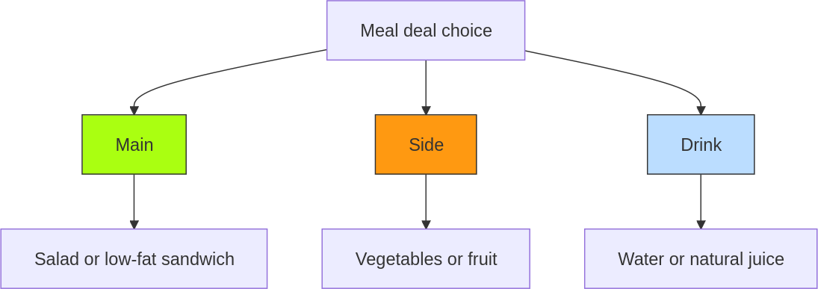
A note on vegetarianism: while this book focuses on establishing fundamental metabolic habits using a flexible approach to protein sources, I know some readers may be curious about plant-based diets. I’ll be sharing my personal journey into vegetarianism—including the why, the how, research, common pitfalls and proven transition strategies—in a future book. For now, focus on maintaining the ratio of natural to refined carbohydrates while choosing protein sources that fit your preferences.

Practical implementation.
The Power Plate Ratio is all about balance. Here’s how you can implement it effectively:
- Natural carbohydrates: fill at least one-third of your plate with seasonal vegetables or fruits like carrots, apples, or leafy greens.
- Protein: include proteins such as chicken, eggs, cheese, or legumes to keep you satisfied.
- Limited refined carbs: choose whole grain options instead of refined ones if available, keeping them to maximum a third—ideally a quarter—of your meal.
- Local alternatives: opt for locally available produce like root vegetables in winter or fresh berries in summer.
Consider these scenarios:
- Packing lunch at home: combine roasted seasonal vegetables with grilled chicken or chickpeas, add a small portion of an unrefined grain—better from ancient crops if possible; if not, no big deal—like 1-2 thin slices of spelt bread or sourdough and include a piece of fruit like an apple. This aligns perfectly with the Power Plate Ratio—the vibrant veggies provide vitamins and minerals, the protein sustains you and the whole grain adds just the right amount of complex carbohydrates.
- Dining out with colleagues: when dining out, prioritize dishes with abundant vegetables. For vegetarian options, choose legume-based dishes like lentil curry or chickpea stew—these provide protein while naturally limiting refined carbs. If selecting meat, opt for lean proteins with extra vegetables on the side. Simple swaps like replacing chips with salad or requesting extra seasonal vegetables help maintain the Power Plate Ratio.
If complimentary bread is served, save it for later in the meal when you can better gauge your refined carbs portion within the Power Plate Ratio. For dessert, start with seasonal fresh fruit—it counts as natural carbs in your Power Plate Ratio, not refined carbs, making it an optimal choice for satisfying your sweet tooth while maintaining metabolic balance. Remember: when dining out, the key is maintaining proportions, not perfection.

Movement: a non-negotiable lunchtime habit.
Movement during lunch is non-negotiable. It allows you to switch from ‘work mode’ to ‘relax and digest’ mode, enhancing mental clarity and reducing stress. Walking away from the office provides a mental reset by engaging your body in rhythmic motion. This can help lower stress levels and shift your nervous system from the sympathetic ‘fight or flight’ state to the parasympathetic ‘rest and digest’ state. This transition is crucial for maintaining focus and productivity throughout the afternoon.
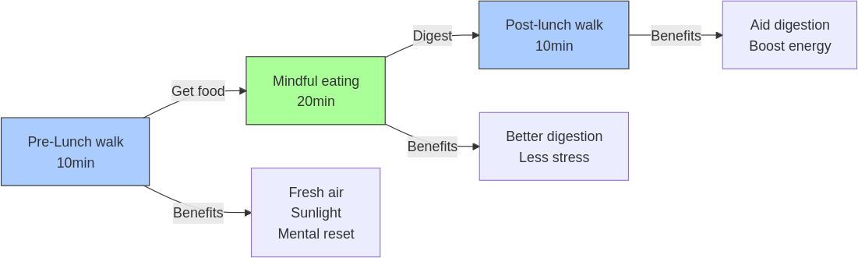
The benefits of being outdoors are immense, particularly when it comes to sunlight exposure. The midday sun is rich in UV-B rays, which are essential for vitamin D synthesis. Unlike the early morning or late afternoon sun, which is richer in UV-A rays, the midday sun provides a more concentrated source of UV-B, allowing you to synthesize vitamin D more efficiently in a shorter amount of time. This exposure supports bone health, immune function and overall mood.
Breathing in fresh air during your walk not only invigorates your senses but also aids in digestion by improving circulation. As you walk back to the office after your meal, this gentle movement helps stimulate digestion and ensures that nutrients are absorbed more effectively. This post-meal walk can also enhance blood flow to your brain, boosting mental clarity and preparing you for a productive afternoon.
John Mackey, CEO of Whole Foods Market, exemplifies this approach by prioritizing healthy eating and taking time for mindful breaks.(52). His commitment to wellness underscores the importance of integrating these practices into your daily routine.
By embracing these strategies, you’ll transform your lunch break from a mere pause into a powerful tool for well-being and productivity. As we move forward into creating an actionable plan with steps and tips tailored just for you, watch how these changes elevate not just your afternoons but your entire workday experience.

Action plan: optimize your lunch strategy.
Transforming your lunch break into a powerful tool for well-being and productivity requires a strategic approach. This action plan provides clear steps and practical tips to help you implement the strategies discussed.

1. Mastering the Power Plate Ratio on the go.
Focus on maintaining balance by selecting meals that prioritize natural carbohydrates from fruits and vegetables. Ensure you include a protein source for satiety while limiting refined carbohydrates. When buying a meal deal or eating out, always include a salad or fruit as a side to maintain the Power Plate Ratio.
- Quick tip: look for options that naturally include fruits or vegetables with every meal deal.

2. prioritizing movement during lunch.
Incorporate movement into your lunch break by walking to a nearby location for your meal. This habit not only provides essential sunlight exposure for vitamin D synthesis but also aids digestion, enhancing both mental clarity and physical health upon returning to work.
- Quick tip: choose a lunch spot within walking distance to seamlessly integrate movement into your routine.

3. Creating a consistent routine.
Establishing a consistent routine involves picking a time for lunch and sticking to it, ideally around 12:30–13:00 every day. If colleagues join you, great; if not, maintain your schedule to regulate hunger hormones effectively.
- Quick tip: invite colleagues to join your lunch schedule for mutual support.

4. Staying motivated and consistent.
Find one accountability partner among your colleagues who share similar goals. Hold each other accountable for maintaining these healthy habits, ensuring you both stay on track even if one falters.
- Quick tip: pair up with someone who can commit to mutual accountability in adopting these habits.

Quick wins.
- Swap sugary drinks: replace sugary beverages with water or natural juices today.
- Take a short walk: incorporate a five-minute walk outside during your next break.
- Choose healthier sides: replace crisps with carrot sticks or fruit in your next meal deal.
- Disconnect and relax: avoid checking your phone and discussing work topics during lunch to enhance mental clarity and promote a restful state.
By following these streamlined steps, you can transform your lunch break into a catalyst for improved well-being and productivity with minimal effort. As you begin implementing these changes, it’s important to be aware of potential pitfalls. In the next section, we’ll explore common mistakes and troubleshooting tips to help you stay on track.

Troubleshooting: master your midday momentum.
As you embark on your journey to transform your lunch break into a powerful tool for well-being and productivity, it’s important to recognize and address common mistakes that can derail your efforts. By understanding these pitfalls and implementing simple solutions, you can stay on track with your healthy habits.
- Skipping meals:
Skipping meals might seem like a time-saver, but it can disrupt your metabolism and lead to overeating later in the day, resulting in energy crashes and decreased productivity. To avoid this, ensure regular meals by setting a consistent meal schedule. Prioritize composing quick, balanced meals that align with the Power Plate Ratio.
- Ignoring portion sizes:
Ignoring portion sizes can lead to unintentional overeating, affecting both your waistline and energy levels. Use smaller plates or visual cues, such as filling half your plate with vegetables, to help control portions without feeling deprived. Finding an accountability partner can help you stay mindful of portion sizes.
- Not planning ahead:
A lack of planning can lead to unhealthy food choices, especially when you’re pressed for time. Instead of batch cooking, focus on quickly assembling a lunch using the Power Plate Ratio. Bring extra fruit or vegetable leftovers from the night before to enhance your meal deal or restaurant choice.
- Overcomplicating healthy eating:
Making healthy eating too complex can lead to frustration and abandonment of good habits. Focus on simple, balanced meals that are easy to prepare and satisfying. Avoid overly restrictive diets that are difficult to maintain long-term. Remember, consistency is key. Setting realistic goals and celebrating small victories can keep you motivated.
- Skipping the walk due to time constraints or weather:
Skipping your walk can hinder mental clarity and digestion. Even if time is tight or the weather isn’t ideal, it’s crucial to leave your office environment for lunch. Whether it’s a short stroll around the block or simply stepping outside for fresh air while eating at a nearby café, changing your surroundings can significantly enhance your mental reset and digestion.

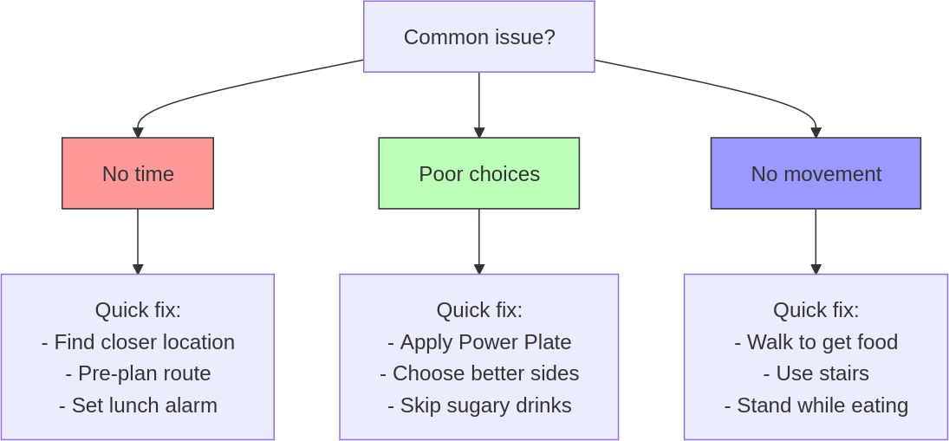
Travelling challenges.
Client lunches, unfamiliar cities, and back-to-back meetings can destroy your midday metabolism boost. That crucial recharge window often gets sacrificed to business demands. But maintaining your Power Plate lunch while travelling isn’t just possible—it’s essential for peak performance during important business trips.
Let’s solve your biggest midday challenges:
1. “I’m stuck in client lunches.”.
Make strategic choices:
- Load up on vegetables first (ideally half your plate) .
- Add quality protein & healthy fats next .
- Keep refined carbs to max 1/3 or less, of the whole meal.
- Guide restaurant choices when possible .
- Keep portions balanced despite the social pressure.
2. “I can’t find healthy options nearby.”.
Create winning strategies:
- Research local markets beforehand .
- Stock up on fresh fruit day one.
- Find the nearest meal deal spot that offers salads.
- Master the Power Plate assembly anywhere.
3. “Back-to-back meetings leave no time.”.
Protect your midday fuel:
- Block 30 minutes in your calendar.
- Find a proper spot to eat.
- Assemble a quick Power Plate meal.
- Focus on one proper sitting, no grazing.
Remember: travel doesn’t have to compromise your midday recharge. Focus on maintaining the Power Plate Ratio—keeping natural carbohydrates, proteins and healthy fats at least double the volume of refined carbs. The key isn’t perfection; it’s making strategic choices that maintain your energy and focus throughout the afternoon.
By addressing these common mistakes with practical solutions, you can enhance your lunchtime routine and sustain healthy habits over the long term. Apply these strategies to ensure success on your journey towards improved well-being and productivity. As you reflect on these insights, consider the following questions and assignments designed to deepen your understanding and commitment to these changes.

Reflection and action: your lunch reset journey.
As you continue on your journey to transform your lunch break into a tool for enhanced well-being and productivity, it’s important to pause and reflect on your current habits and mindset. These reflection questions are designed to prompt introspection and motivate change, helping you identify areas where you may feel stuck and how you can move forward.
- What are the current barriers preventing you from having a balanced and revitalizing lunch break?
Consider the obstacles that consistently arise, whether they’re related with time management, food choices, or environmental factors. Reflect on how these barriers impact your overall well-being and productivity.
- How does your current lunchtime routine align with your health and productivity goals?
Evaluate whether your existing habits support or hinder your aspirations for improved health and efficiency. Identify any discrepancies between your actions and goals.
- Why might you be resistant to making changes in your lunchtime habits?
Explore any underlying reasons for hesitation or resistance to change. Understanding these factors can help you develop strategies to overcome them and embrace new, healthier practices.

Your next move.
- Find a walkable lunch spot and apply the Power Plate Ratio: identify a nearby location you can walk to during your lunch break, seamlessly integrating movement into your routine. Experiment with applying the Power Plate Ratio using meal deals or restaurant options, ensuring balanced nutrition without extra planning.
Track your midday reset.
Day. | Power Plate applied. | Movement break. | Energy level (1-5).
Day 1. | □ Natural carbs.  □ Protein.  □ Limited refined. | □ Pre-lunch walk.  □ Post-lunch walk. | ⚡ □□□□□.
Day 2. | □ Natural carbs.  □ Protein.  □ Limited refined. | □ Pre-lunch walk.  □ Post-lunch walk. | ⚡ □□□□□.
Day 3. | □ Natural carbs.  □ Protein.  □ Limited refined. | □ Pre-lunch walk.  □ Post-lunch walk. | ⚡ □□□□□.
By reflecting on these questions and completing Your next move, you’ll gain valuable insights into your current habits and take meaningful steps towards transforming your lunch break into a powerful tool for well-being and productivity.

Key points.
- Metabolism-boosting lunch break: prioritize a lunch break that enhances well-being and productivity by incorporating balanced nutrition and movement.
- Common pitfalls: avoid skipping meals, ignoring portion sizes and overcomplicating healthy eating. Ensure you leave the office environment for lunch.
- Actionable steps: implement the Power Plate Ratio, integrate walking into your routine, establish a consistent lunch schedule and find an accountability partner.
- Reflect and adjust: consider personal barriers, align habits with goals and explore reasons for resistance to change. Use these insights to refine your approach.

6. REFLECT AND SHARE.

Your journey’s impact.

Chapter objective.
Encourage you to reflect on your progress, share your experiences, and contribute to the book’s community by leaving a review.

“The miracle is this: the more we share, the more we have.” — Leonard Nimoy.

Congratulations.
You’ve reached a pivotal moment in your journey! Just as a well-timed lunch break rejuvenates your body and mind, this chapter is your opportunity to pause, reflect, and celebrate the progress you’ve made so far. Reflection isn’t just about looking back—it’s about gaining insights that fuel your growth moving forward.
Taking time to think about your journey allows you to recognize what’s working, identify challenges, and refine your approach. But there’s even more power in sharing your story. By contributing your thoughts and experiences, you can inspire others who are walking a similar path.

Reflect on your progress.
Let’s take a moment to dive deeper into your experience with this book. Reflection is a powerful tool for understanding where you’ve been and where you want to go. Ask yourself these questions:
- What strategies have made the biggest impact on my daily life?
Pinpointing what works helps you double down on those habits.
- What obstacles did I face while implementing these strategies?
Recognizing barriers equips you with tools to overcome them in the future.
- Who or what has supported me along the way?
Acknowledging supportive people or resources reinforces gratitude and motivation.
- How do I feel about my progress so far?
Emotions tied to successes or setbacks can clarify what drives you and what needs adjustment.
By reflecting on these questions, you’ll gain valuable insights into your journey. Remember, reflection isn’t just about assessing the past—it’s about empowering your next steps with clarity and purpose.

Why reviews matter.
Your review isn’t just a way to share feedback—it’s a chance to pay it forward. Think about when you first discovered this book. Someone else’s review may have inspired you to take action, and now you have the chance to do the same for someone else who’s ready to transform their life.
If you believe the knowledge and strategies in this book have brought you far greater value than the price you paid, leaving a review is the simplest way to show your appreciation. Think of it like this: the insights you’ve gained from this book have the potential to shape your health and mindset for years to come—an investment that’s truly priceless.
By sharing your story, you’re helping others see the value of investing in themselves. Every review encourages someone else to say yes to their health and growth, and it strengthens the incredible community we’re building together.
Beyond that, your feedback matters deeply to me as an author. It helps me improve future editions and create even more resources to guide readers like you. Your voice matters—and your review is one of the most meaningful ways to inspire, connect, and contribute to this journey of transformation.

How to leave a review.
Leaving a review is simple but incredibly impactful. Here’s how you can share your thoughts: .
- Select the platform: Visit the platform where you purchased or downloaded this book (such as Gumroad, Amazon, or Goodreads).
- Find the book: Use the search function to locate the title or check your library or purchase history.
- Share your thoughts:
  - Highlight specific strategies or insights that resonated with you.
  - Reflect on the value you received for the investment—was this $1 well spent?
  - Share personal anecdotes about how this book has impacted your life.
  - Offer constructive feedback if there are areas I could improve—your input helps shape future editions!.
- Submit your review: Once you’re happy with what you’ve written, click submit!.
Take a moment now to express your thoughts—I can’t wait to read your feedback and see how this book has made an impact in your journey!.

The power of sharing.
Imagine someone feeling stuck or doubtful, unsure if they can make a change. Your story—whether it’s a small victory or a major breakthrough—could be exactly what they need to feel inspired and take that first step. Sharing your experiences creates ripples that empower others and reinforce your own accomplishments.
Your review becomes an act of generosity. When you articulate your reflections and share your thoughts, you help others discover the possibility for growth and transformation. Sharing reminds us that we’re not alone in our efforts—it builds connections and strengthens the idea that change is possible.
So take a moment to express your thoughts and experiences. Whether it’s a small insight or a major transformation, your words could make a meaningful difference in someone else’s life—and in your own sense of accomplishment.

Closing note.
Thank you for taking this time to reflect on your progress and share your experience. Your voice matters—not just to me, but to the countless others who are waiting to take their first step. .
Together, we’re building a vibrant community of empowered, healthier individuals. You’ve already achieved so much, and the next chapter of your journey is waiting. Whether it’s leaving a review or simply reflecting on your growth, I’m excited to see the impact you’ll create—let’s keep building momentum together!.

7. ENERGIZE YOUR AFTERNOON.

Beat the slump naturally.

Chapter objective.
Energize your afternoon with strategic movement and posture adjustments, tailored to combat the common afternoon slump, while also providing benefits that work marvellously in the morning.

“Sitting is the new smoking.” — Dr. James Levine.

When sitting became my enemy.
Ever felt like you’re becoming one with your chair? I have. There was a time when I was practically glued to mine, sitting for hours on end. At first, I’d start with perfect posture—back straight, shoulders relaxed. But as the hours ticked by, I’d find myself slouched over, neck craned forward and my spine begging for mercy. It wasn’t long before my back started to protest with persistent pain. My neck joined in too, reminding me that something had to change. This discomfort was a wake-up call, pushing me to seek relief.
With the fatigue from bad posture and hours of sitting, I started seeking external stimulation—I reached for caffeine or quick sugary snacks to keep going. I already knew that caffeine in the afternoon wasn’t good for me and that snacking slowed my metabolism. Yet, I felt trapped in a cycle of temporary fixes, desperately searching for a boost to power through the afternoon. This was surprising because at the time I was experimenting with morning movement and found tremendous benefits, to the point I didn’t need coffee to start my day—just a simple cup of tea. Clearly, something had to give.
Despite the energy fluctuations, my spine and neck were almost screaming for help anyway. So, I decided it was time to find a better solution. That’s when I stumbled upon a simple yet revolutionary idea: taking regular breaks to stand and stretch. It sounds almost too easy, right? But sometimes the simplest changes can have the biggest impact. This small shift set me on a path to reclaiming my well-being and productivity.

The search for solutions.
The motivation to change came from a deep need to alleviate discomfort and regain control over my productivity. I began doing my own research and experimenting with different techniques. What I discovered was eye-opening: the key was scheduling these breaks throughout the day.
I started implementing structured intervals into my routine. I’d work intensely for a set period and then take a few minutes to move around and reset my focus and energy. Every half hour to an hour, I’d stand up and stretch. It was like hitting the reset button on my posture. Each time I sat back down, it was with renewed purpose and proper alignment.

The movement revolution.
The pain began to fade away, replaced by a newfound sense of productivity and clarity. These short breaks weren’t just about physical relief—they were mental refreshers too. During those five-minute intervals, I’d hydrate, visit the toilet, or chat with colleagues for quick project updates. It was amazing how much I could accomplish in those brief moments.
This approach wasn’t about rigidly following a schedule; it was about finding freedom within structure. I learned to balance maximum productivity during focused work sessions with stretching time that boosted my health and clarity. The key was flexibility—knowing when to dive deep into tasks and when to step back and recharge.
While my journey led to positive change, many still face a common challenge: remaining sedentary throughout the afternoon despite knowing its consequences.

The sedentary trap: common habits.
In today’s fast-paced world, many of us find ourselves glued to our desks, especially in the afternoon. It’s a common scenario: energy levels dip and productivity takes a nosedive. But what exactly are we doing wrong?

Sedentary lifestyles.
Sitting for prolonged periods has become the norm, particularly among office workers. A study from Western University’s School of Kinesiology reveals that office workers can spend up to 80% of their workday seated.(53). This sedentary behaviour is deeply ingrained, driven by job demands and workplace culture that prioritizes screen time over movement. Many people lose track of time, engrossed in tasks, unaware of the hours slipping by without a break. The lack of movement not only affects physical health but also contributes to mental fatigue, creating a cycle that’s hard to break. Imagine the missed opportunities for creativity and innovation when our bodies are stuck in one position all day.

Afternoon slump.
The infamous afternoon slump is all too familiar. Research published in PLoS ONE by Texas A&M University highlights a significant decrease in productivity during the afternoon, with an increase in errors and a decrease in concentration.(54). This slump often hits hardest mid-week and on Fridays, when motivation is already low. Employees find themselves staring blankly at screens or mindlessly clicking through emails, hoping for a burst of inspiration that rarely comes. Picture yourself struggling to finish tasks that should be easy, simply because your energy has hit rock bottom.

Reliance on external stimulation.
To combat fading energy, many reach for caffeine or sugary snacks. A survey by Vitabiotics Feroglobin indicates that 37% of people opt for coffee, while 30% choose sugary snacks during these slumps.(55). These quick fixes are convenient and culturally accepted in workplaces, making them an easy choice. The ritual of grabbing a coffee or snack serves as a temporary escape—a momentary boost that masks underlying fatigue without addressing its root causes. Over time, this reliance can lead to dependency, where the afternoon pick-me-up becomes a necessity rather than a choice. Consider how this cycle might be robbing you of sustained energy and focus throughout your day, like it happened with me.

The impact of poor posture.
Poor posture compounds fatigue and discomfort. As we slouch over desks, our bodies cry out for relief—yet many ignore these signals, accepting discomfort as part of the workday norm. This habitual slouching leads to chronic pain and stiffness, affecting overall well-being. Adjustments to chairs or desks are often temporary solutions that fail to address the core issue. The cycle continues as workers adapt to discomfort rather than implementing lasting changes that could improve posture and reduce strain. Think about how much more you could achieve if your body wasn’t constantly battling against poor posture.
While these habits are common, they come with hidden costs that affect both our health and productivity. Let’s examine why these seemingly convenient practices are actually undermining our afternoon energy.

The hidden costs of sitting.
The habits we’ve developed around sitting and working for long hours might seem like a necessary evil in our modern world, but they come with significant downsides. Let’s delve into why these common practices are not just ineffective but potentially harmful.

The impact on circulation and cognitive function.
Prolonged sitting has a profound effect on our body’s circulation. When we remain seated for extended periods, blood flow slows down, particularly to the lower extremities and brain. This reduction in circulation can lead to a cascade of health issues. Dr. James Levine, renowned for his research on sedentary behaviour, famously stated, “Sitting is more dangerous than smoking, kills more people than HIV and is more treacherous than parachuting.”(56). His work underscores that sitting reduces blood flow, contributing to cardiovascular problems and increasing the risk of conditions like deep vein thrombosis.
This decline in blood flow also affects cognitive function. Our brains require a constant supply of oxygen-rich blood to function optimally. When sitting for too long, the decreased cerebral blood flow can impair cognitive abilities over time. This can result in decreased concentration and mental fatigue, making it harder to maintain productivity throughout the day. Imagine trying to solve complex problems or engage in creative thinking while your brain is starved of the resources it needs—it’s like trying to drive a car on an empty tank.

Metabolic consequences.
Sitting for prolonged periods disrupts metabolic processes. A sedentary lifestyle is closely linked to metabolic syndrome—a cluster of conditions that increase the risk of heart disease, stroke, and diabetes. According to a meta-analysis published in PLoS ONE, an increased sedentary lifestyle increases the likelihood of developing metabolic syndrome by 73%.(57). Prolonged inactivity can indeed contribute to insulin resistance, where your body becomes less effective at managing blood sugar levels. This sets the stage for type 2 diabetes and weight gain.
Moreover, when we sit for too long, our bodies burn fewer calories, leading to weight gain and obesity. This is compounded by poor posture, which not only affects musculoskeletal health but also our metabolism by reducing the muscle activity. Consider how this sedentary lifestyle subtly undermines your efforts to maintain a healthy weight or manage existing health conditions—it’s a silent saboteur working against your well-being.

The role of posture and musculoskeletal health.
Poor posture is more than just an aesthetic concern; it has real implications for health and productivity. Dr. Eric K. Holder from Yale Medicine points out that prolonged sitting with bad posture places stress on spinal structures and joints, leading to musculoskeletal issues such as back pain and neck strain.(58). This is often referred to as “gluteal amnesia,” where prolonged sitting deactivates the gluteal muscles, weakening them over time.
Bad posture can also lead to “tech neck,” sometimes known as “nerd neck,” a condition caused by craning the neck forward while working on computers or devices. Many people working with computers end up with their heads shifted forward and their necks at unnatural angles—an all-too-common pattern in today’s digital age. This not only causes discomfort but can lead to chronic pain if not addressed. Picture yourself constantly adjusting your position or stretching your neck just to find relief—these are signs that your body is struggling under the strain of poor posture.
These insights highlight a critical understanding: our bodies generally benefit from movement, not prolonged stillness. While modern work environments demand extended periods of focus at desks, it’s essential to recognize the long-term consequences of these habits.
Now that we understand these challenges, let’s explore practical strategies that can transform your afternoon energy with minimal effort and maximum impact.

Strategic movement: your new approach.
Recognizing the pitfalls of prolonged sitting and poor posture is just the beginning. Now, let’s explore how you can transform your routine to boost health and productivity with minimal effort and immediate benefits.

Embrace movement breaks.
Incorporate regular movement into your day with ease. Set a timer to remind yourself to stand up and stretch every 30 to 60 minutes. These short breaks quickly invigorate your mind and body, improving circulation and focus without disrupting your workflow. Think of them as healthy resets that boost both metabolism and productivity, creating structured time blocks where everything has its place at its time.
As Jim Kwik, an expert in brain performance, wisely says, “As your body moves, your brain grooves.”(59). This highlights how these physical activities can enhance cognitive function alongside physical health.

My personal routine.
My personal break routine involves doing 30 step-ups on a small step I keep nearby—an easy addition to any workstation. This exercise is fantastic for increasing blood flow and invigorating the glutes, which tend to become dormant after prolonged sitting. If you feel embarrassed using a step in front of others, consider doing a few flights of stairs instead. It offers the same benefits of gluteus activation and increased metabolism.
After completing the step-ups or stairs, I incorporate arm rotations backwards to counteract the arching that comes from sitting at a desk. The idea is to counterbalance the shoulders, which often end up in a pronated position.
For those unfamiliar, a pronated position is when your palms face down or backward, often causing the shoulders to roll forward. In contrast, a supinated position is when your palms face up or forward, encouraging the shoulders to open and align properly. By rotating my arms outwards into a supinated position, I promote healthier shoulder alignment.
After arm rotations, I gently crack my back by twisting it on both sides, releasing any built-up tension. I also relieve stress on my neck with the Chin Tuck Exercise, or Neck Retraction, by pulling my head back and tucking my chin in. This effectively stretches and strengthens neck muscles, promoting better posture alignment.
This quick routine only takes about a minute, setting me up for a more productive next session. I still have four minutes left during my break to do whatever feels right—whether it’s drinking water, visiting the toilet, or having a quick chat with someone. Flexibility is key—each break can be tailored to your needs at that moment.
Every two hours (four blocks of 25 minutes work and five minutes break), I take a longer break of 30 minutes. My workflow as a freelancer involves “deep work” during those sessions—intense focus that benefits from substantial rest.
Cal Newport, author of Deep Work, exemplifies this approach by structuring his day into focused time blocks that allow for mental clarity and productivity.
However, if you’re engaged in more shallow work—common for me in the afternoon—you can adjust these intervals for greater flexibility. I usually tend to get up every hour or so to get some movement, as this works better with less intensive tasks. These flexible breaks allow you to personalize your schedule while maintaining consistent movement throughout the afternoon.

Prioritize posture.
Pay attention to your posture with simple adjustments that make a big difference. Ensure your workstation is ergonomically friendly—your screen should be at eye level and your chair should support your lower back. Consider using a standing desk or an ergonomic chair to encourage better alignment without major changes.
To further enhance your posture awareness, take a cue from the Vitruvian Man, the iconic drawing by Leonardo da Vinci. This renowned image exemplifies ideal human proportions and body alignment, demonstrating how we should stand. By modelling yourself after this figure, you can optimize your physical alignment: keep your body straight, with arms slightly out to the sides and palms facing forward, upward and outward.

Tim Cook, CEO of Apple, takes posture seriously by providing standing desks for all employees at Apple headquarters—a simple yet effective way to promote better posture while encouraging movement throughout the day.(60).

Optimize your work environment.
Design your workstation for efficiency so everything you need is within easy reach during work sessions. Consider adding tools like a small step nearby for quick exercises during breaks without needing extra space. Personal touches like plants or artwork can inspire creativity and make your workstation more enjoyable without requiring significant changes or investments.
Using technology wisely can further enhance your work routine. Instead of relying on mobile apps that might distract you, consider using a desktop plug-in with a specific timer set for each task—like 30 minutes to an hour—followed by a five-minute break. This method helps you manage breaks effectively without unnecessary interruptions.
Building social connections during breaks provides mental refreshment and fosters a positive work environment. Organize short walking meetings or invite colleagues for a quick chat away from desks. These interactions not only boost creativity but also strengthen team bonds without requiring extensive planning or effort.
These strategies provide the foundation for change. Now, let’s transform them into a simple, actionable plan you can implement today.

Action plan: your 5-step movement strategy.
Now that you understand the importance of movement and posture, it’s time to put these insights into action. Here’s a streamlined plan to integrate these practices into your daily routine effortlessly.

1. Set up your workstation.
Arrange your workstation for comfort and efficiency. Ensure your screen is at eye level and your chair supports your lower back. Consider a standing desk or ergonomic chair for better posture.
- Quick tip: try different desk layouts to find what enhances your comfort and productivity.

2. Schedule regular breaks.
Use a desktop timer to schedule breaks every 30 to 60 minutes. These short intervals help maintain energy and focus.
- Quick tip: use browser extensions like Selfocus to block distractions during work periods.

3. Incorporate movement.
During breaks, do simple exercises like step-ups or stair climbs to boost circulation. Pair these with arm rotations for posture correction.
- Quick tip: keep a list of quick exercises handy for variety and motivation.

4. Practice posture awareness.
Be mindful of your posture throughout the day. Use the Vitruvian Man as a guide—stand straight with arms slightly out and palms facing forward.
- Quick tip: place a sticker on your monitor as a reminder to check your posture.

5. Foster social connections.
Organize walking meetings with health-minded colleagues. These interactions refresh your mind and enhance creativity.
- Quick tip: encourage regular walking meetings for shared accountability and motivation.

Quick wins.
- Instant inspiration: add a plant or artwork to your workstation today for an immediate mood boost.
- Hydration boost: keep a water bottle at your desk to remind you to stay hydrated throughout the day.
- Screen comfort: lower screen brightness and use dark mode to reduce eye strain and fatigue immediately.
With this action plan in hand, you’re ready to transform your work environment. However, being aware of potential pitfalls will help you maintain these positive changes. Let’s explore common challenges and their solutions.

Troubleshooting: common movement barriers.
Implementing new habits can sometimes lead to unexpected challenges. Here are some common mistakes people encounter when trying to integrate movement and posture improvements into their routine, along with tips on how to troubleshoot them.
- Skipping movement breaks:
Even with a timer set, it’s easy to get absorbed in work and skip breaks. This can lead to prolonged sitting, which diminishes the benefits of your action plan. To counteract this, make it a non-negotiable part of your routine. Consider setting reminders on your agenda or computer that require you to physically move away from your desk. Enlist a colleague or friend to join you for breaks, adding accountability and making it more enjoyable.
- Neglecting posture adjustments:
Forgetting to maintain proper posture can result in discomfort and reduced productivity. It’s crucial to remain vigilant about your posture throughout the day. Use subtle visual cues, like a sticker on your monitor or a small note on your desk, as gentle reminders to check your alignment. Regularly practising posture exercises can also help reinforce good habits.
- Improper workstation setup:
Not adjusting your workstation ergonomically can cause unnecessary strain and discomfort. Ensure that your screen is at eye level and that your chair provides adequate support for your lower back. Periodically reassess your setup, especially if you notice any discomfort or fatigue and make adjustments as needed to maintain comfort.
- Overloading breaks with screen time:
Using breaks to scroll through social media or check emails can negate the benefits of movement breaks. Instead, prioritize physical activity during these times. Step away from screens entirely and engage in simple exercises or stretches that invigorate both body and mind.
- Inconsistent hydration:
Forgetting to hydrate can lead to fatigue and decreased concentration, undermining your productivity efforts. Keep a water bottle visible on your desk as a constant reminder to drink regularly throughout the day. Setting specific hydration goals can also help ensure you stay refreshed and focused.

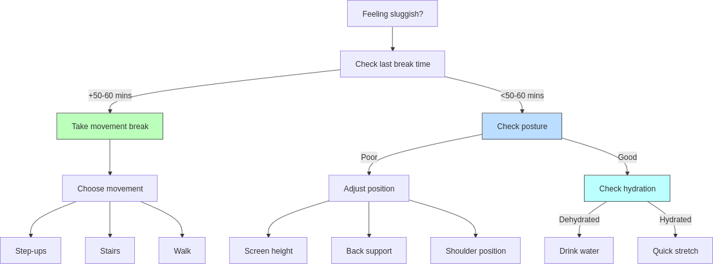
Travelling challenges.
Business travel can wreak havoc on your afternoon energy levels. Between time zone changes, endless meetings and unfamiliar environments, that 15:00 slump hits even harder. Your habits might be disrupted, but your energy doesn’t have to be—let’s take control.
Let’s solve your biggest afternoon challenges:
1. “I’m stuck in long meetings.”.
Create movement opportunities:
- Stand up every hour, no exceptions.
- Batch movement with water breaks.
- Turn some meetings into walking ones.
- Find stairs instead of lifts.
2. “Different time zones mess with my schedule.”.
Take control of your routine:
- Adapt to local meal times quickly.
- Set hourly movement reminders.
- Keep water visible and accessible.
- Find natural light exposure and walk.
- Alternate between sitting and standing.
3. “Hotel rooms affect my posture.”.
Optimize any space: .
- Mix sitting and standing activities, like phone calls.
- Use the room’s layout for movement.
- Maintain proper alignment (shoulders back, neck neutral, spine tall).
- Check your posture every hour.
Remember: travel doesn’t have to destroy your afternoon energy. Focus on maintaining hourly movement and proper posture—even when your usual routine is disrupted. The key isn’t having the perfect setup; it’s creating opportunities for movement wherever you are.
Now that you’re equipped to handle common challenges, let’s pause to reflect on your current habits and identify opportunities for deeper change.

Reflection and action: moving forward.
As you work towards integrating these new habits into your routine, it’s essential to pause and reflect on your current situation. These questions are designed to help you introspect and identify areas that may need change.
- How often do I find myself sitting for extended periods without taking a break?
Reflect on your daily routine and consider the impact prolonged sitting may have on your health and productivity.
- What physical discomforts do I experience during or after work, and how might they be related to my posture or workstation setup?
Think about any recurring aches or pains and how adjustments in posture or ergonomics could alleviate them.
- What barriers prevent me from incorporating regular movement and posture checks into my day?
Identify any obstacles that keep you from maintaining these habits and consider strategies to overcome them.

Your next move.
- Track your afternoon movement for 3 days: set reminders throughout your day to incorporate strategic movement, posture checks, and energizing break activities. Use the table below to document your progress and identify patterns that work best for you.

Time. | Movement type. | Posture check. | Break activity. | Energy level.
10:00. | □ Step-ups.  □ Stairs.  □ Walk. | □ Screen height.  □ Back straight.  □ Shoulders back. | □ Water.  □ Stretch.  □ Chat. | ⚡ □□□□□.
11:00. | □ Step-ups.  □ Stairs.  □ Walk. | □ Screen height.  □ Back straight.  □ Shoulders back. | □ Water.  □ Stretch.  □ Chat. | ⚡ □□□□□.
14:00. | □ Step-ups.  □ Stairs.  □ Walk. | □ Screen height.  □ Back straight.  □ Shoulders back. | □ Water.  □ Stretch.  □ Chat. | ⚡ □□□□□.
15:00. | □ Step-ups.  □ Stairs.  □ Walk. | □ Screen height.  □ Back straight.  □ Shoulders back. | □ Water.  □ Stretch.  □ Chat. | ⚡ □□□□□.
16:00. | □ Step-ups.  □ Stairs.  □ Walk. | □ Screen height.  □ Back straight.  □ Shoulders back. | □ Water.  □ Stretch.  □ Chat. | ⚡ □□□□□.
Key:
Energy level: 1=Sluggish, 5=energized
Track your progress for 3 consecutive days, noting which combinations of movement, posture, and break activities boost your energy most effectively. This data will help you create a personalised afternoon routine that maintains both your productivity and well-being.
Engaging with these reflections and assignments will deepen your understanding of the changes needed to improve your work environment and personal well-being. Embrace this opportunity to transform your productivity and boost your metabolism.

Key points.
- Structured movement and posture breaks: regularly incorporating movement and posture checks into your work schedule enhances both physical health and productivity.
- Common pitfalls: avoid skipping breaks, neglecting posture, improper workstation setup, overloading breaks with screen time and inconsistent hydration to maintain effectiveness.
- Actionable steps: set up an ergonomic workstation, schedule regular breaks, incorporate simple exercises, practice posture awareness and foster social connections through walking meetings.
- Reflect and adjust: use reflection questions to assess your current habits and identify barriers; implement desk stretches as a practical Your next move to adjust your routine for better focus and well-being.

8. UNWIND AND DINE.

Fuel your evening for metabolic mastery.

Chapter objective.
Master your evening routine to supercharge your metabolism, crush cravings and set yourself up for all-day fat burning – without sacrificing your social life or favourite foods.

“The greatest wealth is health.” – Virgil.

Cultural rhythms: a dinner journey.
Picture this: the clock strikes 21:00, and I’m just wrapping up an intense football training session. The air is thick with the scent of freshly cut grass, adrenaline coursing through my veins like a shot of espresso. My muscles are buzzing, yet all I can think about is the warm, inviting kitchen waiting for me at home. Sound familiar? For years, my evenings followed this rhythm — sports late into the night, followed by a hearty dinner that felt like a warm embrace after a long day.
In Italy and Spain, where I grew up, this was the norm. Winter nights meant steaming dishes of risottos or pastas — think creamy “risotto alla zucca” (pumpkin risotto) or comforting “pasta al sugo” (pasta with sauce, usually tomato sauce). My family would gather around the table, laughter echoing, plates clattering. In the summer, we basked in the lingering sun, delaying dinner until as late as 21:30. Meals were often rounded off with sweet, juicy fruits like watermelons and grapes. Who could resist a family meal infused with love under the vibrant sky? But here’s the kicker—these late-night feasts were often high in refined carbs. Delicious? Absolutely. But also a recipe for disrupted sleep and sluggish mornings.

Three countries, three rhythms.
When I moved to Spain, it was like stepping into a parallel universe of even later meals. Lunch at 15:00, dinner at 22:00—it was a cultural shock. In Spain, it’s not unusual to experience the afternoon lull after a big lunch; no wonder they have a siesta as part of their daily routine. With late nights being the norm, many adapt to a polyphasic sleep schedule that accommodates their lifestyle. Yet, for someone used to a bit earlier meals in Italy, it felt like a constant battle against my body’s natural rhythm.
Then came an opportunity to live in the UK for a few months. Inspired by the saying “when in Rome, do as the Romans do,” I decided to fully immerse myself in their culture and meal timings. In the UK, most people stop working around 16:00 because they start at 8:00 and don’t have a long lunch break like in Italy or Spain. This made dinner around 18:00 not just normal but celebrated.

Finding British balance.
Suddenly, I had free evenings to unwind without the weight of a heavy meal sitting in my stomach. It was a revelation. No more rushing from the table to bed; instead, there was time to digest, relax and truly enjoy the evening.
Why did this feel so right? Perhaps it’s the northern latitude’s influence—shorter days mean maximizing daylight hours. Or maybe it’s simply about aligning with our body’s natural clock. Whatever it was, this shift transformed my evenings from rushed to restful.

Blending cultural wisdom.
Returning from the UK, I faced a dilemma: how to blend Spanish lunches with British dinners? The answer lay in structure and flexibility—two concepts central to everything in this book. By adopting British meal timings—a quick lunch at noon followed by an early main meal dinner around 18:00—I found harmony between work efficiency and personal well-being.
This change didn’t just curb late-night cravings; it boosted my energy levels throughout the day. Lunch became lighter and more focused on fuelling productivity rather than inducing an afternoon slump. Dinner turned into a time of nourishment and connection—a chance to unwind with loved ones without the pressure of time ticking away.
Imagine finishing your meal and knowing you have hours to enjoy before bed—reading, catching up with family, or simply relaxing without that post-dinner lethargy. It’s not just about what you eat but when you eat that can redefine your evenings and health.
Many individuals fall into familiar patterns after work that can lead to a decline in energy and overall well-being as the day progresses. recognizing these common habits is essential, as it serves as the foundation for making positive changes to your evening routine. Let’s now explore what most people typically do after work and uncover opportunities for improvement.

Evening routines: the status quo.
After a long day at work, it’s tempting to collapse on the couch and let the evening drift away. For many, this post-work ritual involves grabbing a quick, often unhealthy meal and settling in for the night. But what if this routine is sabotaging your health and energy levels?

The couch trap.
Imagine this: you walk through the door, kick off your shoes and sink into the couch. The TV flickers on and before you know it, hours have passed. This scenario is all too common. According to a report by Nielsen, adults in the U.S. spend an average of over 4 hours per day in front of screens outside of work hours.(61). This sedentary behaviour contributes significantly to weight gain and poor health outcomes. During these hours, many indulge in snacks high in refined sugars and fats—chips, cookies, or sugary drinks—adding extra calories without nutritional value. A study from the University of Minnesota found that 50% of adults snack while watching TV, often choosing unhealthy options.(62).

Late sport activities.
For others, evenings are filled with late sport activities or hobbies that push dinner further into the night. Whether it’s a late-night gym session or an evening sports league, these activities can lead to dining as late as 20:00, 21:00 or 22:00. A study published in the International Journal of Environmental Research and Public Health highlights that eating dinner late and close to bedtime, also due to late-night physical activities, is linked to altered sleep patterns and metabolic processes.(63). On the other hand, pre-workout snacks often consist of solutions full of refined carbohydrates, such as bars or sugary drinks, which can increase insulin levels without providing sustained energy.

Dinner dynamics.
Dinner itself can be a significant contributor to metabolic issues. Timing plays a crucial role; a study by the Barcelona Institute for Global Health found that eating dinner after 21:00 is common in Spain and is associated with a 28% increase in the risk of cerebrovascular diseases compared to those who eat earlier.(64). In Mediterranean countries like Spain and Italy, dinners are often rich in fresh ingredients but are consumed late at night, which can still impact circadian rhythms and lead to poor sleep quality.
The type of food consumed is equally important. In many Western countries, dinners often include refined carbs and unhealthy fats—think fast food or processed meals—which can spike blood sugar levels and lead to increased fat storage. According to a Tufts University study, 42% of the calories consumed by Americans come from what I call ‘refined carbohydrates’, including refined grains, processed foods, added sugars and potatoes, along with processed meats.(65). This trend raises serious concerns about diet quality.
Quantity is another factor; large portions are common as people often compensate for skipped meals earlier in the day. This overeating can result in feelings of guilt and sluggishness as the body struggles to process excess calories. A survey by the International Food Information Council found that nearly 40% of people admit to overeating at dinner due to stress or convenience.(66).

Breaking evening habits.
Recognizing these patterns is crucial for making positive changes. By understanding what most people do after work, you can identify areas where small adjustments could lead to significant improvements in your health and energy levels.
Imagine transforming your evenings from a time of mindless habits into an opportunity for rejuvenation and connection. By shifting away from these common pitfalls, you can create an evening routine that supports your metabolic health and enhances your overall well-being.
As we move forward, let’s explore why these habits don’t work and how you can make effective changes without sacrificing your social life or favourite foods.

Late dining hidden costs.
Understanding the common pitfalls of post-work routines is just the beginning. To truly transform your evenings, it’s essential to grasp why these habits don’t support optimal health and energy levels. Let’s dive into the theoretical concepts and expert insights that shed light on these issues.

The disruption of circadian rhythms.
Eating late at night, especially after 21:00, can significantly disrupt your circadian rhythms. Our bodies are designed to follow a natural cycle of wakefulness and rest, influenced by light and darkness. When we eat late, we interfere with this cycle, which can lead to poor sleep quality and metabolic inefficiencies. According to the National Institute of General Medical Sciences, our circadian rhythms regulate many physiological processes, including digestion and metabolism. When meals are consumed late, it signals to the body that it’s time to stay awake and digest rather than rest and recover. This misalignment can lead to poorer sleep quality as the body struggles to manage digestion while trying to enter sleep mode.
The impact goes beyond just sleep. Dr Satchin Panda, a leading expert in circadian biology from the Salk Institute, emphasizes that eating during your body’s natural resting phase can lead to metabolic imbalances that promote weight gain.(67). He explains that our metabolism is more efficient earlier in the day when our bodies are primed for activity. Eating late in the evening forces your body to store more fat because it’s not prepared to burn energy as effectively during its natural resting phase.

Metabolic slowdown and weight gain.
Late-night eating doesn’t just disrupt your internal clock—it directly impacts your metabolism. Consuming large portions of refined carbohydrates at night leads to significant insulin spikes, which inhibit lipolysis—the process of breaking down fat—and promote fat storage instead. Research published in the North American Association for the Study of Obesity (NAASO) found that people who eat after 20:00 are more likely to gain weight compared to those who eat earlier in the day.(68).
Additionally, these meals often fail to trigger effective satiety signals, leading to overeating due to hormonal imbalances involving ghrelin and leptin—hunger and satiety hormones respectively. This imbalance makes you feel hungrier than you actually are.

The role of stress and emotional eating.
Stress from the day often manifests as emotional eating in the evening. This habit not only adds unnecessary calories but also affects your emotional well-being. After a long day filled with deadlines or challenging interactions at work, many people turn to food for comfort—a behaviour known as stress-eating.
When you’re stressed, your body releases cortisol, a hormone that increases appetite and cravings for processed foods—especially those rich in sugars and fats. Over time, this can lead to a cycle of stress-eating that’s hard to break. Dr Susan Albers, a clinical psychologist specializing in eating behaviours, emphasizes that understanding emotional triggers behind eating is key to breaking this cycle.(69).
It’s important to recognize how stress affects not only what you eat but also how much you eat. Emotional eating often leads to consuming larger portions or snacking mindlessly while watching TV or unwinding after work. These habits disrupt the Power Plate Ratio by increasing insulin levels and inhibiting fat breakdown, leading to metabolic slowdown over time.

The impact on sleep quality.
Poor sleep quality is another consequence of late-night eating and stress-induced snacking. Eating heavy meals close to bedtime can cause discomfort and indigestion, making it difficult to fall asleep or stay asleep throughout the night. Additionally, consuming foods high in sugar or caffeine late in the day can further disrupt sleep patterns by stimulating the nervous system when it should be winding down.
Moreover, engaging in vigorous exercise close to bedtime can also be counterproductive. While exercise is beneficial for health overall, doing it too late increases adrenaline levels and stimulates alertness—making it harder for your body to transition into rest mode.

Hormonal responses during sleep.
According to research published in the BMJ Open Diabetes Research & Care, eating meals with a high glycaemic index—meals rich in refined carbohydrates—before bedtime can cause higher postprandial hyperglycaemia—high blood sugar levels after eating—than at breakfast.(70). This spike in blood sugar often leads to immediate sleepiness, which is why people frequently fall asleep on the sofa after a big meal while watching TV. However, this drowsiness doesn’t translate into restful sleep; both sleep quality and digestion are compromised as the body struggles with processing food while attempting rest.
When the body releases excess insulin in response to high blood sugar levels, it can cause a drop in blood sugar during the night. In turn, this may lead to the secretion of glucagon and cortisol—the stress hormone—which raise blood sugar levels back up as a countermeasure against low glucose levels. As we discussed in Chapter 1, cortisol plays a crucial role in waking us up by increasing alertness and energy levels. However, at night, this hormonal response can disturb sleep, causing awakenings throughout the night as the body tries to stabilize its blood sugar levels.
This is why I put so much emphasis on having an early dinner—to avoid mixing digestion with sleep—allowing your body ample time for proper digestion before winding down for the night.
Dr Frank Scheer from Harvard Medical School explains that aligning meal times with natural daylight hours supports better digestion and energy utilization throughout the day while promoting restful sleep at night.(71). He suggests avoiding heavy meals at least two hours before bed to allow your body enough time for digestion before entering its rest phase.
By understanding these concepts—including how meal timing affects hormonal balance—you gain insight into how seemingly small habits can have a profound impact on your health. Recognizing why these habits don’t work empowers you to make informed decisions about your evening routine.
As we continue, let’s explore practical strategies for transforming your evenings into a time of nourishment and rejuvenation without sacrificing enjoyment or social connections.

Evening energy optimization.
Transforming your evenings into a time of nourishment and rejuvenation doesn’t mean sacrificing enjoyment or social connections. By making small, intentional changes, you can enhance your metabolic health and overall well-being.

Create a transition ritual.
One of the most effective ways to unwind after a busy day is to establish a simple transition ritual that helps you disconnect from work and shift into relaxation mode. The most beneficial and immediate action you can take is to pause and take a deep breath. This small yet powerful act has multiple benefits: it oxygenates your body, brings your attention back to the present moment and helps lower stress levels. By doing so, you signal to your mind and body that the workday is over, easing the transition into a more relaxed state.
Taking a deep breath also helps you disconnect mentally from the pressures of work, allowing you to reset before engaging in any evening activities. Whether you’re shutting down your computer, leaving the office, or entering your car, this conscious pause can make all the difference in how smoothly you shift from work mode to personal time.
The key is consistency—find a moment in your routine that naturally marks the end of your workday and pair it with this simple breathing ritual. Over time, this habit will help condition your body and mind to relax more easily as part of your evening routine.

Prioritize light physical activity and social connections.
Rather than collapsing on the sofa after work, incorporate light physical activity into your routine. A brisk walk or a gentle yoga session can boost your mood and energy levels. According to the British Journal of Sports Medicine, even short bursts of exercise can improve metabolic function and reduce stress.(72).
Take inspiration from Sir Richard Branson, who regularly combines his love for sports with social connections. Whether it’s playing tennis with friends or kitesurfing, Branson finds ways to stay active while maintaining relationships. His approach shows how you can seamlessly integrate physical activity into your social life, making it both enjoyable and beneficial for your health.
Social activities that promote movement—like group fitness classes or walks with friends—can relieve stress and enhance emotional well-being. Socializing in active settings helps you unwind without resorting to unhealthy habits. This dual approach not only supports physical health but also nurtures emotional connections, creating a balanced lifestyle.

Embrace the Power Plate Ratio: a world of variety.
The Power Plate Ratio is the heart of your dinner strategy, transforming this meal into an opportunity for creativity and nourishment. Remember this ratio prioritizes natural carbohydrates from fruits and vegetables (at least 1/3 or more of your plate), moderate protein (around 1/3) for satiety and limits refined carbohydrates (no more than 1/3, ideally 1/4).
The beauty of the Power Plate Ratio lies in its simplicity and flexibility. It provides structure by guiding portion sizes while allowing for endless variety through experimentation with different foods and cooking methods. You can easily personalize this system based on your individual preferences or dietary needs, making it adaptable to any lifestyle.
Here’s how you can think about each group:
- Natural carbohydrates:
Explore the rich variety each season offers. Have you ever tried baking or steaming fruits and vegetables? These methods concentrate their natural sugars and minerals, creating delicious dishes without added salt, sugar, or oils. Whether it’s roasted root vegetables in winter or a fresh fruit salad in summer, let your creativity shine. Experiment with raw options too—crisp salads or fresh fruit platters can be refreshing and nutrient-packed.
- Proteins:
For proteins, consider options beyond just meat and fish. Boiled eggs offer simplicity; cheeses, especially matured varieties, add depth; nuts provide crunch; and legumes like lentils, chickpeas and quinoa—a pseudo-cereal—are versatile additions. Each protein source brings its own unique flavour and texture, encouraging you to explore different combinations that suit your taste preferences.
- Refined carbohydrates:
Even refined carbs can be exciting. Whole wheat bread brings a nutty flavour, while spelt bread offers a unique twist. Whole rice or pasta can serve as comforting bases. And yes, even a small piece of cake or biscuit can fit if it aligns with the 1/3 portion guideline. The key is moderation—enjoy these foods as part of a balanced meal that prioritizes natural ingredients.
This approach encourages you to try new things—mix different fruits and vegetables, experiment with cooking methods like steaming or baking and discover new flavours. By focusing on fresh foods rather than pre-prepared meals, you’re not only nourishing your body but also optimizing digestion, energy levels and metabolic efficiency.

Navigate special occasions mindfully.
Navigating special occasions can be challenging, especially when surrounded by tempting foods that may not align with your usual habits. However, understanding how your body responds to refined carbohydrates can empower you to enjoy these events without derailing your health goals. Dr Rachael Heller and Dr Richard Heller provide insights into how our bodies predict and react to carbohydrate intake based on past meals.(73). They discovered that our bodies prepare for incoming carbs by releasing insulin based on previous meals.(74). If you indulge in refined carbs more than an hour after a carb-heavy meal, your body may release a second wave of insulin—potentially leading to increased fat storage.
To manage this effectively during special occasions:
- Avoid consuming excess refined carbohydrates if your previous meal was also high in carbs.
- If you decide to indulge in refined carbs at an event like a party, ensure that you finish your meal within an hour—this helps prevent prolonged insulin spikes.
Stepping outside the Power Plate Ratio for one meal is not “cheating”—it’s about enjoying more refined carbohydrates than usual for social benefit. In fact, including extra refined carbohydrates, especially from starchy sources like potatoes, can offer benefits for your thyroid function by providing a temporary boost in energy metabolism. The key is moderation: limit these indulgent meals to no more than three dinners a week (3 out of 21) and focus on healthier starches like potatoes rather than fried or highly processed foods. Potatoes are one of the least harmful starches for metabolism and can be enjoyed in a bit larger quantities during these meals.
As long as these indulgences are spaced out and not consecutive meals, stepping outside the Power Plate Ratio occasionally can actually support metabolic flexibility and thyroid health without derailing your progress.
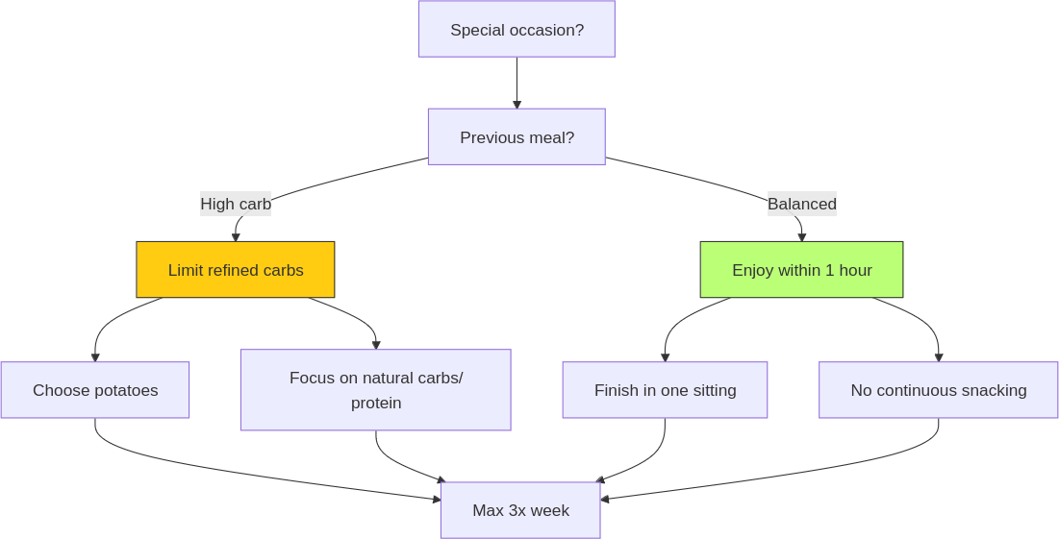
These approaches help prevent prolonged insulin spikes while allowing you to enjoy occasional treats without guilt.
It’s also beneficial to align special events with one of your three main meals of the day—ideally dinner—to avoid adding an extra meal outside your usual routine that could disrupt metabolism. By planning special occasions as part of your regular meal schedule, you maintain metabolic balance and avoid unnecessary insulin fluctuations.
While planning special occasions mindfully, it’s important to note that I don’t recommend alcohol consumption, even during special events. Alcohol slows down your metabolism because your body prioritizes detoxifying it over processing other nutrients. It also provides empty calories with no essential benefits and acts as a toxin, potentially leading to health issues when consumed in excess. If you decide to indulge, it’s your responsibility to consider its effects on your health and metabolism.
At social gatherings like birthday parties, focus on enjoying your meal in a single sitting rather than grazing throughout the event. This way, you can savour the experience without worrying about disrupting your metabolic balance.

Establish an earlier dinner time.
One of the most effective changes you can make is establishing an earlier dinner time. Aim to eat at least two hours before bed—this allows ample time for digestion before sleep. By doing so, you prevent the overlap between digestion and rest, which can disrupt both processes.
Take a cue from Arianna Huffington, who has long advocated for early dinners as part of her overall wellness routine.(75). Huffington enjoys simple meals like grilled fish and vegetables early in the evening to ensure proper digestion before winding down for bed. Her emphasis on sleep as a cornerstone of health reinforces the importance of aligning meal times with your body’s natural rhythms.
Eating earlier not only supports better digestion but also helps regulate blood sugar levels before sleep. It’s especially important if your dinner includes any refined carbohydrates since consuming them too close to bedtime can spike insulin levels and interfere with fat-burning processes during sleep.
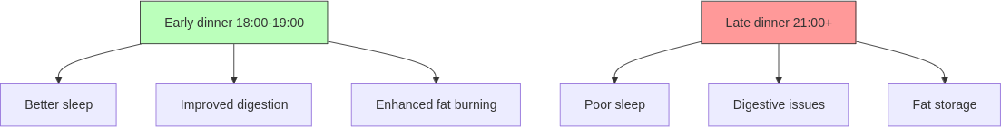
By implementing these strategies—light activity inspired by Richard Branson’s active lifestyle; fresh food assembly using the Power Plate Ratio with vegetarian options; mindful social eating at special events following Dr Heller’s advice on carb timing; and an earlier dinner inspired by Arianna Huffington—you create an evening routine that supports both metabolic health and overall well-being without sacrificing enjoyment or flexibility.
As we move forward into the next section, we’ll break down these strategies into actionable steps so you can easily incorporate them into your daily life.

Action plan: evening transformation.
Now that we’ve explored strategies for transforming your evenings into a time of nourishment and rejuvenation, let’s break them down into actionable steps. This plan is designed to be simple, flexible and easy to implement, so you can start seeing results quickly without feeling overwhelmed.

1. Choose your preferred habit to pair with a deep breath.
To effectively shut down “work mode,” identify a habit you already do at the end of your workday. Whether it’s closing your laptop, stepping outside for fresh air, or entering your car, pair this habit with a deep breath. This will help you transition smoothly into relaxation mode by oxygenating your body and lowering stress levels.
- Quick tip: focus on being fully present during this moment—it’s not about rushing but about consciously shifting from work mode to personal time.

2. Pick one light physical activity you enjoy.
Select a light physical activity that you genuinely enjoy doing before dinner. This could be as simple as a brisk walk, gentle yoga, or stretching exercises. The goal is to move your body without feeling like it’s an obligation—just 10–15 minutes can help boost your mood and energy levels.
- Quick tip: keep your activity simple—choose something enjoyable that doesn’t require special equipment or preparation.

3. Settle into an earlier dinner time.
Aim to have dinner between 18:00 and 19:00, giving yourself at least two hours before bed for digestion. This early dinner time helps support better sleep quality and allows your body ample time to process food before rest. After completing your light physical activity session, use this opportunity to nourish your body with dinner—this is an ideal time to boost metabolism as your body is primed to absorb nutrients efficiently post-exercise.
- Quick tip: take advantage of the post-exercise window—your body is ready to refuel, making it the perfect time to enjoy a balanced meal that supports both recovery and metabolic health.

4. Assemble your dinner plate with seasonal ingredients.
When preparing dinner, follow the Power Plate Ratio by choosing seasonal ingredients that are easy to prepare. Fill one-third of your plate with natural carbohydrates (fruits and vegetables), one-third with protein (like eggs or legumes) and limit refined carbohydrates to no more than one-third. Keep it simple by using only a few ingredients that can be assembled in under 20 minutes.
- Quick tip: embrace seasonal variety—let nature guide your choices by picking what’s fresh and available at the moment.

5. Plan for occasional indulgences mindfully.
When attending social events or special occasions, remember that stepping outside the Power Plate Ratio for one meal is perfectly fine. Limit these indulgent meals with extra refined carbs (like potatoes) to no more than three dinners a week. These meals can actually benefit your thyroid function by boosting energy metabolism. Focus on enjoying each bite mindfully and avoid consecutive indulgences.
- Quick tip: prioritize potatoes or other starchy vegetables over fried foods for a healthier indulgence.

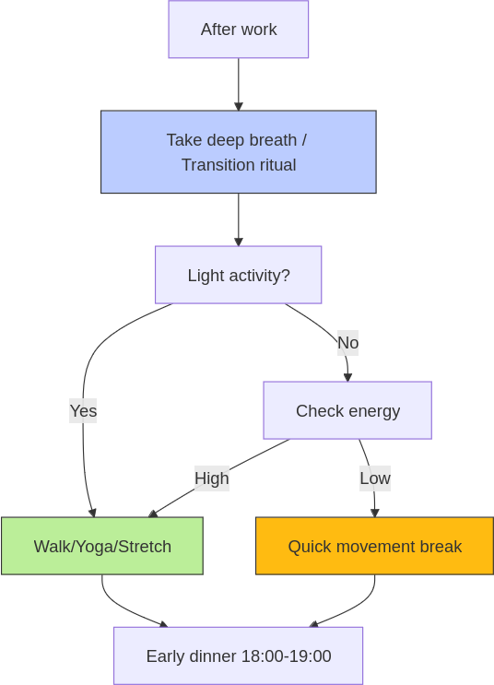
Quick wins.
Here are three Quick wins designed specifically to help you take immediate action while staying aligned with simplicity, mindfulness and flexibility:
- Use your commute as a transition: whether you’re driving home or walking back from work, use this time as a mental shift from work mode to relaxation mode. As suggested in Chapter 3, switch on some of your favourite upbeat music during the trip back home—it’s an easy way to lift your mood and prepare yourself for an evening of nourishment.
- Choose one activity you enjoy: instead of forcing yourself into structured exercise routines, pick one light physical activity that genuinely makes you feel good—whether it’s stretching while listening to music or taking a leisurely stroll around your neighbourhood. This will make it easier to stay consistent without feeling like it’s an obligation.
- Make dinner about presence: tonight, focus on being present during dinner—whether you’re sticking to the Power Plate Ratio or indulging at a social event. Slow down, chew each bite thoroughly and savour every flavour. This mindful approach will help you enjoy food more while also supporting digestion.
By integrating these Quick wins into your routine today, you’ll start experiencing positive changes almost immediately—whether it’s better digestion tonight or improved sleep quality tomorrow morning.
However, as with any lifestyle shift, there can be challenges along the way. In the next section, we’ll explore some common mistakes and troubleshooting tips to help you stay on track and overcome any obstacles that might arise. Let’s make sure you’re fully equipped to navigate any bumps in the road with ease and confidence.

Troubleshooting: routine challenges.
Even with the best intentions, it’s easy to fall into certain traps that can derail your evening routine. The good news is that these mistakes are common and with a few simple adjustments, you can get back on track quickly.
- Overcomplicating your evening routine.
Trying to do too much in the evening can lead to overwhelm and inconsistency. Simplify by focusing on one or two key habits, like taking a deep breath or doing light physical activity. Quality over quantity is key—start small and build consistency. This way, you’ll avoid burnout and ensure your routine is sustainable.
- Still eating too late.
Pushing dinner too late disrupts digestion and sleep quality. Aim for an early dinner between 18:00 and 19:00 to give your body ample time for digestion before bed. Use your post-activity period as a natural transition into preparing dinner while your body is primed for nourishment. This will help you maintain better energy levels and improve sleep. When dinner cannot be eaten earlier, have a lighter one.
- Skipping physical activity.
Fatigue after work can make it tempting to skip movement, but even light activity can boost energy levels. Choose something enjoyable, like a brisk walk or gentle yoga, that doesn’t feel like a chore. Pair it with something you enjoy—like listening to music—to make it easier. By making it part of your transition from work mode, you’ll be more likely to stick with it.
- Overindulging at social events.
Social gatherings often come with tempting foods that don’t align with your usual habits. Allow yourself up to three indulgent meals per week with extra refined carbs (like potatoes), but avoid consecutive indulgences. Focus on mindful eating during these occasions—savour each bite slowly to avoid overeating while still enjoying the social experience.
- Not being present during meals.
Distractions like TV or phones can take away from mindful eating, leading to faster consumption and less satisfaction. Slow down, chew thoroughly and savour each bite without distractions for better digestion and enjoyment. Creating a calm dining environment will help you stay present during meals and support healthier eating habits.

Travelling challenges.
Let’s get real: business travel destroys evening routines. Between client dinners, hotel food and late meetings, it’s easy to wreck your metabolism. But here’s the truth: your results don’t care about your travel schedule.
Let’s solve your biggest evening challenges:
1. “I have mandatory business dinners.”.
Strategic power moves:
- Load your plate with vegetables first.
- Add lean protein second.
- Keep refined carbs to 1/3 of the plate.
- Finish eating within 60 minutes.
- Save alcohol for special occasions (max 3x/week with food).
2. “Work never seems to end.”.
Create non-negotiable boundaries:
- Set a hard stop to work mode.
- Change environment (clothes or even just rooms).
- Get outside for 10 minutes if possible.
- Create physical distance from work (close laptop, DND on emails).
- Protect your recovery time.
3. “Hotel food is killing my results.”.
Take control:
- Find fresh food options nearby (local fruit as your fail-safe).
- Choose roasted over fried every time.
- Request simple modifications.
- Keep portions in check.
- Finish dinner by 20:00 when possible.
Remember: you get three “disrupted meals” per week. Use them wisely—never back-to-back, always finish before 20:00 if possible. When having potatoes, choose roasted or steamed (fried food destroys metabolism). Your body doesn’t care about your business dinner—it only knows if you’re fuelling it right or wrong.
Mistakes are part of any journey towards building better habits—what matters is how quickly you adjust when things go off track. By recognizing these common pitfalls early on and applying simple solutions, you’ll be able to maintain consistency in your evening routine without feeling overwhelmed or discouraged.
Now that you’ve identified potential challenges and how to overcome them, it’s time to reflect on your own experiences and put these insights into practice.

Reflection and action: evening progress.
Now that you’ve explored how to transform your evenings into a time of nourishment and rejuvenation, it’s important to pause and reflect on where you currently stand. Taking a moment to assess your habits and mindset will help you identify areas for improvement and motivate meaningful change. Use these questions to guide your reflection:
- What are the biggest obstacles preventing you from creating a consistent evening routine?
Reflect on what might be holding you back—whether it’s time constraints, lack of energy, or distractions. Understanding these barriers is the first step towards overcoming them.
- How do you feel after your current evening routine?
Think about how your body and mind feel after your typical evening activities. Are you relaxed, energized, or drained? This reflection will help you recognize whether your routine is serving you or if adjustments are needed for better balance.
- Why do you think certain habits (like eating late or skipping physical activity) have become part of your routine?
Consider why these habits have taken root. Is it convenience, stress, or simply a lack of awareness? Identifying the reasons behind these patterns can motivate you to make small but effective changes.

Your next move.
Reflection is valuable, but action is where real change happens. To start building momentum towards a healthier evening routine, here’s a simple yet powerful assignment:
- 10-minute movement + family dinner prep using the Power Plate Ratio.
Engage in a 10-minute movement session today, such as stretching or a brisk walk. Then, involve your family in preparing a simple dinner using the Power Plate Ratio—keep it minimal with just three ingredients. This combination of light movement and mindful eating will help boost energy levels and reinforce healthy habits. By involving your family, you create shared experiences that make these habits more enjoyable and sustainable.
Evening activity. | Mon. | Tue. | Wed. | Thu. | Fri.
Deep breath. | □. | □. | □. | □. | □.
Light movement. | □. | □. | □. | □. | □.
Dinner time. | □ 18-19.  □ 19-20.  □ 20+. | □ 18-19.  □ 19-20.  □ 20+. | □ 18-19.  □ 19-20.  □ 20+. | □ 18-19.  □ 19-20.  □ 20+. | □ 18-19.  □ 19-20.  □ 20+.
Power Plate Ratio. | □ 1/3+ Veg.  □ 1/3 Protein.  □ 1/3- Refined. | □ 1/3+ Veg.  □ 1/3 Protein.  □ 1/3- Refined. | □ 1/3+ Veg.  □ 1/3 Protein.  □ 1/3- Refined. | □ 1/3+ Veg.  □ 1/3 Protein.  □ 1/3- Refined. | □ 1/3+ Veg.  □ 1/3 Protein.  □ 1/3- Refined.
Taking action today will help solidify the changes you’re working towards. Remember, consistency is built one small step at a time—start now.

Key points.
- Disconnect, move and nourish: the key to a successful evening routine is disconnecting from work, engaging in light, enjoyable movement and preparing a healthy early dinner using the Power Plate Ratio. This combination helps you transition smoothly into relaxation mode while supporting both physical and mental well-being.
- Common pitfalls: overcomplicating your routine; eating too late; skipping physical activity due to fatigue; overindulging at social events; being distracted during meals.
- Actionable steps: choose a simple habit to signal the end of your workday (like taking a deep breath); engage in 10–15 minutes of light movement that you enjoy; aim for an early dinner between 18:00 and 19:00 using seasonal ingredients and the Power Plate Ratio; involve your family in meal preparation to make it more enjoyable and sustainable.
- Reflect and adjust: take time to reflect on your current evening routine—what’s working and what isn’t? Identify areas where you can simplify or improve and make small adjustments as needed to stay consistent. Remember, progress is built one step at a time.

9. RECHARGE AND PREPARE.

Maximize your night for tomorrow’s success.

Chapter objective.
Learn how to optimize your post-dinner hours to enhance learning, relaxation and preparation for the next day, while improving sleep quality and overall well-being.

“The secret of change is to focus all your energy not on fighting the old, but on building the new.” – Socrates.

From digital chaos to sleep mastery.
I used to think my evenings were my time to unwind. But instead of truly relaxing, I was glued to my phone. I’d scroll aimlessly through social media, hopping from one app to another, or binge-watch YouTube videos late into the night. Sometimes, I’d drift off with the phone still in my hand, the screen glowing until it eventually timed out. Other nights, I’d tell myself, just one more video. But that one video would turn into five more and before I knew it, it was well past midnight.
The next morning? A disaster. I’d wake up feeling as though I hadn’t slept at all—groggy, heavy and desperate to hit snooze. My body would cry out for more sleep, but life doesn’t wait. I had work to do, responsibilities to handle. Instead of starting the day feeling refreshed and ready to go, I was already running on empty.

The downward spiral.
It wasn’t just the mornings that suffered. My entire day felt like a blur. My energy levels were low, my focus scattered and I couldn’t seem to shake off that constant feeling of exhaustion. I’d grab coffee after coffee just to stay awake, but it never really worked. By midday, I was already counting down the hours until I could get back home and relax.
And then there was reading—something I used to love but had completely abandoned. At some point in my life, books just stopped being a priority. The idea of sitting down with a good book felt like something other people did—people who had time and energy. But me? I was “too busy” scrolling through social media or watching TV series.
To make matters worse, meditation and journaling seemed like a joke to me back then—some sort of mystical nonsense that had no place in my life. Why sit still when there were a million things demanding my attention? Why write down my thoughts when I could distract myself with endless entertainment?

The moment everything changed.
But then something happened that changed everything. Ironically enough, it started with—you guessed it—late-night YouTube videos. One night while scrolling through random content (when I should have been sleeping), I stumbled across a video about sleep optimization. It caught my attention because deep down, I knew something had to change.
I watched video after video about how poor sleep impacts everything—from energy levels to productivity, even fitness goals. And that’s when it hit me: if I wanted to improve my well-being—and build muscle as part of my fitness journey—I needed better sleep.
That realization was like a switch flipping in my brain. Sleep wasn’t just about feeling rested any more; it was about recovery and growth too. If I wanted to see real progress in the gym and in life, sleep had to become a priority.

Researching sleep optimization.
So naturally, I dove into research mode. Articles, podcasts, studies—you name it—I consumed everything about sleep optimization. Circadian rhythms? Check. Melatonin production? Check. Blue light exposure? Double check.
I learned how our bodies are wired for specific sleep cycles and how ignoring those cycles can throw everything off balance—from mood and energy levels to cognitive performance and metabolism.
But here’s the kicker: even though I was learning all this great information about sleep…I was still watching these videos late at night. Talk about irony! It became clear that if I wanted real change, knowledge wasn’t enough—I had to take action.

Making sleep non-negotiable.
That’s when I decided to make sleep non-negotiable.
I started experimenting with different routines until I found one that worked for me—the 10-3-2-1 technique:
- 10 hours before bed: no caffeine.
- 3 hours before bed: no food.
- 2 hours before bed: no work.
- 1 hour before bed: no screens.
This structure gave me control over my evenings in a way I hadn’t experienced before. By cutting out distractions and setting clear boundaries around what could interfere with my sleep, everything started falling into place.
The key? Scheduling sleep first.
Once sleep became the foundation of my routine—something that came first before anything else—I noticed immediate improvements in how I felt during the day. Even after just a few nights of better rest, mornings weren’t chaotic any more; they were structured and productive because they started from a place of rest.

The results.
Over time, this routine became second nature. Instead of waking up groggy and desperate for more sleep, I started waking up naturally—often just minutes before my alarm went off at 6 o’clock. And instead of dragging myself through the day on caffeine fumes, I had energy…real energy.
I’d head straight into a home-gym workout feeling strong and ready to tackle whatever came next (remember from Chapter 1 how important morning movement is for boosting your metabolism?). My focus improved too—I wasn’t constantly battling brain fog or fatigue any more because my body had finally got the rest it needed.
But here’s what really surprised me: once I mastered sleep as part of my daily routine… everything else followed naturally.
All those habits you’ve read about in this book? They came after optimizing my sleep because once you’ve got rest dialled in—everything else becomes easier.
And yet…most people don’t prioritize their evenings this way. They don’t schedule their sleep first or set boundaries around their downtime—and as a result? Their nights are chaotic; their mornings are stressful; their days feel like an uphill battle from start to finish.
So what do most people do instead? Let’s have a look at some common evening habits that sabotage not only your night but also your next day’s success.

Modern sleep saboteurs.
Most people have good intentions when it comes to their evenings. After a long day of work, it’s natural to want to relax and unwind. But instead of using this time to recharge and prepare for the next day, many of us fall into habits that leave us feeling drained and unprepared for tomorrow. Let’s explore some of the most common evening routines that might sound familiar.

Checking work emails late into the night.
For many professionals, the workday doesn’t really end when they leave the office. The temptation to check emails after hours is hard to resist—after all, who doesn’t want to stay on top of things? You might think responding to that last-minute email or reviewing tomorrow’s agenda will give you a head start. But here’s what’s really happening: 70% of employees admit to checking their work emails outside of normal working hours, according to a survey by Fluent.(76).
Even more concerning, research from Adobe found that 62% of millennials check their work emails while lying in bed.(77). It’s become so ingrained in our lives that we often don’t even realize how much it’s creeping into our evenings. You might be sitting in bed, phone in hand, thinking you’re being productive—but are you really relaxing? Or are you keeping your brain in “work mode” long after you should be winding down?

Engaging in passive entertainment.
After a long day at work, it’s easy to turn to your phone or tablet as a way to unwind. Scrolling through Instagram, watching YouTube videos, or catching up on the latest Netflix series feels like a harmless way to relax. But here’s where things get tricky: according to Comparitech, the average person spends about 6 hours and 40 minutes a day looking at screens—whether it’s browsing social media, watching videos, or reading articles online.(78). A significant portion of this screen time happens after dinner, right before bed.
Think about it—how often does “just one episode” turn into two…or three? Before you know it, it’s well past your intended bedtime. Many adults watch TV or use digital devices right before bed, typically losing track of time completely. The problem is that this screen time doesn’t just eat into your evening—it also affects how well you sleep.
What’s more surprising? A report from Statista revealed that 60% of people admit they quite often stay up later than planned because they get caught up in passive entertainment.(79). We’ve all been there—telling ourselves we’ll just watch one more video or check one more post—but these habits can stretch late into the night without us even realizing it.

Neglecting preparation for tomorrow.
How many times have you woken up in a rush because you didn’t prepare for the day ahead? Maybe you couldn’t find your keys, hadn’t packed your lunch, or didn’t even know what was on your schedule for the morning. If this sounds familiar, you’re not alone—56% of people say they don’t prepare for their day the night before, according to a 2022 survey by Euromonitor.(80).
It seems like such a small thing—skipping those few minutes of preparation before bed—but it adds up quickly. Instead of starting your morning with focus and intention, you’re already behind schedule before you’ve even started your day.
Think about how much smoother your mornings could be if everything was ready to go—clothes laid out, lunch packed and tasks prioritized—all done the night before.

Skipping personal development activities.
Evenings are also an ideal time for personal growth—whether it’s reading a book, listening to a podcast, or practising mindfulness techniques like meditation or journaling. Yet most people let this valuable time slip away in favour of more passive activities.
It is estimated that only 24% of adults engage in personal development activities during their leisure time.(81). The rest? They’re more likely spending their evenings watching TV or browsing social media. This missed opportunity for growth not only affects mental well-being but also limits long-term career success.
For example, research by the National Endowment for the Arts found that individuals who read regularly are 2.5 times more likely to engage in further education and self-improvement activities compared to those who don’t.(82).
It’s easy to see how these habits can become ingrained over time—passive entertainment feels relaxing while consuming it, but what are we giving up by not investing in ourselves during those precious evening hours?
Most people don’t realize how these seemingly small habits add up over time. They feel like ways to relax or stay on top of things—but are they really helping? Or are they quietly sabotaging your next day’s success?
Let’s have a closer look at why these habits don’t work—and what you can do differently.

The biology of better sleep.
Most people don’t realize how these seemingly small habits add up over time. They feel like ways to relax or stay on top of things—but are they really helping? Or are they quietly sabotaging your next day’s success?
Let’s break it down.

Disrupting your sleep cycle.
When you spend your evenings glued to the screens—whether it’s your phone, tablet, or TV—you’re not just cutting into your relaxation time; you’re disrupting your body’s natural sleep cycle. Our bodies are wired for specific rhythms—circadian rhythms—that help regulate when we feel awake and when we feel sleepy. These rhythms are closely tied to light exposure, which is why spending time in front of screens late at night can throw everything off balance.
The blue light emitted by phones, tablets, laptops, and TVs interferes with the production of melatonin—the hormone that signals to your brain that it’s time to wind down. According to Dr. Charles Czeisler, a professor at Harvard Medical School and one of the world’s leading sleep experts, exposure to blue light before bed can delay melatonin release by up to three hours.(83). This means that even if you’re physically tired, your brain is still wired for wakefulness.
Your body is left confused—unsure whether it’s time to rest or stay awake—which means your sleep becomes shallow and fragmented. You might spend eight hours in bed but wake up feeling like you barely slept at all. How often have you woken up groggy, feeling like you’re already behind before the day has even started?

Keeping your brain in “work mode”.
Then there’s the issue of checking work emails late into the night. You might think responding to a few messages before bed will help you stay ahead of tomorrow’s tasks, but what it’s really doing is keeping your brain in “work mode” when it should be winding down for rest.
When you engage in work-related tasks right before bed, your brain remains active—processing information, solving problems and staying alert for more notifications. This heightened state of alertness makes it much harder for your mind to transition into a relaxed state conducive to sleep. Instead of letting work thoughts intrude into your rest time, take 5 minutes to mentally review your day in reverse—from this moment back to morning—this helps your brain process and sort through the day’s events naturally. This simple practice signals to your mind that it’s time to wind down, making the transition to sleep smoother.
Again, Arianna Huffington, author of The Sleep Revolution, has spoken extensively about how late-night work habits can lead to burnout and decreased productivity.(84). She notes that constantly being connected to work “creates a false sense of urgency,” making it difficult for people to switch off mentally and physically. Over time? This constant mental strain can chip away at your energy reserves until burnout becomes inevitable.

Passive entertainment isn’t real rest.
Now let’s talk about passive entertainment—whether it’s binge-watching TV shows or scrolling through social media. It feels like relaxation, but it doesn’t provide the mental rest we actually need after a long day. Instead of allowing our minds to unwind, these activities overstimulate our brains with constant input—whether it’s plot twists in a series or endless updates on social media feeds.
The result? Cognitive overload.
When your brain is bombarded with information late into the night, it struggles to process everything efficiently. This makes it harder for you to “switch off” when it’s time for bed because your mind is still racing with all the content you’ve consumed.
There’s a reason why Dr. Matthew Walker, neuroscientist and author of Why We Sleep, stresses that true relaxation comes from activities that allow our brains to slow down—not speed up.(85). He explains that engaging in stimulating activities (like watching TV or scrolling through social media) right before bed can increase stress levels and make it harder for us to achieve restful sleep.

Chaotic mornings lead to chaotic days.
Finally, let’s consider what happens when you neglect preparation for tomorrow. Waking up without a plan—rushing around trying to find your keys or pack your lunch—sets a chaotic tone for the rest of the day. Instead of starting with focus and intention, you’re already playing catch-up before you’ve even left the house.
When you start your day feeling rushed and disorganized, it affects everything—from how productive you are at work to how well you manage stress throughout the day. Studies show that people who begin their mornings with structured routines are more likely to experience higher levels of productivity and lower levels of stress compared to those who start their days in chaos.(86).
It may seem like a small thing—skipping those few minutes of preparation before bed—but over time? These small habits compound into bigger issues that alter both your personal well-being and professional performance.
So while these evening habits might feel like they’re helping in the short term—whether it’s staying on top of work or relaxing with some entertainment—they’re actually working against you in ways you might not even realize. But here’s the good news: by making a few simple changes, you can transform your evenings into a time for true rest and preparation—and set yourself up for success tomorrow.
Let’s explore what you can do differently.

Rewire your night routine.
Now that we’ve unpacked why those common evening habits don’t work, let’s explore how you can transform your nights into a powerful tool for success. It’s about making intentional choices that align with your goals and well-being. Here’s how you can start making those changes.

Embrace the power of sleep cycles.
Understanding and leveraging the natural rhythm of sleep cycles is key to waking up refreshed. Each cycle lasts about 90 minutes, moving through stages from light sleep to deep sleep and REM. Waking up at the end of a cycle, rather than in the middle, can significantly reduce grogginess. Aim for at least four cycles (six hours) per night, but ideally, aim for five cycles (7.5 hours). For those who can afford more rest, six cycles (nine hours) can be optimal.
To calculate your ideal bedtime, work backward from your desired wake-up time in 90-minute increments. For example, if you want to wake up at 6:30, aim to be asleep by 23:00.
This method ensures you’re aligning with your body’s natural rhythms for optimal rest.
Consider Jeff Bezos, who famously prioritizes getting eight hours of sleep each night.(87). He believes that being well-rested improves his decision-making abilities and overall productivity. By following a disciplined sleep routine like Bezos, you too can enhance your performance and start each day with clarity and energy.

Prepare for tomorrow today.
One of the simplest yet most effective ways to reduce morning chaos is by preparing the night before. Spend a few minutes each evening organizing what you’ll need for the next day—whether it’s laying out clothes, packing lunch using leftovers with the Power Plate Ratio, or reviewing your schedule. This small investment of time pays off big in terms of reduced stress and increased productivity.
Think of your kitchen as a starting point for the day ahead. Set it up for a quick breakfast assembly by arranging items like oats, fruits, or smoothie ingredients according to the Power Plate Ratio so they’re ready to go. This makes it easier to fuel your body with nutritious options without the morning rush.
Also, place your keys and any important documents by the door. This simple act ensures you leave the house effortlessly, without worrying about forgetting something crucial. By removing these small stressors from your morning routine, you create a smoother transition into your day.
Use this time to also prepare a space for gentle morning movement, ensuring you can start the day with energy and focus. Whether it’s rolling out a yoga mat or setting up a corner for stretching exercises, having a designated area ready helps make morning activity an easy habit.

Invest in personal growth.
Evenings are prime time for personal development—an opportunity often overlooked in favour of more passive activities. Dedicate some time each night to activities that nurture your growth, such as reading, journaling, or learning something new.
Take inspiration from Warren Buffett, who famously spends hours each day reading to expand his knowledge and understanding of the world.(88). Buffett attributes much of his success to this habit of continuous learning. By investing in yourself during these quiet hours, you’re not only enhancing your skills but also boosting your mental well-being. It’s about building habits that support long-term success and fulfilment.
Consider using audio formats like podcasts or audiobooks to multitask—listen while preparing for tomorrow or winding down. Aim for at least an hour or one book chapter each evening.

Balance entertainment with mindfulness.
While it’s ideal not to overindulge in passive entertainment at night—especially if it involves screens—it doesn’t mean you have to cut it out entirely. After preparing for tomorrow and investing in personal growth, there’s still room for relaxation and enjoyment.
Feel free to watch an episode of your favourite show as a way to unwind after a productive evening. However, consider saving longer commitments like movies for weekends when you have more time to indulge without compromising your sleep routine. Watching movies on week nights can lead to falling asleep mid-film, disrupting your circadian rhythm.
Instead of screen-heavy activities every night, balance them with calming alternatives like reading an entertaining physical book or practising meditation. A powerful way to quieten the inner voice is taking 5 minutes before sleep to mentally review your day in reverse—from this moment back to morning. This simple practice helps process the day’s events and clear your mind. These mindful options prepare your brain for restful sleep.
Ultimately, it’s about choice—knowing what works best for you and creating an evening routine that feels both rewarding and restful.

Set boundaries with technology.
Technology is a double-edged sword—it can connect us but also keep us tethered to work and distractions long after we should have logged off. Set clear boundaries with your devices by designating tech-free zones or times in your home. For instance, make your bedroom a sanctuary for rest by keeping phones and laptops out.
If you find it difficult to disconnect, consider using apps that limit screen time or remind you when it’s time to unplug. And while blue light glasses are a great tool for reducing exposure, aim to put away screens at least 30 minutes before bed. This not only improves your sleep but also frees up time for bedtime rituals like putting on pyjamas, brushing teeth, regulating room temperature, getting into bed and switching off lights.
By making these intentional changes, you’re not just improving your evenings—you’re setting yourself up for success every day. Remember, transformation doesn’t happen overnight; it’s the result of consistent effort and mindful choices. Embrace these strategies as part of your journey towards a more balanced and productive life.
Now that we’ve laid the groundwork for change, let’s dive into an action plan that will help you implement these strategies effectively.

Action plan: sleep revolution.
Transforming your evenings into a time of preparation and relaxation requires a clear plan. Here’s how you can implement these strategies effectively, setting yourself up for success each day.

1. Calculate your ideal bedtime.
Determine your wake-up time as your starting point. Count back 4-6 sleep cycles (90 minutes each) and add 30 minutes for winding down. This ensures you align with your body’s natural rhythms, helping you wake up refreshed.
- Quick tip: for most people, use the 8 hours before your wake-up time reference, it will give you 5 cycles (7.5 hours) + 30 minutes for your bedtime routine—simple and effective.

2. Execute tomorrow’s head start.
Prioritize tasks for the next day by reviewing your schedule and setting clear priorities. Prepare essentials like clothes and meals in advance. Lay out your outfit, pack lunch with the Power Plate Ratio and organize any documents you’ll need. Set up your kitchen for a quick breakfast assembly.
- Quick tip: use a checklist to ensure nothing is forgotten in the morning rush.

3. Craft Your power-up period.
Dedicate time each evening to personal growth through activities like reading or listening to podcasts. Balance this with relaxation techniques such as meditation or stretching.
- Quick tip: make this period non-negotiable by scheduling it in your calendar.

4. Optional entertainment time.
After learning, enjoy some light entertainment like an episode of a favourite show. Save longer screen times like movies for weekends when you have more flexibility.
- Quick tip: use a watch timer or simple alarm to remind yourself when it’s time to wind down from screens.

5. Design your sleep sanctuary.
Optimize your bedroom for restful sleep by adjusting temperature, light and sound. Open a window slightly for fresh air flow, minimize light with blackout curtains and reduce noise with earplugs or white noise machines. Establish a pre-sleep ritual to signal it’s time to wind down. Once in bed, take 5 minutes to mentally review your day in reverse—from this moment back to morning. This practice helps clear your mind, process the day’s events, and prepare for restful sleep.
- Quick tip: lowering room temperature slightly enhances sleep quality through better airflow.
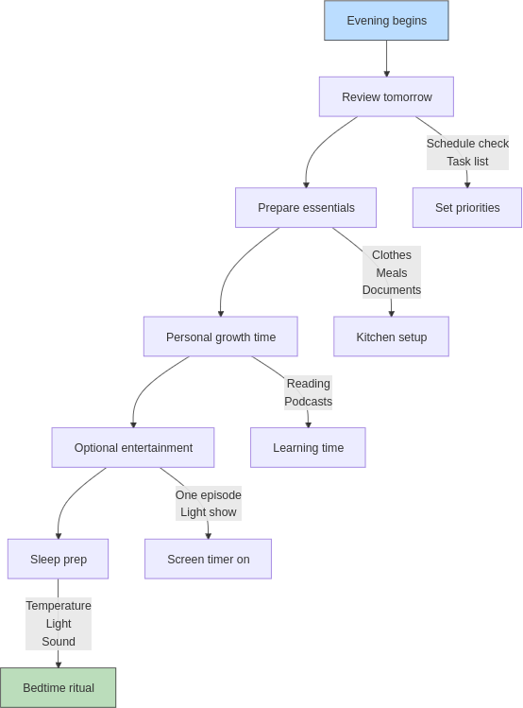

Quick wins.
- Set a consistent wake-up time: helps regulate your body’s internal clock.
- Hydrate before bed: keeps you hydrated overnight.
- Involve your family in the learning time: telling what you have learnt reinforces the concepts and learning together makes the process more stimulating.
- Limit caffeine intake: avoid in the afternoon and evening.
- Stretch before sleep: relieves tension for better rest.
By following this streamlined action plan, you’re not just improving your evenings—you’re laying the foundation for daily success. Remember, consistency is key; these changes will become second nature with practice. As you embark on this journey towards a more balanced life, let’s explore some common pitfalls and how to troubleshoot them effectively.

Troubleshooting: sleep optimization.
As you implement your new evening routine, it’s natural to encounter a few bumps along the way. Here are some common mistakes and how to troubleshoot them effectively, ensuring your journey towards a balanced and productive life remains smooth.
- Overloading the evening with too many activities:
Trying to fit too much into your evening—from reading and podcasts to preparing for tomorrow and socialising—can lead to burnout. Simplify by choosing a few key activities that align with your goals. Focus on quality over quantity and remember that flexibility is key; today might be a podcast and a TV series, while tomorrow could be reading and chatting with friends. This approach reduces stress and enhances the value of each activity.
- Neglecting consistent sleep and wake times:
Inconsistent sleep schedules can disrupt your body’s internal clock, making it harder to wake up refreshed. Ideally, maintain regular sleep times, but if your schedule is hectic, use 90-minute sleep cycles to optimize rest. Even aiming for four cycles (six hours) can help you adapt without waking up in the middle of a cycle feeling tired. Flexibility allows you to adjust as needed.
- Using electronic devices too close to bedtime:
Screen time before bed can impact sleep quality due to blue light interference with melatonin production. Implement a screen-free period at least 30 minutes before bedtime and designate tech-free zones in your home. Reducing screen time enhances your ability to wind down naturally.
- Letting work encroach on personal time:
Allowing work tasks to spill into personal time can increase stress levels. Set clear boundaries for work hours and use separate spaces for work activities to help disconnect mentally. Protecting personal time ensures space for rest and rejuvenation.
- Adapting strategies for high-stress periods:
During high-stress times, remain flexible with your routine. prioritize self-care by adjusting activities as needed—focus more on relaxation techniques or reduce evening commitments. Plan adjustments proactively to maintain balance even during challenges.

Travelling challenges.
Your sleep quality takes the biggest hit when travelling. Between noisy hotel rooms, different time zones and endless work demands, getting proper rest feels impossible. But quality sleep isn’t a luxury—it’s your metabolic secret weapon.
Let’s solve your biggest sleep challenges:
1. “Hotel rooms wreck my sleep.”.
Take control immediately:
- Block all light sources (use eye mask).
- Keep room temperature cool (16-18°C).
- Keep devices away from bed.
- Follow your wind-down ritual no matter what.
2. “Jet lag is killing me.”.
Master the time zone game:
- Travelling west? Add sleep cycles first night.
- Travelling east? Cut cycles, wake at target time.
- Get outside in daylight immediately.
- Use movement + water + meals strategically.
- Skip the caffeine—it’ll only mask the problem.
3. “Work never stops.”.
Draw hard lines:
- Set non-negotiable work shutdown.
- Keep all devices out of bedroom.
- Communicate boundaries clearly.
- Protect your wind-down time.
- Maintain sleep schedule religiously.
Remember: quality sleep is your metabolic edge. Focus on environment control and strategic sleep cycles. Natural remedies (movement, hydration, light, nutrition) beat artificial solutions every time. Your recovery is the foundation of your performance—protect it fiercely.
By recognizing these common pitfalls and applying effective solutions, you’ll be better equipped to maintain a consistent and beneficial evening routine. Flexibility is key; adapting your approach as needed will help you stay on track towards achieving your goals without unnecessary stress or effort.
As you refine your routine, let’s explore some reflection questions and your next move to deepen your understanding and commitment.

Reflection and action: sleep mastery.
As you work on refining your evening routine, it’s important to take a moment to reflect on your current habits and consider how they align with your goals. These reflection questions are designed to help you gain insight into your current situation and motivate meaningful change.
- What evening habits are currently holding you back from achieving a restful night’s sleep and a productive morning?
Consider the specific activities or routines that might be disrupting your sleep or adding stress to your mornings. Reflecting on these can help identify areas for improvement.
- How does your current evening routine align with your long-term personal and professional goals?
Think about whether your nightly activities support the growth and success you envision for yourself. This reflection can illuminate whether changes are needed to better align with your aspirations.
- Why do you think you’ve been stuck in certain unproductive evening habits and what small steps can you take to start changing them?
Understanding the reasons behind persistent habits can reveal underlying challenges or barriers. Identifying small, actionable steps can make the process of change feel more manageable.

Your next move.
- Choose a learning content and make your own checklist: plan ahead by selecting a book, audiobook or podcast that interests you for tomorrow’s evening learning time. Today, tweak this checklist for tomorrow’s preparation, including setting up a space for morning movement, laying out clothes for after your shower, organising the kitchen for a quick Power Plate breakfast assembly and placing keys and documents by the door.
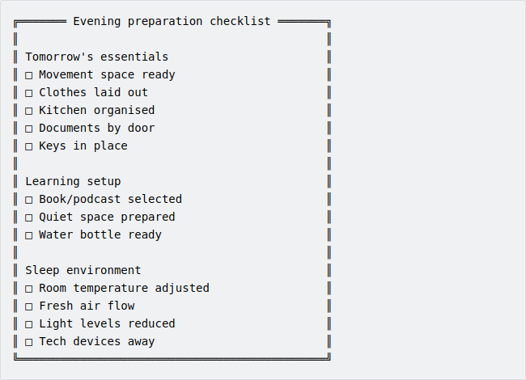
Adjust this checklist to suit your needs and use it tomorrow evening to prepare efficiently for the next day.
Reflecting on these questions and completing the Your next move will deepen your understanding of how small changes can lead to significant improvements in your daily life. Embrace this opportunity to transform your evenings into a powerful foundation for success.

Key points.
- Optimizing your evenings: transform your nights into a time of learning and preparation to ensure a productive tomorrow, anchored by a restful sleep.
- Common pitfalls: avoid overloading your evening with too many activities, inconsistent sleep schedules, excessive screen time before bed, letting work encroach on personal time and failing to adapt during high-stress periods.
- Actionable steps: calculate your ideal bedtime using sleep cycles, prioritize next-day tasks, dedicate time to personal growth, balance entertainment with mindfulness and design a sleep-friendly environment.
- Reflect and adjust: regularly assess your evening habits and make necessary adjustments to align with your goals; use reflection questions to identify areas for improvement and implement changes that enhance your routine.

10. FROM KNOWLEDGE TO ACTION.

Your complete metabolic blueprint.

Chapter objective.
Transform everything you’ve learned into a powerful 30-day action plan. This chapter synthesizes all key strategies into a clear roadmap, helping you build sustainable habits that speed up your metabolism and revolutionize your energy levels.

“Success is the sum of small efforts, repeated day in and day out.”.
— Robert Collier.

A day-in-the-life scenario of someone implementing all the strategies.
Congratulations—you’ve made it this far. The book is practically finished and by now, you’ve absorbed the strategies that can transform your metabolism and your life. But theory is only half the battle. It’s time to see what it looks like in action. Let’s walk through a day in the life of someone who’s fully implementing everything you’ve learned.

Early morning routine: setting the metabolic tone.
You wake up early, not because you have to, but because you want to. The night before, you calculated your ideal sleep cycles, so you’re waking up refreshed and ready to go. Before your feet even hit the floor, you’ve already set the tone for the day by hydrating with a tall glass of water—activating your metabolism from the start.
Next comes movement. You don’t need an hour-long workout to make an impact. A quick 10-minute burst of high-intensity interval training (HIIT) or even a short yoga session or light stretching does the trick. Your body is now primed for fat-burning mode, without taking up too much time from your busy morning.
Breakfast? It’s not just any meal—it’s a metabolic powerhouse. The night before, you organised your kitchen for a quick assembly: all the ingredients and utensils are ready to go. Now, all you need to do is put together a breakfast following the Power Plate Ratio—natural carbs, protein & healthy fats and refined carbs (in that order). You’re fuelling your body for sustained energy without spiking insulin levels.

Morning momentum: building energy for success.
You leave the house without rushing because everything is already prepared. Your commute isn’t just about getting from point A to point B—it’s purposeful. Whether you’re listening to a podcast, enjoying classical music, or simply being present and letting go of things outside of your control, you’re using this time to set a positive tone for the day ahead.
Once at work, you keep your energy steady by pairing hydration with movement breaks. Every 30-60 minutes, you stand up and move for 5 minutes—whether it’s stretching or walking around. This keeps blood flowing and muscles invigorated, boosting your metabolism naturally. Instead of reaching for extra coffee or sugary snacks, you’re choosing real energy through movement and hydration.

Midday: keeping the fire burning.
Lunch isn’t an afterthought; it’s another opportunity to keep your metabolism humming. If you didn’t pack lunch from home, no problem—you can still stick to the Power Plate Ratio by making smart choices with a meal deal or at a restaurant. Opt for salads over sandwiches when possible, but if a sandwich is your main, choose a low-fat option like a chicken salad sandwich. Pair it with fruit or veggies—like carrot sticks with hummus—and always go for still water or sugar-free juices as your drink.
If needed, bring something simple from home—like an extra fruit or salad—to complete the ratio and ensure balance.
And when that afternoon slump starts creeping in? Just like in the morning, you pair regular movement with hydration. A quick 5-minute stretch or walk around the block, combined with sipping water, is all you need to reset your energy levels and keep your metabolism elevated. This consistent pattern of movement and hydration keeps you productive and in fat-burning mode—without relying on caffeine or sugar.

Afternoon: transitioning out of work.
As the workday ends, it’s time to shift gears and manage stress levels. You have a trigger that signals the switch from “work mode” to personal time—whether it’s shutting down your computer, changing clothes, or starting your favourite playlist. This simple action helps you disconnect completely from work and fully enjoy the trip back home with a “vacation” mindset.
After work, you engage in a social-movement activity that you love—whether it’s playing a sport, attending a yoga or Pilates class, or simply going for a walk with a friend. This not only keeps your body active but also helps clear your mind.
Back home, you unwind by preparing a healthy early dinner, following the Power Plate Ratio and enjoying it with your family. It’s a moment to relax and connect.

Evening: preparing for tomorrow.
After dinner, you dive into your scheduled learning time—whether it’s listening to a podcast or reading a book (maybe even this one). You also take a few minutes to prepare for tomorrow: choosing breakfast ingredients, setting up your yoga mat, laying out clothes and placing keys and documents by the door.
Finally, you have some time for social media, chatting with friends, or passive entertainment. While it’s better to keep screen time minimal and focus on non-digital activities like reading or meditation, the choice is yours—balance is key.

Night: the metabolic reset.
You fall asleep knowing that every small action today has contributed to speeding up your metabolism. Your sleep is deep and restorative because you’ve optimised everything—from room temperature to bedtime rituals. And as you drift off, your body isn’t just resting; it’s recovering and preparing for another day of metabolic success.
This is what life looks like when all the strategies come together—a seamless flow of habits that don’t just fit into your busy schedule but enhance it. This isn’t about perfection; it’s about consistency and making small efforts that compound over time.
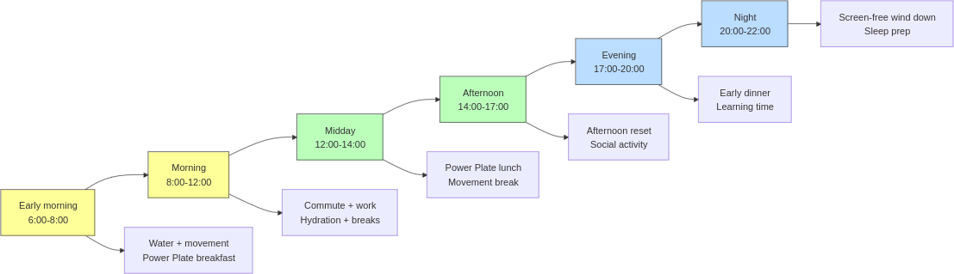
Now that you’ve seen what a day looks like when all these strategies are implemented, it’s time to take action and make this routine your own.

A one-page summary of key actions for each part of the day.
Here’s a quick breakdown of the key actions you can take throughout the day to boost your metabolism and stay on track. These small but powerful steps will keep your energy levels steady, help you burn fat and set you up for long-term success.

Early morning routine: setting the metabolic tone.
- Hydrate first: start your day with a tall glass of water to activate your metabolism.
- Move your body: a quick 10-minute session of HIIT, yoga, or stretching primes your body for fat-burning.
- Power Plate breakfast: assemble a balanced breakfast with natural carbs, protein & healthy fats and refined carbs to fuel your morning.

Morning momentum: building energy for success.
- Purposeful commute: use your commute to listen to a podcast, enjoy classical music, or practice being present.
- Hydration + movement: every 30–60 minutes at work, stand up and move for 5 minutes while staying hydrated. This keeps your metabolism elevated and prevents energy dips.

Midday: keeping the fire burning.
- Power Plate lunch: whether packed from home or bought on the go, stick to the Power Plate Ratio—opt for salads or low-fat sandwiches paired with fruit or veggies.
- Combat the afternoon slump: pair hydration with a quick movement break (stretching or walking) to reset energy levels without relying on caffeine or sugar.

Afternoon: transitioning out of work.
- Trigger to switch off work mode: use a simple action—like shutting down your computer or changing clothes—to disconnect from work and enter personal time.
- Social-movement activity: engage in a sport, yoga class, or walk with a friend to stay active and clear your mind.

Evening: preparing for tomorrow.
- Healthy early dinner: follow the Power Plate Ratio for dinner to support recovery and avoid heavy digestion overnight—experiment with different ingredients over time to keep things fresh.
- Scheduled learning time: spend time reading or listening to a podcast to invest in personal growth.
- Prepare for tomorrow: choose breakfast ingredients, set up your yoga mat, lay out clothes and place keys/documents by the door.

Night: the metabolic reset.
- Wind down without screens: limit screen time before bed and focus on relaxing activities like reading or meditation.
- Optimize sleep environment: ensure your room is cool, dark and quiet to promote deep, restorative sleep that supports metabolic recovery.
These key actions are designed to fit seamlessly into your busy schedule while maximising your energy and metabolism throughout the day. Stick with them consistently and you’ll see how small daily efforts can lead to big results over time.

30-Day Transformation Challenge: start small, build big wins.
You’ve absorbed the strategies and now it’s time to put them into action. This 30-Day Transformation Challenge is designed to help you activate your metabolism, boost your energy and start seeing results in just 30 days—without overwhelming yourself or overhauling your entire life.
The key to success in this challenge is to start small and build momentum over time. You’ll focus on two chapters each week, implementing the strategies one step at a time. By the end of the 30 days, you’ll have mastered all 8 key strategies and you’ll still have 2 bonus days to reflect, refine and celebrate your progress.
Here’s the step-by-step breakdown of the 30 days:

Week 1: energize your mornings (days 1-7).
In the first week, we’ll focus on starting your day with intention and setting the foundation for a productive, energized day.
- Day 1-3: chapter 1 – Rise and shine: energize your day with morning movement.
Start your mornings with a quick burst of movement—whether it’s stretching, yoga, or a 10-minute HIIT session. This will get your metabolism going and set the tone for a more energized day.
- Day 4-7: chapter 2 – Breakfast boost: ignite your metabolic engine in minutes.
Prepare a Power Plate breakfast that incorporates natural carbs, proteins and healthy fats. This will fuel your body for the day ahead and help stabilise your metabolism.

Week 2: maximize your commute and workday (days 8-14).
Now that your mornings are energized, it’s time to focus on making the most of your commute and workday.
- Day 8-10: chapter 3 – Commute with purpose: transform your travel time into success time.
Use your commute as a time to learn, reflect, or energize. Whether it’s listening to a podcast, practising mindfulness, or walking part of the way, make your commute an active part of your routine.
- Day 11-14: chapter 4 – Focus and flow: mastering your workday hydration.
Focus on staying hydrated throughout your workday. Drink water regularly and pair hydration with movement breaks. This will keep your energy levels steady and prevent mid-afternoon crashes.

Week 3: recharge your midday and afternoon (days 15-21).
As we move into the third week, it’s time to recharge your midday habits and beat the afternoon slump.
- Day 15-18: chapter 5 – Lunch and leisure: recharge with a walk and a meal.
Take a walk during your lunch break to recharge and refocus. Pair this with a balanced meal that follows the Power Plate Ratio to keep your metabolism running efficiently.
- Day 19-21: chapter 7 – energize your afternoon: beat the slump naturally.
Instead of reaching for caffeine or sugar, use movement and hydration to beat the afternoon slump. Take regular breaks to stretch or walk and keep your water intake consistent.

Week 4: finish strong with evening and night routines (Days 22-28).
In the final week, we’ll focus on evening and night strategies that set you up for success the next day.
- Day 22-24: chapter 8 – Unwind and dine: fuel your evening for peak performance.
Prepare a balanced dinner that follows the Power Plate Ratio. Avoid heavy, processed foods late in the evening to set yourself up for better sleep and recovery.
- Day 25-28: chapter 9 – Recharge and prepare: maximize your night for tomorrow’s success.
Create an evening wind-down routine that helps you relax and prepare for the next day. Whether it’s stretching, reading, or journaling, this routine will support better sleep quality and help you wake up feeling refreshed.

Bonus days: reflect, refine and celebrate (days 29-30).
- Day 29-30: bonus.
You’ve completed the challenge! Use these two extra days to reflect on your progress, refine any strategies that need adjusting and celebrate your wins. Whether it’s better energy, fat loss, or more consistent daily habits, you’ve built a foundation for long-term success.

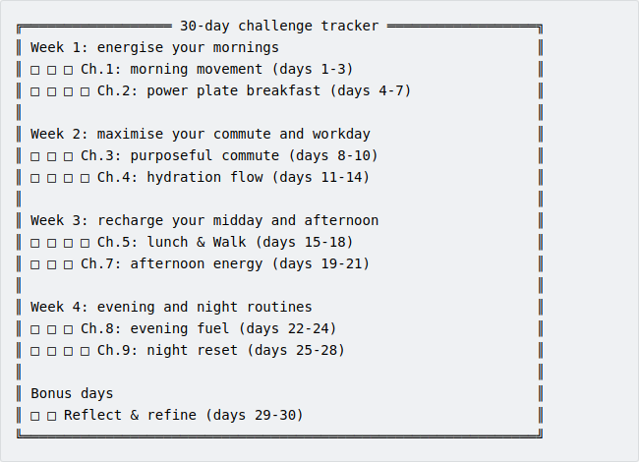
The power of small, consistent actions.
Remember, the key to success is consistency. By following this challenge and implementing these strategies over the next 30 days, you’ll see how small, consistent actions can lead to big results. Don’t rush the process—focus on building momentum and you’ll start experiencing the benefits of a faster metabolism and more energy in no time.
Let’s get started—your 30-day transformation begins today!.

Common struggles with building new habits
(and how to overcome them).
Implementing new habits can be exciting at first, but it’s common to hit roadblocks along the way. Whether you’re struggling with consistency, feeling overwhelmed by perfectionism, or simply not starting at all, these quick fixes will help you stay on track and build lasting change.

1. Struggling to start.
- The challenge: you’ve read through the strategies but haven’t started yet because it feels overwhelming or you’re waiting for the “perfect” time.
- Quick fix: start small—just pick one habit (like drinking water in the morning) and focus on that for now. Once it feels natural, add another habit. There’s no need to do everything at once.

2. Inconsistency over time.
- The challenge: you start strong but find yourself slipping back into old habits after a few days or weeks.
- Quick fix: identify your triggers—what causes you to slip? Whether it’s stress or lack of time, create a simple plan to counteract those triggers (like scheduling movement breaks or preparing meals ahead of time). If you miss a day or two, don’t stress—just get back on track. Consistency is built over time, not overnight.

3. Perfectionism (all-or-nothing thinking).
- The challenge: you feel like if you can’t do something perfectly, it’s not worth doing at all—so you end up doing nothing.
- Quick fix: aim for “good enough.” Even if you don’t follow every strategy perfectly, small efforts still compound over time. It’s better to do something imperfectly than nothing at all.

4. Being too hard on yourself.
- The challenge: you’re overly critical of your progress and feel discouraged if you don’t see immediate results.
- Quick fix: celebrate small wins along the way—whether it’s implementing the Power Plate Ratio in your lunch or skipping that afternoon coffee. These small actions add up and deserve recognition.

5. Feeling overwhelmed by too many changes.
- The challenge: trying to implement too many new habits at once can feel overwhelming and lead to burnout.
- Quick fix: prioritize what matters most right now. Focus on the habit that will have the biggest impact on your day (like sleep or hydration) and let go of the pressure to do everything perfectly. Once you feel more in control, gradually introduce other habits as needed.
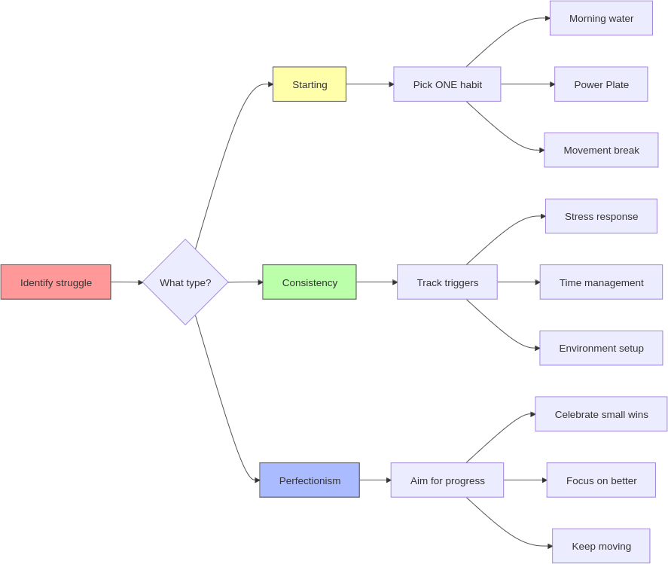
Building new habits isn’t easy—but it’s also not about being perfect from day one. The key is to stay flexible, celebrate small wins and keep moving forward—even when things get tough. Remember, lasting change happens gradually over time, so be patient with yourself as you adapt these strategies into your life.

Success metrics to track progress and stay motivated.
Tracking your progress doesn’t have to be complicated. You don’t need fancy gadgets, apps, or endless data to see results. While metrics can be helpful, they can also become distractions that slow you down or cause unnecessary stress. The goal here is to keep things simple and actionable, so you can start right away—without extra effort or hidden costs.
At the end of each day, take a few minutes to reflect on how things went. No need for journals, apps, or wearable devices—just a quick mental check-in will do. This way, you’ll know what’s working and where you can make small adjustments, without getting bogged down by too much information.

1. Energy levels throughout the day.
- What to reflect on: how did your energy feel today? Did you stay steady throughout the day, or did you hit any crashes?
- Why it matters: consistent energy means your metabolism is working efficiently. If you’re not relying on caffeine or sugar to get through the day, that’s a clear sign you’re on the right track.
- How to measure: at the end of each day, quickly think about how your energy levels were—morning, afternoon and evening. Over time, patterns will emerge.

2. Consistency with key habits.
- What to reflect on: did you stick to the Power Plate Ratio in your meals? Did you hydrate and move regularly throughout the day?
- Why it matters: consistency is what drives results. Even if it’s not perfect every day, checking in on how often you’re following through helps keep you accountable.
- How to measure: mentally review whether you hit your key habits today—hydration, movement breaks and balanced meals. No need for a tracker—just reflect on whether today was a successful day.

3. Sleep quality.
- What to reflect on: how did you feel when waking up this morning? Were you refreshed or dragging yourself out of bed?
- Why it matters: sleep is the foundation for everything else—energy, metabolism and focus. Waking up feeling rested means your sleep cycles are working for you.
- How to measure: forget sleep trackers—just ask yourself how easily you woke up and how refreshed you felt in the morning.

4. Reduction in reliance on stimulants (caffeine/sugar).
- What to reflect on: did you rely on caffeine or sugary snacks today to push through an energy slump?
- Why it matters: cutting back on stimulants shows that your body is generating real energy from proper hydration, nutrition and movement—not quick fixes.
- How to measure: simply note whether today was a caffeine-free or sugar-free day. If so, that’s a win worth celebrating.

5. Improved focus and productivity.
- What to reflect on: how focused were you during work or personal tasks today? Did you get more done without distractions?
- Why it matters: a well-functioning metabolism doesn’t just give you physical energy—it sharpens your mental focus too. Improved productivity is a sign that both your body and brain are working efficiently.
- How to measure: at the end of each day, think about how productive and focused you were during key tasks—did your focus improve compared to previous days?

6. Progress towards long-term goals (not just weight loss).
- What to reflect on: are you feeling healthier overall? Do your clothes fit better? Are you noticing improvements in strength or stamina?
- Why it matters: success isn’t just about weight—it’s about how good you feel in your body and mind. Non-scale victories like increased stamina or confidence are signs of real progress.
- How to measure: take note of non-scale victories—like feeling stronger during workouts or more comfortable in your clothes—and reflect on these alongside any physical changes.
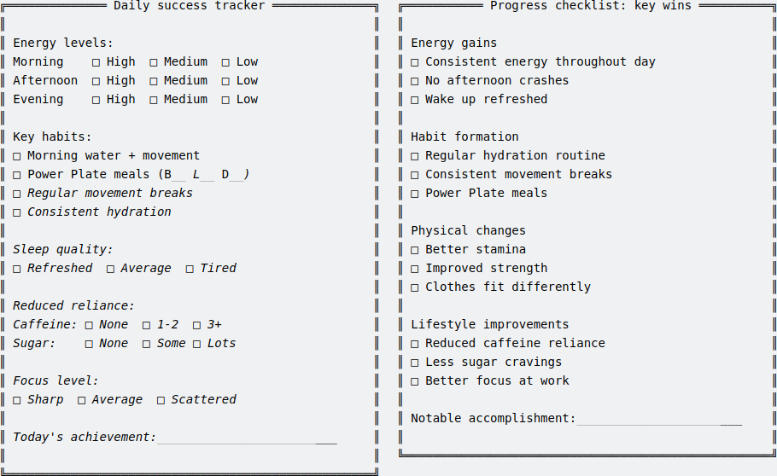
Your daily review doesn’t need to be complicated or time-consuming. In just 5 minutes—whether while preparing for tomorrow or brushing your teeth before bed—you can reflect on what went well and where there’s room for improvement. No apps, no wearables—just a quick mental check-in to keep you on track.
Remember, the goal is progress, not perfection. Small adjustments each day will lead to big changes over time.

Case studies of people who’ve implemented these strategies.
It’s one thing to read about a strategy, but it’s another to see how it plays out in real life. Below are a few stories of people who implemented these simple strategies and saw real results—without overcomplicating things or adding extra stress. These case studies prove that small, consistent actions can lead to big, lasting changes.

Case study 1: Maria — The busy entrepreneur who mastered her mornings.
Before: Maria runs her own business and was always running on fumes. Her mornings were chaotic—rushing out the door with a coffee in hand, skipping breakfast and relying on caffeine and sugar to get through the day. By mid-afternoon, she’d crash and by evening, she was too drained to enjoy time with her family.
What she did: Maria started by implementing just one habit—drinking a tall glass of water first thing in the morning. That small action led to another: preparing her breakfast the night before using the Power Plate Ratio. She also began adding 5 minutes of stretching in the morning to wake up her body.
The results: within two weeks, Maria noticed she didn’t need as much coffee to stay alert. Her energy was more consistent throughout the day, and she no longer hit the dreaded afternoon slump. By simplifying her morning routine and focusing on hydration and balanced meals, she was able to reclaim her mornings—and actually enjoy her evenings with her family.

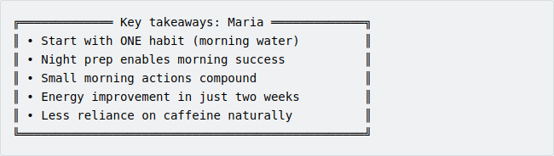
Case study 2: David — The corporate professional who beat the afternoon slump.
Before: David works in a corporate environment with long hours and a demanding schedule. He used to rely on a heavy lunch and multiple cups of coffee to power through his busy afternoons, but by 15:00, he was crashing hard. This led him to snack on sugary treats to stay awake, which only made him feel sluggish later.
What he did: David followed the advice to pair movement with hydration. He started standing up every 30–60 minutes for a quick walk around the office and increased his water intake throughout the day. At lunch, he switched to the Power Plate Ratio, opting for lighter meals like salads with lean protein and healthy fats, paired with fruit instead of sugary snacks.
The results: in less than a month, David noticed his energy levels were more stable. By reducing his reliance on caffeine and sugar, he felt sharper and more focused throughout the afternoon. He didn’t need coffee to stay awake, and his productivity improved as a result. He even mentioned he felt more energized during his evening workouts.

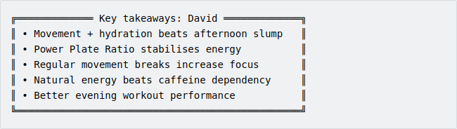
Case study 3: Rebecca — The business owner who learned to let go without losing control.
Before: Rebecca, the owner of a growing business, was a true finisher—everything had to pass through her final approval. While she delegated tasks, she still insisted on reviewing every detail, which led to constant stress. Working mostly from her home office, she struggled to disconnect and even her once-a-week office visits were packed with back-to-back meetings, leaving her drained by the end of the day.
What she did: Rebecca created a trigger to switch off “work mode” by shutting down her computer, closing her office door and putting her phone on “Do Not Disturb” in the late afternoon. She also added a 20-minute yoga session in the evenings to help wind down, focus on the present and release the tension of the day.
The results: within a few weeks, Rebecca felt more relaxed and in control. By setting clear boundaries, she was able to step back without losing oversight. Her stress levels dropped, and she began enjoying her evenings again, feeling more energized for the next day.

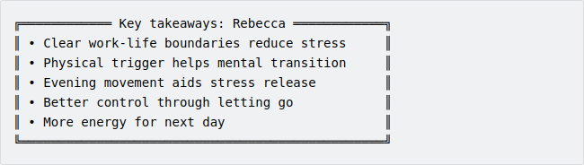
Case study 4: Nick — The ambitious professional balancing fitness and career.
Before: Nick, a rising marketing manager, struggled to maintain his fitness routine alongside his demanding career. Despite hitting the gym regularly, he noticed his recovery was suffering and often felt sluggish during important morning meetings. His late-night work habits led to rushed dinners and mindless eating while answering emails.
What he did: Nick started following the Power Plate Ratio for dinner and created clear boundaries between work and personal time. He implemented a screen-free wind-down routine, replacing late-night emails with relaxation techniques. His evening meals became lighter and more structured, focusing on nutrient-dense foods that supported both his professional and fitness goals.
The results: Nick’s energy levels transformed. Better evening nutrition and sleep quality made him sharper in morning meetings and more effective at work. His workout recovery improved significantly, allowing him to maintain his fitness goals while excelling in his career. He finally found the balance between professional ambition and personal well-being.
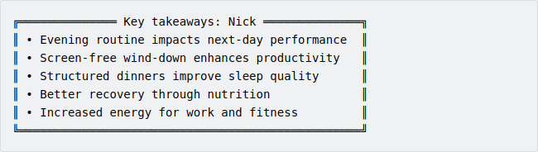
These stories show that real results come from small, consistent actions—not drastic overhauls or complicated systems. Whether you’re looking to boost energy, beat the afternoon slump, or simply enjoy your evenings more, these strategies can fit seamlessly into your life. It’s about finding what works for you and building on it each day.

Share this book when they ask.
As you start seeing results from this book—like greater energy, focus, and improved health—people around you may notice too. They might ask what you’ve been doing differently.
Mentioning this book when someone asks is a simple, natural way to share what worked for you. Not only could you help them take the first step toward better health, but sharing something you’ve learned also has benefits for you—it reinforces your knowledge, keeps you accountable, and makes it easier to stick to your habits when the people around you understand your goals.
For example, sharing these strategies with friends or family can even make dining out easier, as others will know your preferences and what supports your metabolic health. Helping others improve their lives might just make your own journey smoother too.

Stay in touch.
If this book has been helpful to you, and you’d like to stay updated on what I’m working on, you can visit my website and sign up for my newsletter.
The newsletter is a way to stay connected and receive occasional updates about future books, future courses (if there’s demand), exclusive insights, and when 1-on-1 coaching becomes available.
No spam, no fluff—just meaningful updates delivered straight to your inbox.
On my website, you can also contact me directly to share your feedback, ask questions, or let me know how this book has impacted your journey—I’d love to hear from you.
There’s no pressure—this is simply a way to stay connected if you’ve found my work helpful and want to hear more.
Find everything here: https://tommasozanette.com.

Conclusion: finish what you started.
Congratulations. You’ve made it to the very end of the book, but this is where the real work begins. Reading alone won’t change anything—action is what drives results. You now have the tools to boost your metabolism, even with a busy schedule. The next step? Put them to work.
Your metabolism doesn’t have to slow down just because life is hectic. In fact, the more packed your schedule, the more crucial it is to keep your metabolism working for you, not against you. By making small, consistent changes—like hydrating, following the Power Plate Ratio and taking short movement breaks—you’ll start seeing immediate improvements in your energy, focus and health.
This isn’t about perfection. It’s about building momentum. Each small step compounds over time and the best part? These strategies fit seamlessly into even the busiest days.
As you move forward, keep this book close by. It’s your manual—a guide you can return to when you need a reminder, a boost, or a way to get back on track. But here’s the goal: over time, you’ll build such strong habits that you’ll need this book less and less. You’ll revisit it not because you’re struggling, but because you’re ready to refine, adjust and level up.
So, finish what you started. Take action now. Don’t wait for the perfect moment—it doesn’t exist. Start small, stay consistent and watch your metabolism—and your life—transform faster than you thought possible.
Remember, only you can change your life. Excuses? Leave them behind. If you don’t act, nothing changes. You are in control. You already have everything you need to succeed—it’s time to make it happen.
Success doesn’t come from complexity—it comes from simple, consistent actions. You can start today, with what you have, exactly where you are.
No excuses. No waiting. Just action. Start now and keep moving forward.

REFERENCES.

1. Tracy B. Eat That Frog & The ABCDE Method [Internet]. Self Help presented at; 2011 Aug 27; YouTube. Available from: https://www.youtube.com/watch?v=FKOMTZ7PPLg .
2. Benkirane O, Delwiche B, Mairesse O, Peigneux P. Impact of Sleep Fragmentation on Cognition and Fatigue. Int J Environ Res Public Health [Internet]. 2022 Nov 22 [cited 2024 Dec 24];19(23).:15485. Available from: https://www.mdpi.com/1660-4601/19/23/15485 .
3. Rai J. Forbes. 2021. Why You Should Stop Checking Your Phone In The Morning (And What To Do Instead). Available from: https://www.forbes.com/councils/forbescoachescouncil/2021/04/02/why-you-should-stop-checking-your-phone-in-the-morning-and-what-to-do-instead/ .
4. Arciero PJ, Ives SJ, Mohr AE, Robinson N, Escudero D, Robinson J, et al. Morning Exercise Reduces Abdominal Fat and Blood Pressure in Women; Evening Exercise Increases Muscular Performance in Women and Lowers Blood Pressure in Men. Front Physiol [Internet]. 2022 May 31 [cited 2024 Dec 24];13:893783. Available from: https://www.frontiersin.org/articles/10.3389/fphys.2022.893783/full .
5. Breus M. Learn the perfect hormonal time to sleep, eat, and have sex [Internet]. TEDxManhattanBeach; 2019 Mar 21. Available from: https://www.youtube.com/watch?v=rmbv7yZ2buE .
6. Ratey J. Run, Jump, Learn! How Exercise can Transform our Schools [Internet]. 2012 Nov 19. Available from: https://youtu.be/hBSVZdTQmDs?si=cJY-jYKWxbsLQd5G .
7. Lipa D, BBC Sounds. Apple CEO Tim Cook on what it takes to run the world’s largest company [Internet]. (Dua Lipa: At Your Service). Available from: https://youtu.be/JXQYO8poXC8?t=130&si=tohH__jKs8IeLyLP .
8. World Day J. The Only 3 Exercises Jennifer Aniston Has Never Stopped Doing Since ‘Friends [Internet]. World Day. 2024. Available from: https://www.journee-mondiale.com/en/the-only-3-exercises-jennifer-aniston-has-never-stopped-doing-since-friends/ .
9. Hackenschmidt G, Golden Era Bookworm. GEORGE HACKENSCHMIDT’S HEALTH BOOSTING HOME WORKOUT!! NO WEIGHTS NECESSARY! FOR ALL WALKS OF LIFE! [Internet]. 2020 Mar 27. Available from: https://youtu.be/dXMSUG-jfUc?si=6A3ClF-p0h7QHxL5 .
10. Adolphus K, Lawton CL, Dye L. The effects of breakfast on behavior and academic performance in children and adolescents. Front Hum Neurosci [Internet]. 2013 [cited 2024 Dec 24];7. Available from: http://journal.frontiersin.org/article/10.3389/fnhum.2013.00425/abstract .
11. Online Colleges. Breakfast Infographic [Internet]. Online Colleges; 2012. Available from: https://lowdownblog.com/wp-content/uploads/2012/09/breakfast-infographic.jpg .
12. Environmental Working Group. Sugar in Children’s Cereals [Internet]. Environmental Working Group. 2011. Available from: https://www.ewg.org/research/sugar-childrens-cereals .
13. Lone A, Alnawah AK, Hadadi AS, Alturkie FM, Aldreweesh YA, Alhedhod AT. Coffee Consumption Behavior in Young Adults: Exploring Motivations, Frequencies, and Reporting Adverse Effects and Withdrawal Symptoms. Psychol Res Behav Manag [Internet]. 2023 Sep [cited 2024 Dec 24];Volume 16:3925–37. Available from: https://www.dovepress.com/coffee-consumption-behavior-in-young-adults-exploring-motivations-freq-peer-reviewed-fulltext-article-PRBM .
14. Resume Builder. 1 in 7 workers spend $400+ monthly on lunch [Internet]. Resume Builder; 2023 Oct. Available from: https://www.resumebuilder.com/1-in-7-workers-spend-400-monthly-on-lunch/ .
15. Mondelez International. 2023 STATE OF SNACKING GLOBAL REPORT [Internet]. 2023. Available from: https://www.mondelezinternational.com/stateofsnacking/ .
16. Guinter MA, Park YM, Steck SE, Sandler DP. Day-to-day regularity in breakfast consumption is associated with weight status in a prospective cohort of women. Int J Obes [Internet]. 2020 Jan [cited 2024 Dec 24];44(1).:186–94. Available from: https://www.nature.com/articles/s41366-019-0356-6 .
17. Zeballos E, Todd JE. The effects of skipping a meal on daily energy intake and diet quality. Public Health Nutr [Internet]. 2020 Dec [cited 2024 Dec 24];23(18).:3346–55. Available from: https://www.cambridge.org/core/product/identifier/S1368980020000683/type/journal_article .
18. Chatterjee R, Inchauspé J. Use These FOOD HACKS To Boost Energy, END CRAVINGS & Reduce Inflammation [Internet]. (Health Tips). Available from: https://youtu.be/RB9p4GnMg98?si=ARxeGftEh1O4kpJ_&t=721 .
19. Cooper SB, Bandelow S, Nute ML, Morris JG, Nevill ME. Breakfast glycaemic index and cognitive function in adolescent school children. Br J Nutr [Internet]. 2012 Jun 28 [cited 2024 Dec 24];107(12).:1823–32. Available from: https://www.cambridge.org/core/product/identifier/S0007114511005022/type/journal_article .
20. Suez J, Korem T, Zilberman-Schapira G, Segal E, Elinav E. Non-caloric artificial sweeteners and the microbiome: findings and challenges. Gut Microbes [Internet]. 2015 Mar 4 [cited 2024 Dec 28];6(2).:149–55. Available from: https://www.tandfonline.com/doi/full/10.1080/19490976.2015.1017700 .
21. Debras C, Chazelas E, Sellem L, Porcher R, Druesne-Pecollo N, Esseddik Y, et al. Artificial sweeteners and risk of cardiovascular diseases: results from the prospective NutriNet-Santé cohort. BMJ [Internet]. 2022 Sep 7 [cited 2024 Dec 28];e071204. Available from: https://www.bmj.com/lookup/doi/10.1136/bmj-2022-071204 .
22. Pew Research Center. Social Media and News Fact Sheet [Internet]. Pew Research Center. 2024. Available from: https://www.pewresearch.org/journalism/fact-sheet/social-media-and-news-fact-sheet/ .
23. Hi Road. Where in the U.S. do drivers complain the most about the roads? [Internet]. 2022 May. Available from: https://www.hiroad.com/driving-and-stress .
24. Mesmer-Magnus J, Guidice R, Andrews M, Woolum A, Robertson E. Implications of employees who work while commuting: A moderated mediation analysis. Pal R, Sun Y, Wang P, editors. Hum Syst Manag [Internet]. 2023 Jul 19 [cited 2024 Dec 24];42(4).:403–18. Available from: https://journals.sagepub.com/doi/full/10.3233/HSM-220090 .
25. United States Census Bureau. Why We Ask Questions About... Commuting / Journey to Work [Internet]. 2023. Available from: https://www.census.gov/acs/www/about/why-we-ask-each-question/commuting/ .
26. Epel ES, Blackburn EH, Lin J, Dhabhar FS, Adler NE, Morrow JD, et al. Accelerated telomere shortening in response to life stress. Proc Natl Acad Sci [Internet]. 2004 Dec 7 [cited 2024 Dec 28];101(49).:17312–5. Available from: https://pnas.org/doi/full/10.1073/pnas.0407162101 .
27. McGonigal K. How to make stress your friend [Internet]. 2013 Sep 4. Available from: https://www.youtube.com/watch?v=RcGyVTAoXEU .
28. Yu R. Stress potentiates decision biases: A stress induced deliberation-to-intuition (SIDI) model. Neurobiol Stress [Internet]. 2016 Jun [cited 2024 Dec 28];3:83–95. Available from: https://linkinghub.elsevier.com/retrieve/pii/S2352289515300187 .
29. Branson R. My morning routine [Internet]. Richard Branson’s Blog. 2017. Available from: https://www.virgin.com/branson-family/richard-branson-blog/my-morning-routine .
30. Kay G. Twitter cofounder Jack Dorsey’s daily routine: a ‘wake me up’ cocktail and 7-minute workouts [Internet]. Business Insider. 2024. Available from: https://www.businessinsider.com/jack-dorsey-daily-routine-block-twitter .
31. Killer SC, Blannin AK, Jeukendrup AE. No Evidence of Dehydration with Moderate Daily Coffee Intake: A Counterbalanced Cross-Over Study in a Free-Living Population. Thompson D, editor. PLoS ONE [Internet]. 2014 Jan 9 [cited 2024 Dec 24];9(1).:e84154. Available from: https://dx.plos.org/10.1371/journal.pone.0084154 .
32. Lugli C. A survey on hydration and use of plastic water bottles among Italian health sector workers. Ann Ig Med Prev E COMUNITA [Internet]. 2024 Oct 1 [cited 2024 Dec 24];36(6).:695–702. Available from: https://doi.org/10.7416/ai.2024.2639 .
33. Riebl SK, Davy BM. The Hydration Equation: Update on Water Balance and Cognitive Performance. ACSMS Health Fit J [Internet]. 2013 Nov [cited 2024 Dec 24];17(6).:21–8. Available from: https://journals.lww.com/00135124-201311000-00006 .
34. Mattes RD. Hunger and thirst: Issues in measurement and prediction of eating and drinking. Physiol Behav [Internet]. 2010 Apr [cited 2024 Dec 24];100(1).:22–32. Available from: https://linkinghub.elsevier.com/retrieve/pii/S0031938409004132 .
35. CDC. Fast Facts: Sugar-Sweetened Beverage Consumption [Internet]. CDC Nutrition. 2024. Available from: https://www.cdc.gov/nutrition/php/data-research/sugar-sweetened-beverages.html .
36. Wittbrodt MT, Millard-Stafford M. Dehydration Impairs Cognitive Performance: A Meta-analysis. Med Sci Sports Exerc [Internet]. 2018 Nov [cited 2024 Dec 24];50(11).:2360–8. Available from: https://journals.lww.com/00005768-201811000-00021 .
37. Mosconi L, Kwik J. Brain Foods that Are Good for You [Internet]. 2018 Dec 14. Available from: https://www.youtube.com/watch?v=qxiAmJllp4I .
38. Huberman A, Knight Z. The Science of Hunger & Medications to Combat Obesity [Internet]. (Huberman Lab). Available from: https://youtu.be/C5KpIXjpzdY?t=6803&si=ORJnvbx3_2t9SaOc .
39. Cristiano Ronaldo HATES Coca-cola [Internet]. 2021. Available from: https://youtube.com/shorts/_nw7FOgOgtA?si=qReDLzV-3f6JzBmx .
40. Just Eat for Business. The Lacklustre Lunch Breaks Study [Internet]. 2022 Sep. Available from: https://business.just-eat.co.uk/blog/lacklustre-lunch-breaks .
41. Garza KB, Ding M, Owensby JK, Zizza CA. Impulsivity and Fast-Food Consumption: A Cross-Sectional Study among Working Adults. J Acad Nutr Diet [Internet]. 2016 Jan [cited 2024 Dec 24];116(1).:61–8. Available from: https://linkinghub.elsevier.com/retrieve/pii/S2212267215005407 .
42. Paychex. The Afternoon Crash: Assessing Workplace Productivity and Roadblocks [Internet]. 2020 Jan. Available from: https://www.paychex.com/articles/human-resources/afternoon-crash-workplace-productivity-and-roadblocks .
43. Pacheco LS, Tobias DK, Li Y, Bhupathiraju SN, Willett WC, Ludwig DS, et al. Sugar-sweetened or artificially-sweetened beverage consumption, physical activity, and risk of cardiovascular disease in adults: a prospective cohort study. Am J Clin Nutr [Internet]. 2024 Mar [cited 2024 Dec 31];119(3).:669–81. Available from: https://linkinghub.elsevier.com/retrieve/pii/S0002916524000017 .
44. Guillou L, Durand V, Raymond M, Berticat C. Chronic refined carbohydrate consumption measured by glycemic load and variation in cognitive performance in healthy people. Personal Individ Differ [Internet]. 2023 May [cited 2024 Dec 24];206:112138. Available from: https://linkinghub.elsevier.com/retrieve/pii/S0191886923000612 .
45. APA. Stress and Eating [Internet]. 2013. Available from: https://www.apa.org/news/press/releases/stress/2013/eating .
46. Wouters S, Thewissen V, Duif M, Van Bree RJ, Lechner L, Jacobs N. Habit strength and between-meal snacking in daily life: the moderating role of level of education. Public Health Nutr [Internet]. 2018 Oct [cited 2024 Dec 24];21(14).:2595–605. Available from: https://www.cambridge.org/core/product/identifier/S1368980018001283/type/journal_article .
47. Just Eat for Business. UK Desk Eating Habits Report [Internet]. 2020 Mar p. 60. Available from: https://business.just-eat.co.uk/hubfs/2020_Pdfs/Desk_eating_habits_whitepaper.pdf .
48. Huberman A, Brackett M. How to Increase Your Emotional Intelligence [Internet]. Available from: https://youtu.be/kG5Qb9sr0YQ?t=5100&si=LCd4a6sUhH9J-GXJ.
49. Inchauspé J. The 10 Glucose Goddess Hacks: easy tricks that will change how you feel forever [Internet]. 2024 Feb 21. Available from: https://www.youtube.com/watch?v=1PkshTBkWZ8 .
50. Adnan D, Trinh J, Bishehsari F. Inconsistent eating time is associated with obesity: A prospective study. EXCLI J 21Doc300 ISSN 1611-2156 [Internet]. 2022 [cited 2024 Dec 24]; Available from: https://www.excli.de/index.php/excli/article/view/4324 .
51. Change Your Mealtimes [Internet]. Just One Thing - with Michael Mosley. BBC; 2021. Available from: https://www.bbc.co.uk/sounds/play/m000zt7d .
52. Zacharias N, Mackey J. John Mackey of Whole Foods Market on the Healthiest Way to Eat for the Planet [Internet]. (Eat for the Planet). Available from: https://megaphone.link/NSR2567193065 .
53. Hiemstra M, Dillon-Rossiter K, Bartmann N, Prapavessis H, Rollo S, Mitchell M. When it comes to sedentary behaviour modification, should people be told what to do? A randomized comparison trial among home-based office workers living in Ontario, Canada. Transl Behav Med [Internet]. 2024 Feb 7 [cited 2024 Dec 24];14(2).:106–16. Available from: https://academic.oup.com/tbm/article/14/2/106/7243052 .
54. Roh T, Esomonu C, Hendricks J, Aggarwal A, Hasan NT, Benden M. Examining workweek variations in computer usage patterns: An application of ergonomic monitoring software. Wolniak R, editor. PLOS ONE [Internet]. 2023 Jul 6 [cited 2024 Dec 24];18(7).:e0287976. Available from: https://dx.plos.org/10.1371/journal.pone.0287976 .
55. Vitabiotics. How to beat the energy slump [Internet]. 2023 Nov. Available from: https://www.vitabiotics.com/blogs/health-areas/how-to-beat-the-energy-slump .
56. MacVean M. ‘Get Up!’ or lose hours of your life every day, scientist says. Science and Medicine [Internet]. 2014 Jul 31; Available from: https://www.latimes.com/science/sciencenow/la-sci-sn-get-up-20140731-story.html .
57. Edwardson CL, Gorely T, Davies MJ, Gray LJ, Khunti K, Wilmot EG, et al. Association of Sedentary Behaviour with Metabolic Syndrome: A Meta-Analysis. O’Connor KA, editor. PLoS ONE [Internet]. 2012 Apr 13 [cited 2024 Dec 24];7(4).:e34916. Available from: https://dx.plos.org/10.1371/journal.pone.0034916 .
58. Katella K, Holder EK. Why Is Sitting so Bad for Us? [Internet]. Yale Medicine. 2019. Available from: https://www.yalemedicine.org/news/sitting-health-risks .
59. Kwik J. As your body moves, your brain grooves. [Internet]. 2022. Available from: https://www.linkedin.com/posts/jimkwik_as-your-body-moves-your-brain-grooves-activity-6991381801113952256-ahyC .
60. Leswing K. All Apple employees now get standing desks — and Tim Cook has said he believes ‘sitting is the new cancer’ [Internet]. Business Insider. 2018. Available from: https://www.businessinsider.com/apple-employees-standing-desks-tim-cook-sitting-cancer-2018-6 .
61. Gaines B, Nielsen. Shocking Average Screen Time Statistics [2024 Data] [Internet]. 2024 Oct. Available from: https://evoca.tv/screen-time-statistics/ .
62. Eisenberg ME, Larson NI, Gollust SE, Neumark-Sztainer D. Snacking on Television: A Content Analysis of Adolescents’ Favorite Shows. Prev Chronic Dis [Internet]. 2016 May 19 [cited 2024 Dec 24];13:160014. Available from: http://www.cdc.gov/pcd/issues/2016/16_0014.htm .
63. Chung N, Bin YS, Cistulli PA, Chow CM. Does the Proximity of Meals to Bedtime Influence the Sleep of Young Adults? A Cross-Sectional Survey of University Students. Int J Environ Res Public Health [Internet]. 2020 Apr 14 [cited 2024 Dec 24];17(8).:2677. Available from: https://www.mdpi.com/1660-4601/17/8/2677 .
64. Palomar-Cros A, Andreeva VA, Fezeu LK, Julia C, Bellicha A, Kesse-Guyot E, et al. Dietary circadian rhythms and cardiovascular disease risk in the prospective NutriNet-Santé cohort. Nat Commun [Internet]. 2023 Dec 14 [cited 2024 Dec 24];14(1).:7899. Available from: https://www.nature.com/articles/s41467-023-43444-3 .
65. Shan Z, Rehm CD, Rogers G, Ruan M, Wang DD, Hu FB, et al. Trends in Dietary Carbohydrate, Protein, and Fat Intake and Diet Quality Among US Adults, 1999-2016. JAMA [Internet]. 2019 Sep 24 [cited 2024 Dec 24];322(12).:1178. Available from: https://jamanetwork.com/journals/jama/fullarticle/2751719 .
66. International Food Information Council. 2024 IFIC Food & Health Survey [Internet]. 2024 Jun. Available from: https://foodinsight.org/2024-food-health-survey/ .
67. Panda S, Huberman A. Intermittent Fasting to Improve Health, Cognition & Longevity [Internet]. (Huberman Lab). Available from: https://youtu.be/7R3-3HR6-u4?t=3780&si=oQXXlWx0xtkD-ZmQ .
68. Baron KG, Reid KJ, Kern AS, Zee PC. Role of Sleep Timing in Caloric Intake and BMI. Obesity [Internet]. 2011 Jul [cited 2024 Dec 24];19(7).:1374–81. Available from: https://onlinelibrary.wiley.com/doi/10.1038/oby.2011.100 .
69. Albers S. Taking Control of Emotional Eating [Internet]. (Health Essentials). Available from: https://youtu.be/tGim1aQpdZY?t=102&si=N0TK0TiYaIMYROHF .
70. Haldar S, Egli L, De Castro CA, Tay SL, Koh MXN, Darimont C, et al. High or low glycemic index (GI) meals at dinner results in greater postprandial glycemia compared with breakfast: a randomized controlled trial. BMJ Open Diabetes Res Care [Internet]. 2020 Apr [cited 2024 Dec 24];8(1).:e001099. Available from: https://drc.bmj.com/lookup/doi/10.1136/bmjdrc-2019-001099 .
71. Chellappa SL, Qian J, Vujovic N, Morris CJ, Nedeltcheva A, Nguyen H, et al. Daytime eating prevents internal circadian misalignment and glucose intolerance in night work. Sci Adv [Internet]. 2021 Dec 3 [cited 2024 Dec 24];7(49).:eabg9910. Available from: https://www.science.org/doi/10.1126/sciadv.abg9910 .
72. Stamatakis E, Johnson NA, Powell L, Hamer M, Rangul V, Holtermann A. Short and sporadic bouts in the 2018 US physical activity guidelines: is high-intensity incidental physical activity the new HIIT? Br J Sports Med [Internet]. 2019 Sep [cited 2024 Dec 24];53(18).:1137–9. Available from: https://bjsm.bmj.com/lookup/doi/10.1136/bjsports-2018-100397 .
73. Heller RF, Heller RF. Hyperinsulinemic obesity and carbohydrate addiction: the missing link is the carbohydrate frequency factor. Med Hypotheses [Internet]. 1994 May [cited 2024 Dec 24];42(5).:307–12. Available from: https://linkinghub.elsevier.com/retrieve/pii/0306987794900043 .
74. Heller RF, Heller RF. Profactor-H (elevated circulating insulin): The link to health risk factors and diseases of civilization. Med Hypotheses [Internet]. 1995 Oct [cited 2024 Dec 24];45(4).:325–30. Available from: https://linkinghub.elsevier.com/retrieve/pii/0306987795900896 .
75. Huffington A. Comment on ‘For New Yorkers, 6 p.m. Is the New 8 p.m. For New Yorkers, 6 p.m. Is the New 8 p.m.’ [Internet]. 2022. Available from: https://www.linkedin.com/posts/ariannahuffington_for-new-yorkers-6-pm-is-the-new-8-pm-activity-6978121879941218304-cGz0 .
76. Fluent. 2018 Fluent Inbox Report [Internet]. 2018. Available from: https://info.fluentco.com/hubfs/Fluent File Downloads/Reports/FluentReport_InboxReport_2018.pdf?_hsenc=p2ANqtz-8HyoI5mGMPVZ6PZrBh16DTBws-P6Ro0jXLkhsILUKpwOt9AIlDdRY8-qzIYV0EngW04BqzCjkBKkH8XaZIluRwcXuT8w&_hsmi=96001515&hsCtaTracking=64a5fe3a-7a6d-4846-863.
77. Brandon J. Why 62 Percent of Millennials Check Their Email in Bed (it’s About the Same in the Bathroom) [Internet]. Inc. 2019. Available from: https://www.inc.com/john-brandon/why-62-percent-of-millennials-check-their-email-in-bed-its-about-same-in-bathroom.html .
78. Moody R. Screen Time Statistics: Average Screen Time by Country [Internet]. Comparitech; 2024 Mar. Available from: https://www.comparitech.com/tv-streaming/screen-time-statistics/ .
79. Stoll J, Statista. Share of adults who have lost sleep due to performing selected media activities in the United States as of September 2019 [Internet]. Statista; 2019 Nov. Available from: https://www.statista.com/statistics/1075485/bingeing-habits-media-consumption-us/ .
80. Maatta P, Euromonitor. 51 Morning Routine Statistics That Make You Stronger, More Productive And Successful [Internet]. Dream Maker. 2024. Available from: https://dreammakerr.com/morning-routine-statistics/ .
81. Horrigan J. Lifelong Learning and Technology [Internet]. Pew Research Center. 2016. Available from: https://www.pewresearch.org/internet/2016/03/22/lifelong-learning-and-technology/ .
82. National Endowment for the Arts. To Read or Not To Read: A Question of National Consequence [Internet]. 2007 Nov p. 98. Report No.: 47. Available from: https://www.arts.gov/sites/default/files/ToRead.pdf .
83. Harvard Medical School, Czeisler CA. Blue light has a dark side [Internet]. Harvard Health Publishing. 2024. Available from: https://www.health.harvard.edu/staying-healthy/blue-light-has-a-dark-side .
84. Vee G, Huffington A. Arianna Huffington, Nighttime Routines & The Importance of Sleep [Internet]. (AskGaryVee). Available from: https://www.youtube.com/watch?v=_JYMIQY2260 .
85. Huberman A, Walker M. The Science & Practice of Perfecting Your Sleep [Internet]. (Huberman Lab). Available from: https://www.youtube.com/watch?v=gbQFSMayJxk .
86. McClean ST, Koopman J, Yim J, Klotz AC. Stumbling out of the gate: The energy‐based implications of morning routine disruption. Pers Psychol [Internet]. 2021 Sep [cited 2024 Dec 24];74(3).:411–48. Available from: https://onlinelibrary.wiley.com/doi/10.1111/peps.12419 .
87. Wolfe S. Jeff Bezos explains why getting 8 hours of sleep is important when making important decisions [Internet]. Business Insider. 2018. Available from: https://www.businessinsider.in/tech/jeff-bezos-explains-why-getting-8-hours-of-sleep-is-important-when-making-important-decisions/articleshow/65813135.cms .
88. Nomadic S. How Warren Buffett’s Reading Habits Contribute to His Success [Internet]. Picture Pefect Portfolios. 2024. Available from: https://pictureperfectportfolios.com/how-warren-buffetts-reading-habits-contribute-to-his-success/ .

